

Staff Headlines

19th August 2021

HealthWell Programme Phase 2 Launch
We are delighted to announce that the second phase of the 2021/22 EA HealthWell Programme (August– October) is now available for all EA staff. Now in its third year, the programme continues to enable staff to be proactive about their own self-care.
You can view the full HealthWell Programme via EA's HealthWell Hub which is accessible 24/7 via mobile, tablet or PC.
The programme provides staff with the latest health and wellbeing initiatives, sessions and campaigns taking place over the next three months. We will continue to add to the programme during this time and endeavour to respond to additional demand where possible.
Book early to avoid disappointment – there are plenty of different areas of interest you might want to learn more about.
For any queries on the above please do not hesitate to contact EA's Health and Wellbeing Team by email: healthandwellbeing@eani.org.uk
EA Health and Wellbeing Team

Corporate Induction Programme Launch
The Education Authority (EA) has launched a Corporate Induction Programme for all newly appointed staff.

Induction provides a great opportunity for employees to find out about EA, their new department, their team, and their new role.

All information relating to the Corporate Induction can be found on SharePoint here.

On this SharePoint site you will find:

- A Manager Induction Toolkit
- An Employee Induction Journey
- Frequently Asked Questions (FAQ’s)
- Information on the Buddy System

Managers will need to access the ‘Manager Induction Toolkit’ and also direct their new member of staff to the ‘Employee Induction Journey’. Within these documents you will find lots of helpful information on why induction is important and the key areas you should cover with any new employee.

As well as completing their induction with their manager, new EA employees are required to join a ‘Corporate Welcome Session’. These sessions have been designed to enable new employees to meet, establish networks and meet key stakeholders within EA; all whilst learning more about the organisation in a fun, relaxed environment.

Welcome Sessions can now be booked on the dates noted below:
(NB: Welcome Sessions are mandatory for all employees who are new to EA since 1st January 2021)

- 16th September 2021
- 14th October 2021
- 11th November 2021
- 9th December 2021

To register for one of the sessions noted above via the booking platform, it is recommended that you use Google Chrome as your web browser.

If you have any questions in relation to the Corporate Induction, please contact a member of Organisational Development and Learning by email: OrganisationalDevelopment@eani.org.uk

EA Organisational Development and Learning Team

A-Level and GCSE Results Days
EA Chairperson congratulates Young People on AS and A-Level Results
EA Chairperson Barry Mulholland celebrated with students at Belfast Boy’s Model Secondary School last week as they received their AS and A-level results.
Barry Mulholland praised the hard work and determination of all young people across Northern Ireland as they received their results after a challenging year. He said:

“I would like to congratulate all students receiving their AS and A level results. This is an important milestone in the educational journey of hard work and dedication that these young people have embarked on. These students have had to deal with continued disruption to their education as we navigate through the Covid-19 pandemic and they should be incredibly proud of everything they have achieved.”

EA Education Director congratulates Young People on GCSE Results
EA Education Director Michele Corkey also celebrated with pupils at Newry High School as they received their GCSE results last week.
During her visit, Michele praised the hard work and dedication of all young people across Northern Ireland receiving their results, saying:

“Today’s results are great testament to the hard work that our young people have invested in over the past two years. I would like to congratulate everyone receiving results today.”

Well done to everyone who received results!

Staff Spotlight
Throughout the year, we will be shining the spotlight on new EA staff to celebrate their arrival and to learn more about them and their new role within EA. In this edition of Staff Headlines, we find out more about Philip Moore and Laura Magee.

Philip Moore

Philip joined EA on 17th June as Head of Communications, previously working as the Head of Communications for the Health and Social Care Board.

What are you looking forward to the most in your new role?
In his new role, Philip is most looking forward to working with great colleagues to continue to enhance communications and engagement; build on the strong digital channels; and develop and harness strong relationships throughout EA, the wider school community, educational partners and wider stakeholders to help ensure children and young people have the best start in life.

What do you like to do outside of work?
Outside of work, Philip enjoys spending time with his family and three girls, mountain walking, mountain biking, camping, playing guitar and watching Liverpool.

Laura Magee

Laura joined EA on 27th July as a Category Manager (Furniture and Equipment). She previously worked as a Procurement Team Leader with BSO PaLS.

What are you looking forward to the most in your new role?
In her new role, Laura is most looking forward to managing and building a new portfolio of work, establishing, and developing relationships with suppliers and customers and working as part of a team to achieve value for money.

What do you like to do outside of work?
Outside of work, Laura enjoys taking walks on the beach, usually with a takeaway coffee and bun! Her biggest non work-related achievement is being a mum to her little boy Harry who is 2 years old.

GLEAM Staff Network Initiatives
EA will be celebrating LGBTQ+ Pride throughout the months of July and August.

The EA LGBT+ Staff Network, GLEAM, have arranged a series of initiatives to raise awareness of the GLEAM network and to help to create the environment where all our staff can be themselves at to work every day.

Celebrating Pride Initiatives

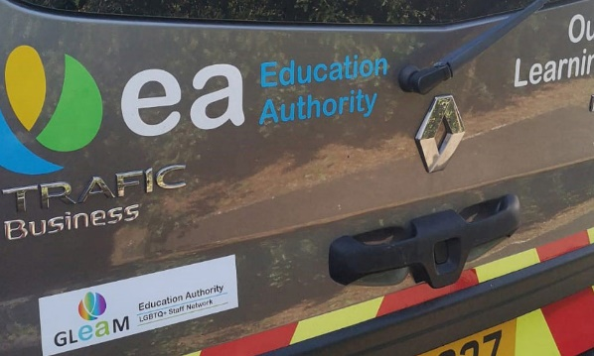
The LGBTQ+ Staff Network have arranged for staff in our buildings to have access to awareness raising materials to show support for their colleagues and celebrate diversity. Staff in our buildings can get a free Lanyard and/or Pen at reception.

Our transport vehicles that we are using over the summer will have bumper stickers on them all summer.

All our social media channels and the EA website will have an alternative ‘rainbow’ EA logo over this period.

EA have created a virtual background for MS Teams and video calls that we are encouraging staff to use during the following weeks – to celebrate Pride and show support for our GLEAM network and LGBT colleagues. The use of the background is voluntary and can be used by staff over the summer.

EA Now Special Pride Edition

Look out for EA Now a special edition for Pride this year including an introduction to some of our GLEAM staff network members, also available on our website.

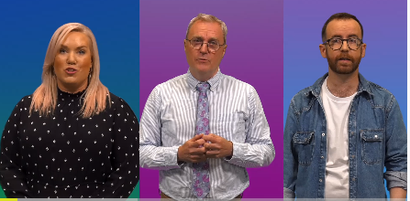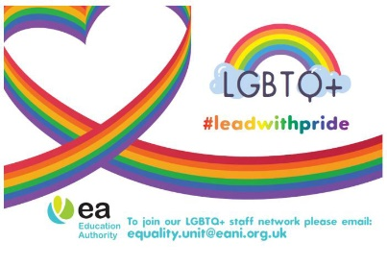

Education Minister visits Magilligan Field Centre

On the 28th July, Magilligan Field Centre (MFC) welcomed a visit from the Education Minister, Michelle McIlveen.

The Education Minister was given a tour of the Centre’s facilities and was introduced to the staff involved in the running of both residential and day visits for schools from across Northern Ireland.

During the visit, staff shared their stories about the positive impact of the Centre's outdoor learning programmes for young people.

She also heard more about the online teacher training and resource development that has become a feature of the work carried out by the MFC advisory teachers, Michael Cross and Natalie McLucas, over the past year.

We want to hear from you
If you have any news or stories that you would like to be considered for inclusion in an upcoming edition of Staff Headlines, please email comms@eani.org.uk

