EA Sensory Service 

Roger Pen Microphone
Roger Pen  1. Indicator light LED  2. Decline call  3. Accept call  4. Charging and audio input  5. Microphone mode change  6. Connect  7. On/off/mute  8. Microphones  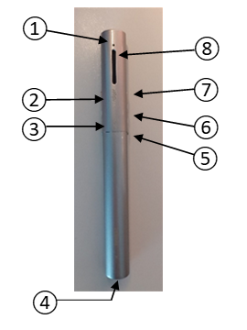 | How to Connect a Roger Receiver  - Make sure Roger Pen and the Roger receiver are both powered on.  - Hold Roger Pen within 10 cm / 4 inches of the Roger receiver.  - Press the Connect button on your Roger Pen.  - The indicator light will turn green for two seconds to confirm a successful connection.  - Repeat steps 2 & 3 to connect a second receiver. | Understanding the Status Indicator Light  Indicator light Meaning  Switched on  Switching off, Bluetooth in standby mode  Switching off  Audio input detected  Microphone / audio input muted  Charging  Fully charged  Low battery – charge your Roger Pen  Active phone call

For further advice please contact the Sensory Service via phone: 028 25 661 258 or email: sensoryservice@eani.org.uk

