EA Sensory Service 

Bone Anchored Hearing Aids (BAHA)
Children with a conductive hearing loss (whereby there is an issue with the outer or middle ear) may benefit from the use of a hearing aid. For some children, the conventional behind the ear hearing aid is not suitable. This may be for a number of reasons such as continual chronic ear infections or due to an abnormality or malformation of the outer or middle ear.
A Bone Anchored Hearing aid or BAHA transmits sound vibrations through the bone, bypassing the outer and middle ear and transmitting directly to the cochlea. Unlike conventional hearing aids, a BAHA is a surgically implanted device (not to be confused with a cochlear implant).
Children who are too young to have surgery or whose hearing loss is temporary can wear a bone conduction hearing aid on a softband. The softband is placed around the child’s head with the sound processor sitting on the skin behind the child’s ear.
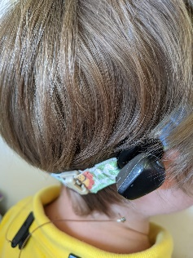
This video demonstrates how to position the BAHA correctly.
Instructions on how to change the battery in a BAHA are included here.
Unlike hearing aids, the BAHA does not have as many components to clean. Here is a link which gives an overview of how to maintain your BAHA.
The following links gives further information regarding the BAHA 4, BAHA 5 , BAHA 6 and Ponto 4 device such as changing the program and using the remote.
The NDCS website has further information about Bone Anchored Hearing Aids and Bone conduction hearing aids.
- The Education Authority Sensory Service is not responsible for the content of the resources linked on this page nor does it constitute endorsement
For further advice please contact the Sensory Service via phone: 028 25 661 258 or email: sensoryservice@eani.org.uk

