Oracle Browser and Performance Advice

Browser to be used with Oracle

The recommended browser for the Oracle Financial System is Microsoft Edge (or the new update version Microsoft Edge Chromium for iFS identified users). IE11 and Chrome are not recommended as these are causing issues in both functionality and performance within Oracle.
- The blue arrow below shows the Microsoft Edge icon 
- The red arrow below shows the Microsoft Edge (Chromium) icon 

To open up the Microsoft Edge browser, click on the Windows/Start menu on the bottom left hand corner of your screen (highlighted below in yellow) and click on the Microsoft Edge icon available to you.
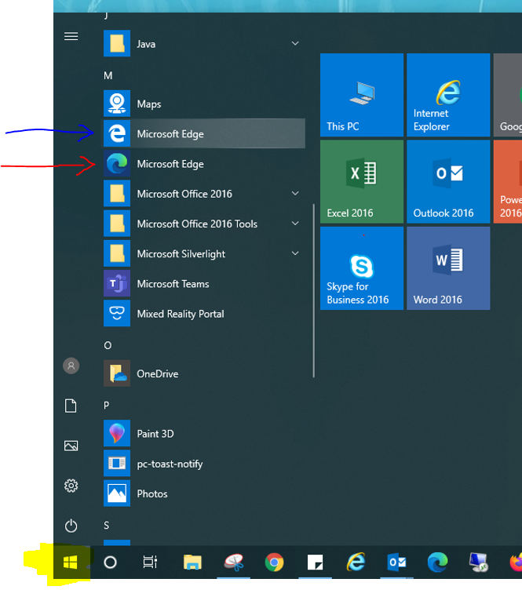

The Oracle link should be copied into search bar in the browser. It’s useful to save this link as a favourite. (Oracle External access)

Performance Advice – Clearing Cookies and Cache

A build- up of cookies and cache can cause problems such as loading and performance issues. It is advised to clear these within the browser on a weekly basis.

- How to Clear Cache and Cookies in Microsoft Edge

Open up the Edge, press the keys Ctrl, Shift and Delete at the same time on the keyboard. The following pop up will appear, click on the ‘Clear’ button. Close the browser and reopen again, log in to Oracle as normal.

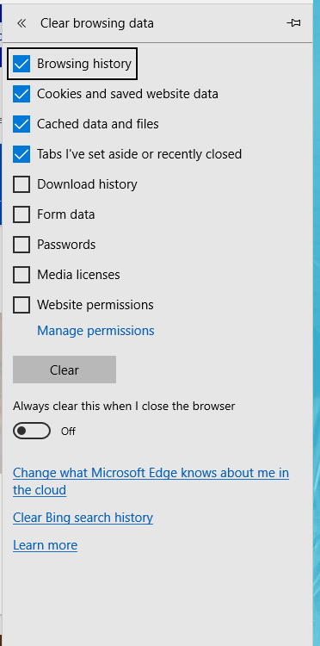

- How to Clear Cache and Cookies in Microsoft Edge (Chromium)

Open up the Edge, press the keys Ctrl, Shift and Delete at the same time on the keyboard. The following pop up will appear, ensure “Time Range” is set to “All time”, click on the blue ‘Clear Now’ button. Close the browser and reopen again, log in to Oracle as normal.

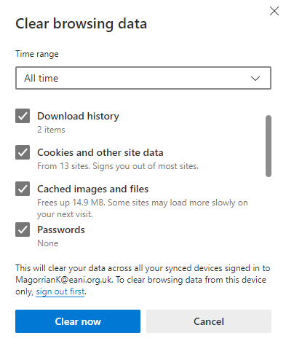

To set your browser to clear cache automatically on closure click on three dots and select “Settings”

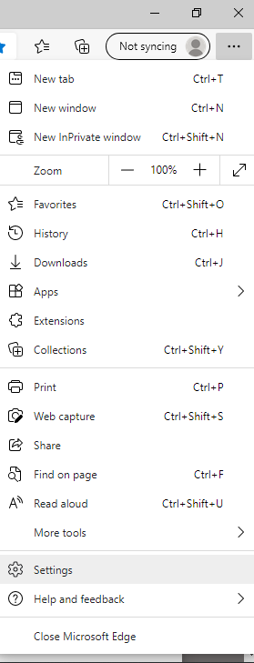
Select “Privacy, search and services” select as below and close Edge

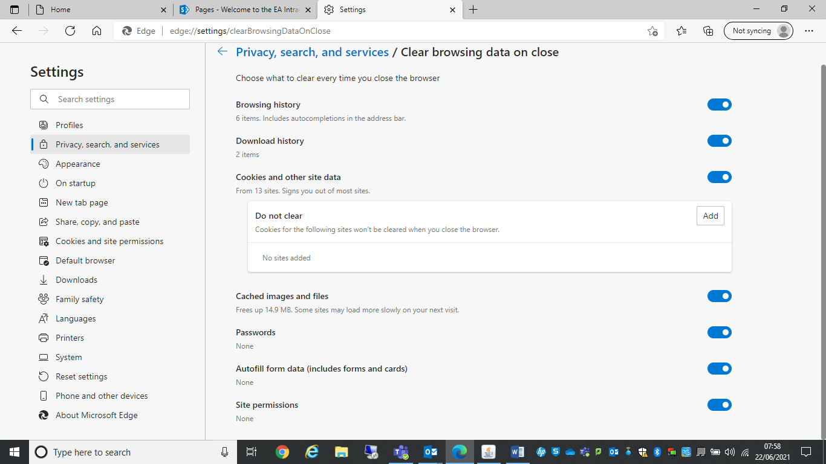

If you are still experiencing issues after these steps have been followed, please email ifs.queries@eani.org.uk reference Browser Issues with your issue.

