

Admissions to Pre-School and Primary
Education Authority School Portal – User Guide

JANUARY 2021
Version | Published on
Version 3.0 | 28 January 2021

Doc Ref
Northern Ireland Admissions – Schools Users/Provider Portal Schools Admission Portal Customisation

Contacting the Service Desk
Admissions Helpdesk (028) 9598 5595
Technical queries - C2K Service Desk 0870 6011666
School Document Hub Login queries: Email: digital@eani.org.uk or call the Admissions Helpdesk (028) 9598 5595 select option 2 and
option 4

Providing Feedback on Documentation
The Education Authority (EA) always welcomes comments and feedback on the quality of its documentation including handbooks. If you have any comments, feedback or suggestions regarding this handbook (PDF file) or any other aspect of our documentation, please email:

preschooladmissions@eani.org.uk
primaryadmissions@eani.org.uk
postprimaryadmissions@eani.org.uk

Please ensure that you include the document name, version, and aspect of documentation on which you are commenting.

This User Guide will be updated as required to reflect changes in processes and/or amendments/refinements to the School Portal.

Contents

Section 1 – ADMISSIONS LOG IN 4
1.1 Where Do You Access The School Portal? 4
1.2 Log In and Registration 5
1.3 Navigating the School Portal 5
1.4 Nursery Schools & Playgroups 7
Section 2 - VIEW APPLICATIONS 8
2.1 Select ‘View Applications’ 8
2.2 Applications screen – Primary 8
2.3 Applications screen – Reception 10
2.4 Applications screen - ‘Target Age’ or ‘Penultimate’ Nursery 10
2.5 Number of Applications 11
2.6 PAN – Published Admission Number 11
2.7 Viewing Applications by order of preference 11
2.8 Previewing an Application 12
2.9 Exporting Applications 12
Section 3 - REPORTS 12
3.1 What reports are available? 12
3.2 Accessing Reports 13
3.2 Creating a new Report 13
3.3 Selecting which report to run 14
3.4 Report Format Options 14
3.5 Running the Report 15
3.11 How do I know the report is ready? 16
3.12 How do I view a report? 16
3.12 How do I select an individual application? 17
3.13 Viewing Previous Reports 17
Section 4 - PROCESSING APPLICATIONS 18
4.1 Actioning Applications 18
4.2 Filters and Columns 18
4.3 Showing and Hiding Columns 19
4.4 How do I sort the order of applications? 20
4.5 Offer Status Details 22
4.6 Allocating/Refusing Applications 23
4.7 Keying application details to SIMS (Schools with access to C2k) 23

Section 1 – ADMISSIONS LOG IN
Welcome to the School Admissions Portal. For purposes of this document the term school includes primary schools, nursery schools and those voluntary and private providers participating in the pre-school education programme (PSEP).

1.1 Where Do You Access The School Portal?
Schools with access to C2K: The Schools Portal can be accessed on My School Desktop

(a) Log into My School

(b) From the Launch Panel, Click View All | Click Education Authority tab and launch the EA Services for Schools app. This will open the “Connecting Schools to EA” page.

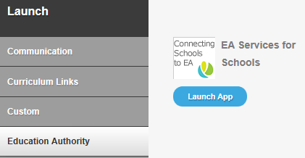
NB: Please note that this only applies to Primary Schools and users in Nursery units, not playgroups or other nursery schools.

Schools without access to C2K:-

- Log onto www.eani.org.uk
- Click ‘school management’ from top menu
- Click ‘Digital Admissions Online Resource Hub’ and scroll down to link as shown below:-

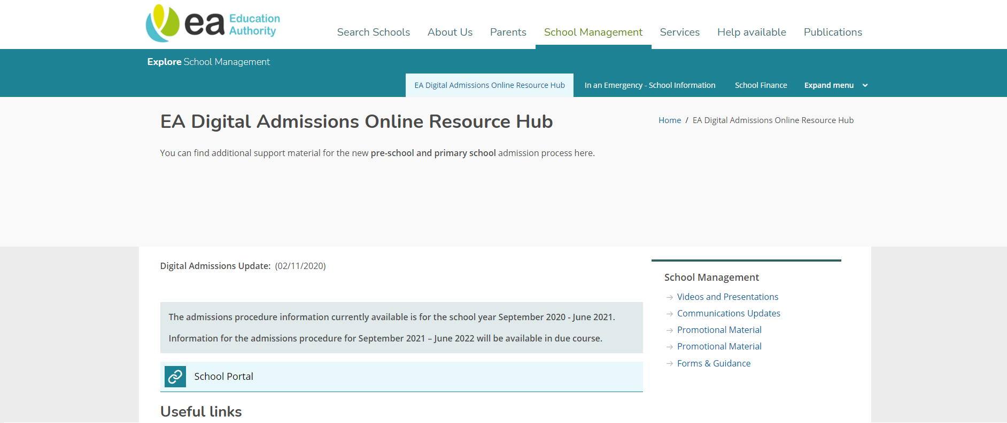
Or by typing:-

https://providerportal.eani.org.uk/ProviderPortal_LIVE/Account/Account/Login

into your browser.

1.2 Log In and Registration
All providers should have received the communication from EA’s IT Department (dated 7 December 2020) which contained a reminder of your login details and the option to request an additional login. If you would like an additional login and have not already done so, please contact the Helpdesk number below.
If your setting has not requested an additional login or a change of login but the person who used the account last year has left their employment you should change the password on the account to ensure that the information is secure.
If there are any issues with logins please contact the EA Helpdesk 028 9598 5595.
- Log onto the school portal using the Username and Password allocated to your school.
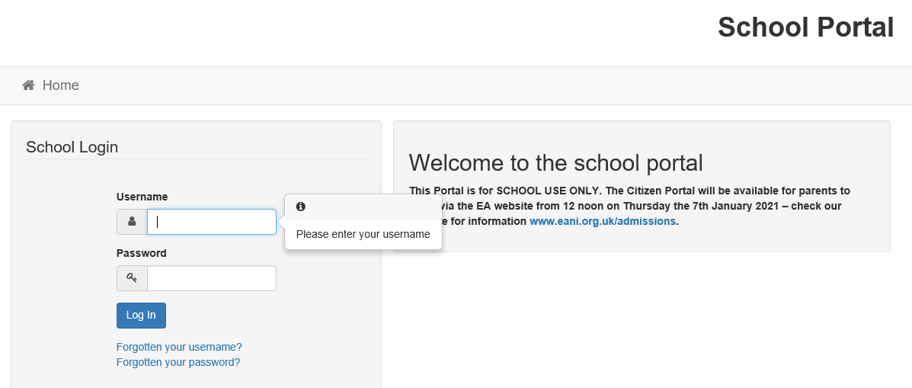

1.3 Navigating the School Portal
You have now reached the School Portal. Depending on your access rights, you will see tiles for Reporting, School Admissions and your School Access maintenance. The School Access Maintenance tile is where you can change account details i.e. update your password, change secret question/answer, etc.
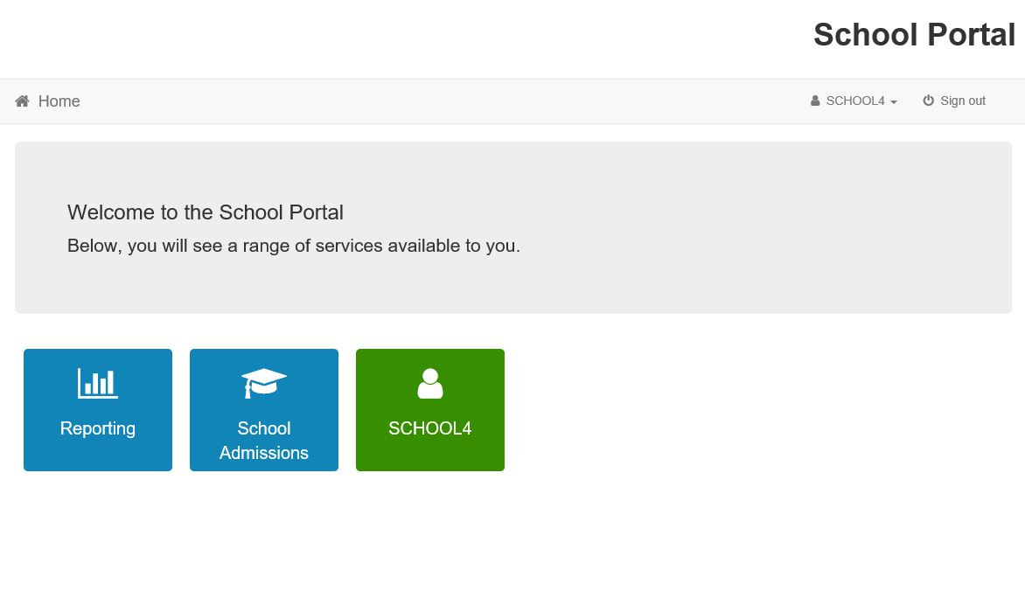

(a) To see applications for P1 admissions, please select ‘School Admissions’.
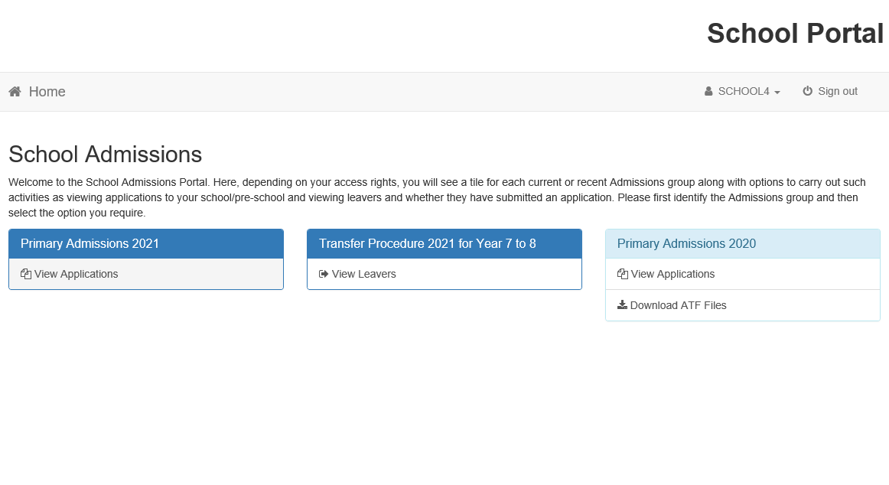
(b) For Primary Schools with a Reception Class these applications are on a separate tile:- 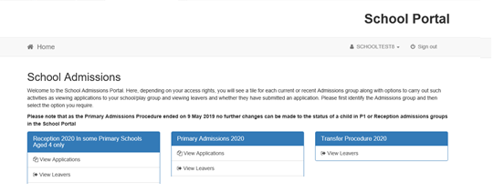
NB: PLEASE DISREGARD ‘VIEW LEAVERS’
(c) For Primary Schools with a Nursery Unit there is a tile for Nursery Unit Applications for both Target Age and Under Age (penultimate)
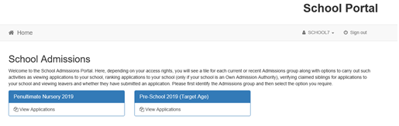

1.4 Nursery Schools & Playgroups
Log on details are the same as detailed in 1.1 and 1.2.

- There is a tile for both Target Age and Under Age (penultimate) applications. The underage applications tile does not appear on a Playgroup screen.

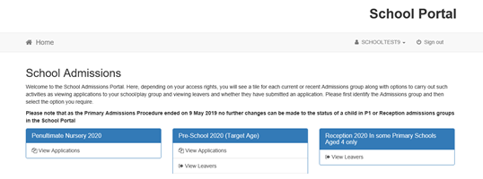

Section 2 - VIEW APPLICATIONS
Clicking on the view applications link will allow the user to review and respond to the applications received. You will be able to view applications as they become available in the EMS central database i.e. at any time from 7 January 2021 onwards. Viewing applications is dependent on a background procedure which automatically run several times a day.
NB You will also be able to see the number of applications in respect of children for whom your school is listed at second and subsequent preferences - however you will not be able to view their details. Such applications will become available for you to action only if they are refused admission by their higher preference school.

2.1 Select ‘View Applications’
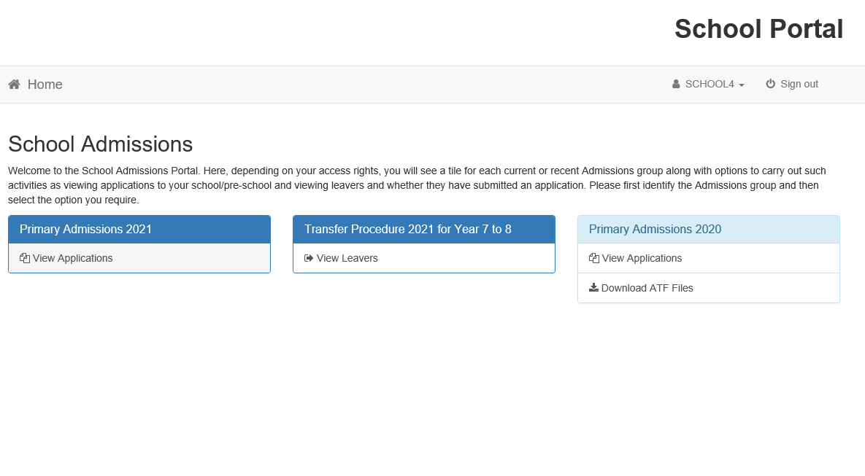

2.2 Applications screen – Primary
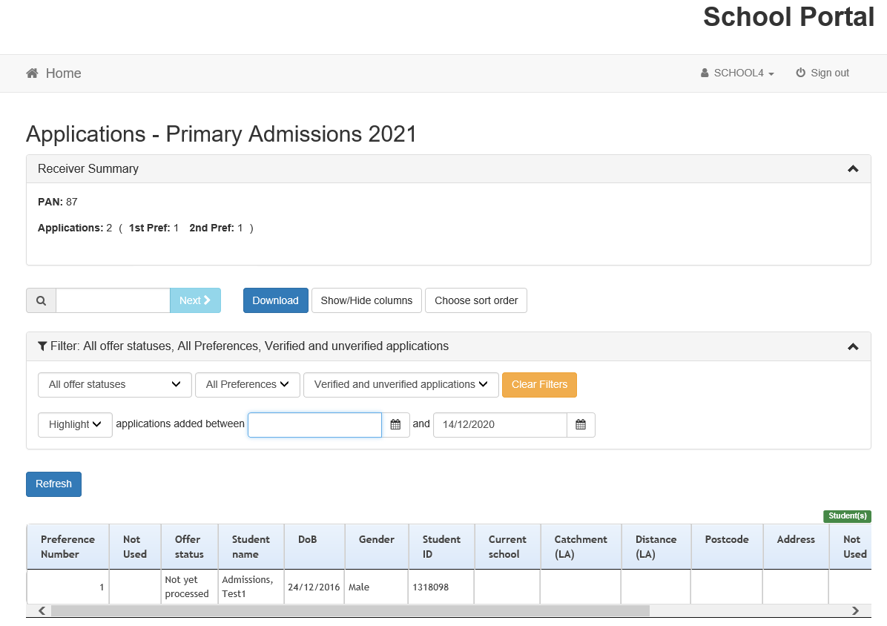

2.3 Applications screen – Reception
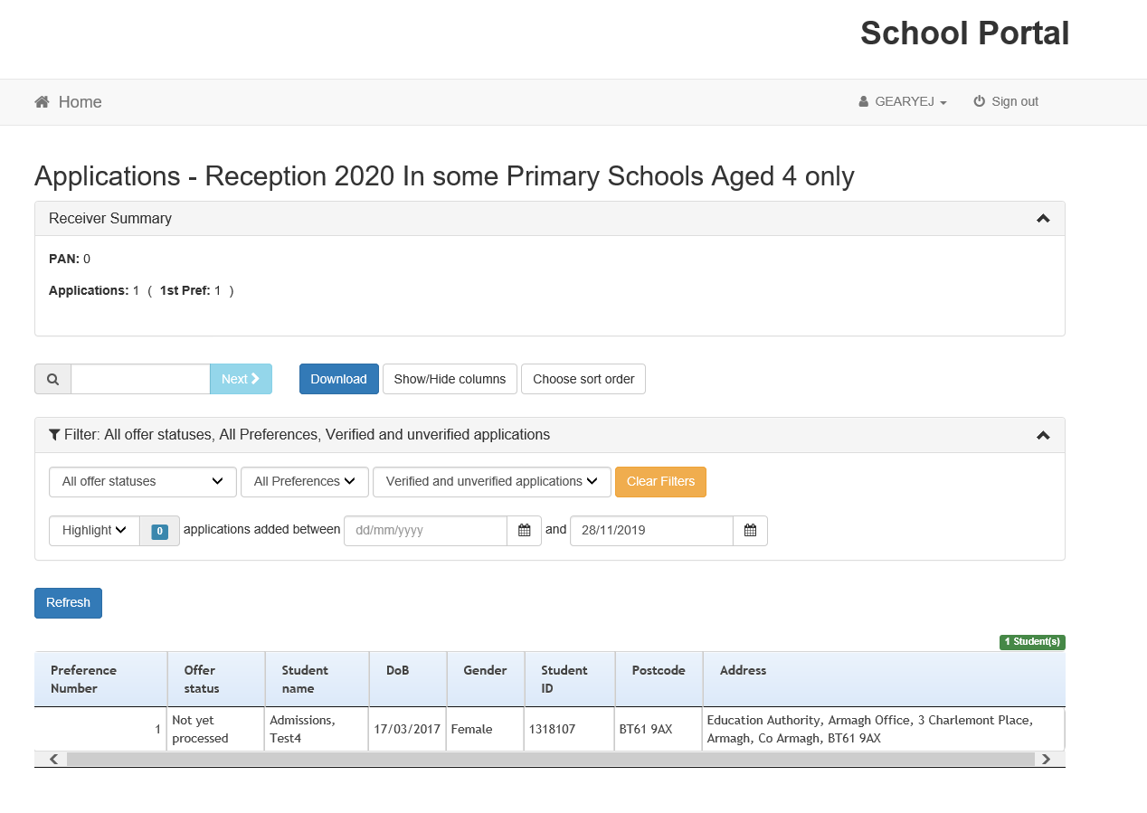

2.4 Applications screen - ‘Target Age’ or ‘Penultimate’ Nursery
NB: To see Applications on either Penultimate or Target Age. Mixed pattern Nursery Schools need to login as FT in order to run the composite report for FT and PT in the reporting tool.
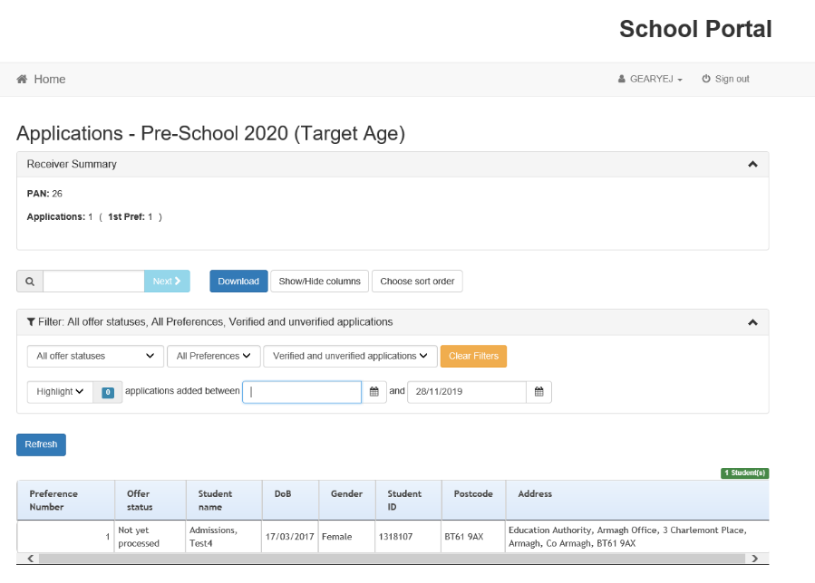
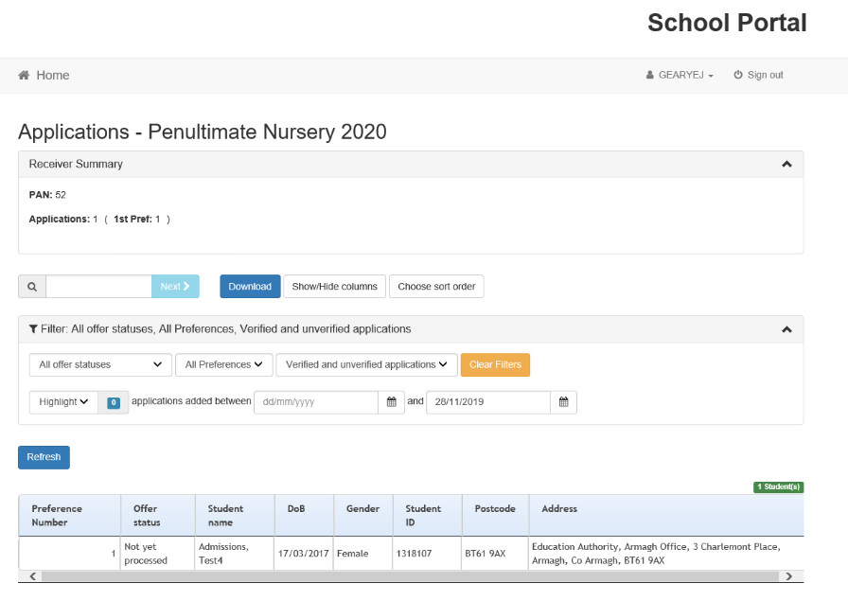

2.5 Number of Applications
The number of applications will include ALL PREFERENCES – you will NOT see the details for these pupils until they move to ‘Provisional’. Many of these preferences will not become active on your portal as they will be selected at a higher preference. You can use the filter to select the ‘Provisional’ applicants.

2.6 PAN – Published Admission Number
The term PAN - Published Admission Number refers to the Admission Number determined by the Department of Education for schools. In the case of non-statutory settings participating in the PSEP, this term refers to the number of funded places allocated to the provider by the EA’s Pre-School Education Group. 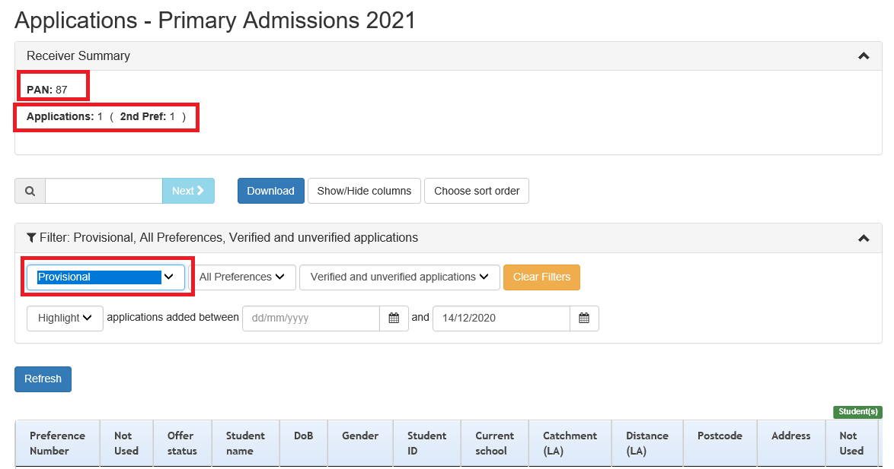

2.7 Viewing Applications by order of preference
You can also view the applications by offer status, order of preference etc.
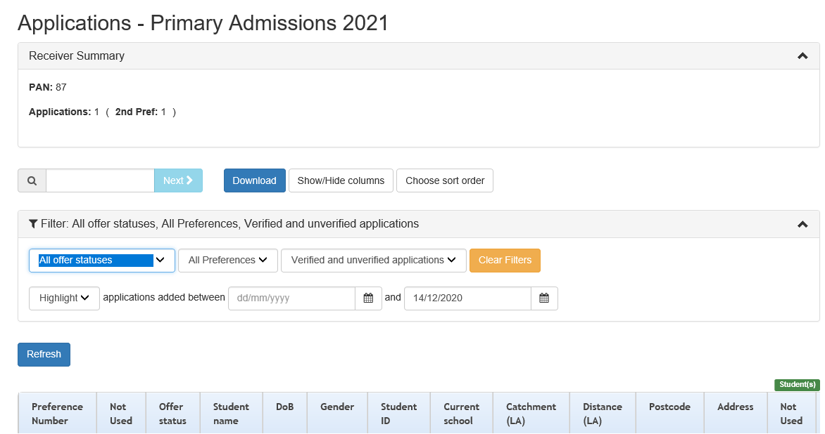

2.8 Previewing an Application
Clicking on a specific row will show the details of the child’s application.
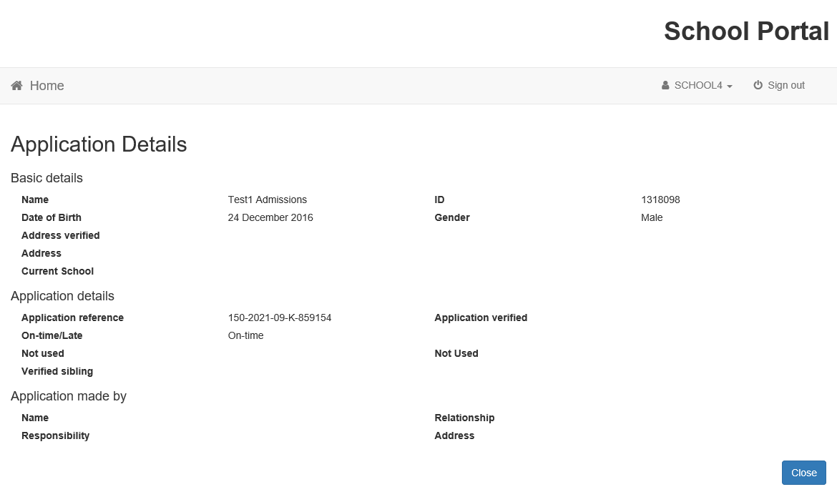
Please view the applications and consider all information submitted via the school portal, verify the date of birth and ensure that each child’s name has been recorded as shown on the birth certificate. Should there be any changes to the child’s details, please complete the Applicant and Pupil Details Correction Form (available on the Digital Admissions Hub) and forward to preschooladmissions@eani.org.uk or primaryadmissions@eani.org.uk as appropriate.

2.9 Exporting Applications
By selecting the ‘download’ option a spreadsheet is generated in Microsoft Excel with the list of applications and the details of all the applications, more detailed reports are available in the ‘Reporting’ option. (See 3 below) 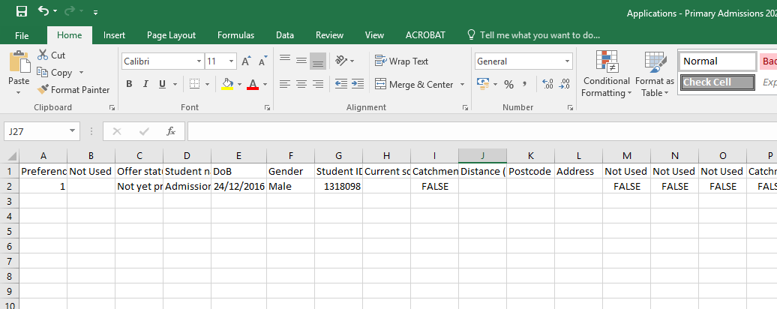

Section 3 - REPORTS

3.1 What reports are available?
There are 6 reports currently set up in the School Portal.
These reports are:-
- Composite Report for Mixed Pattern Nursery Schools & Units
- Composite Report applications for Irish Medium Units
- Pre-school Individual Application
- Pre-school Applicant & Pupil Detail Report
- Primary School Applicant & Pupil Detail Report
- Primary School Individual Application

The detailed individual application report contains information on the applicant, child, preference and answers to set questions e.g. Social Disadvantage, sibling or eldest. For integrated schools this reports also includes ‘Religion’.
The individual application report contains details of information entered to the Citizen Portal. This report can be run for all applications or for an individual child by entering their Student ID.

3.2 Accessing Reports
To access reports click on the ‘Reporting’ tile:-
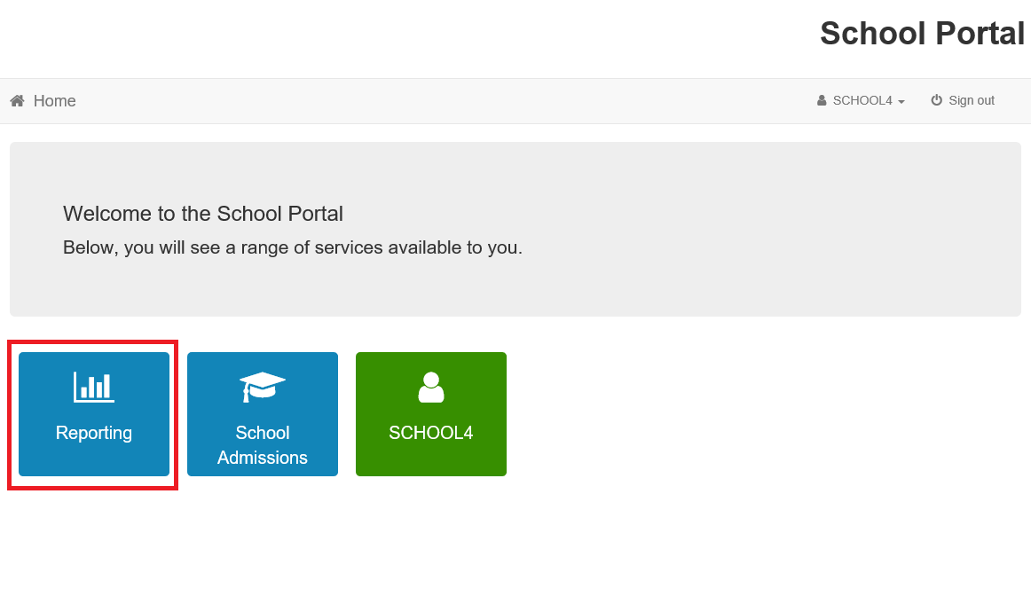

3.2 Creating a new Report
Click ‘Run a Report’ for a new report to be created:- 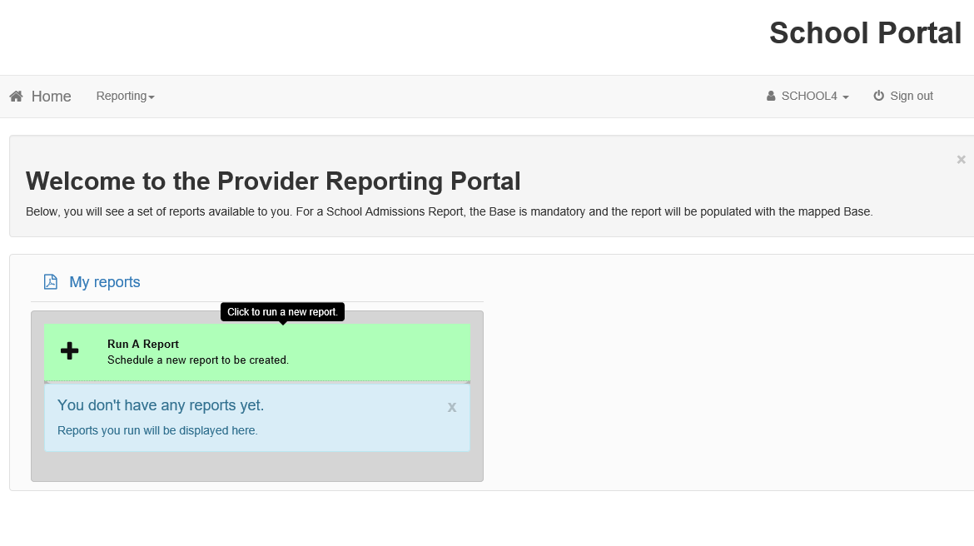

3.3 Selecting which report to run
Report choice has a drop down menu - select report to be run:-:- 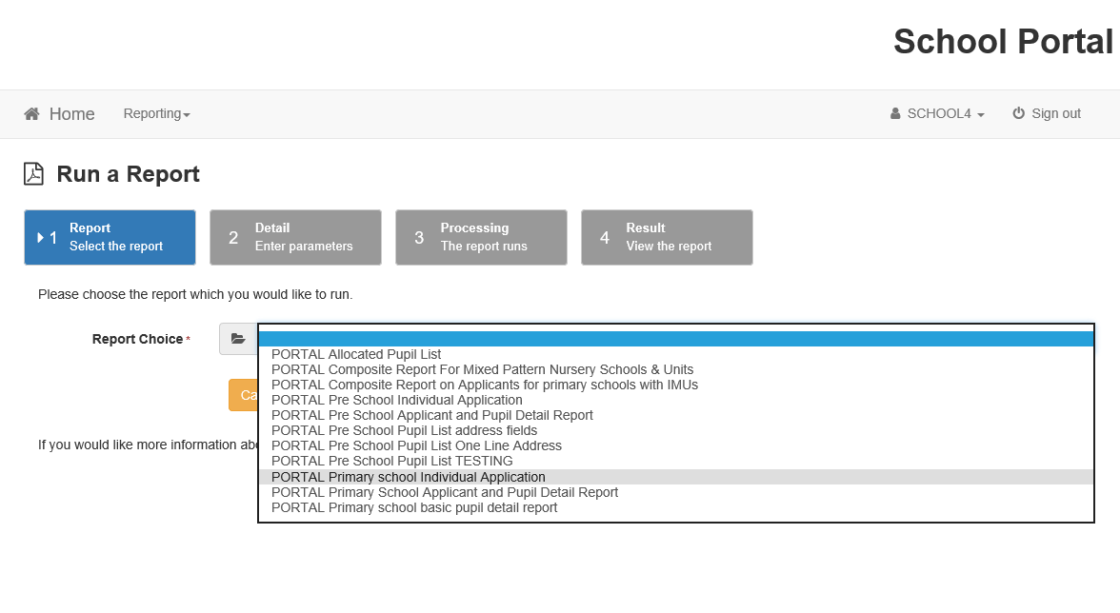

3.4 Report Format Options
For best results run reports as follows:-
- Individual Application Report – PDF
- Applicant and Pupil Detail Report in ‘Excel Record’.

The Detail report is designed to be opened in Excel Record, please select Excel Record first, give the report a title and then enter the parameter by selecting ‘P’ ‘Y’ or ‘B’ etc.:-
Select Excel Record first:-
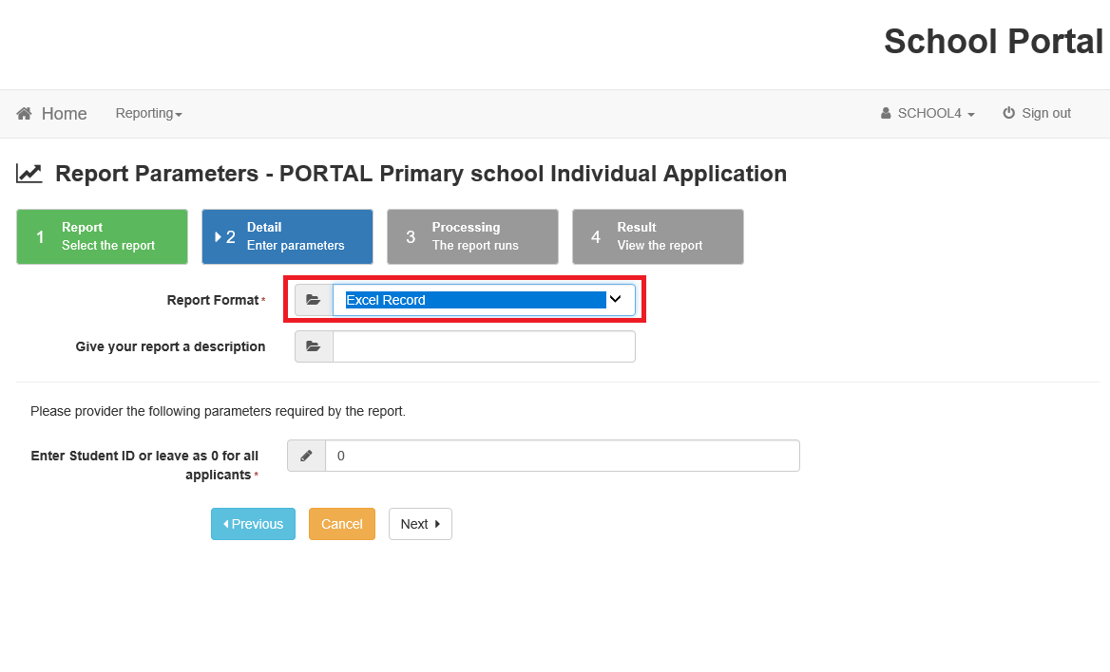
Give your report a name:-
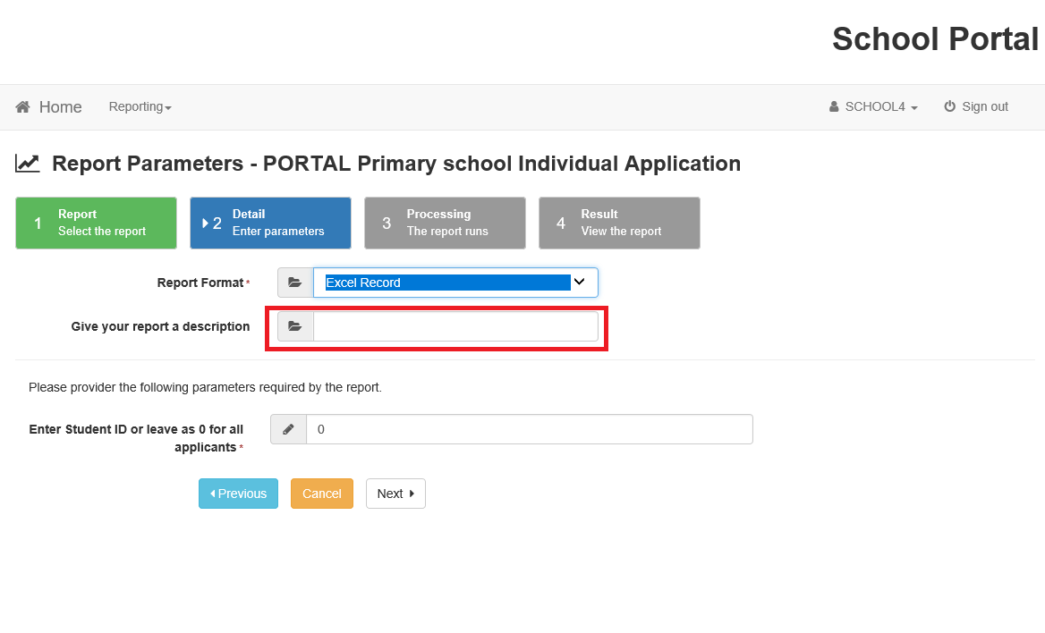
Select Provisional, Allocated or Provisional & Allocated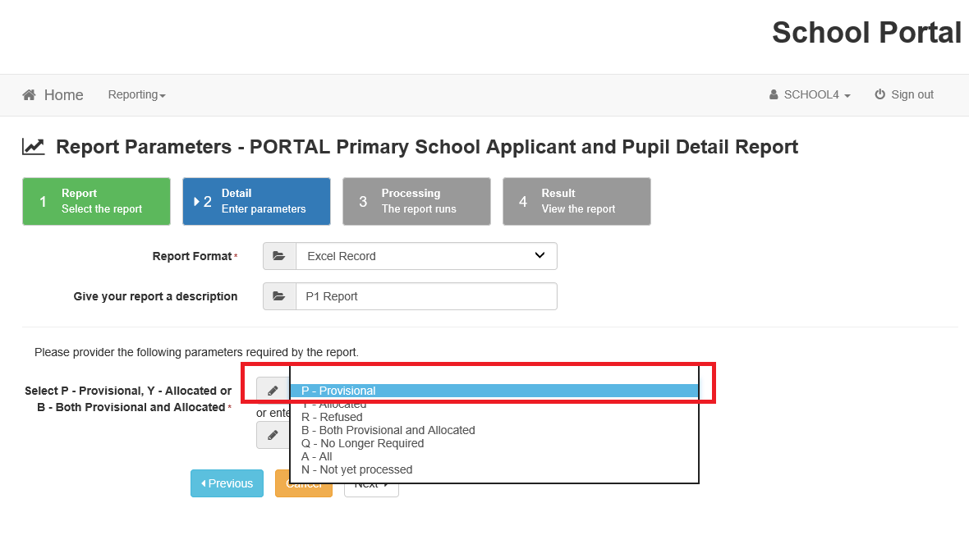

3.5 Running the Report
Click Next to start executing the report:- 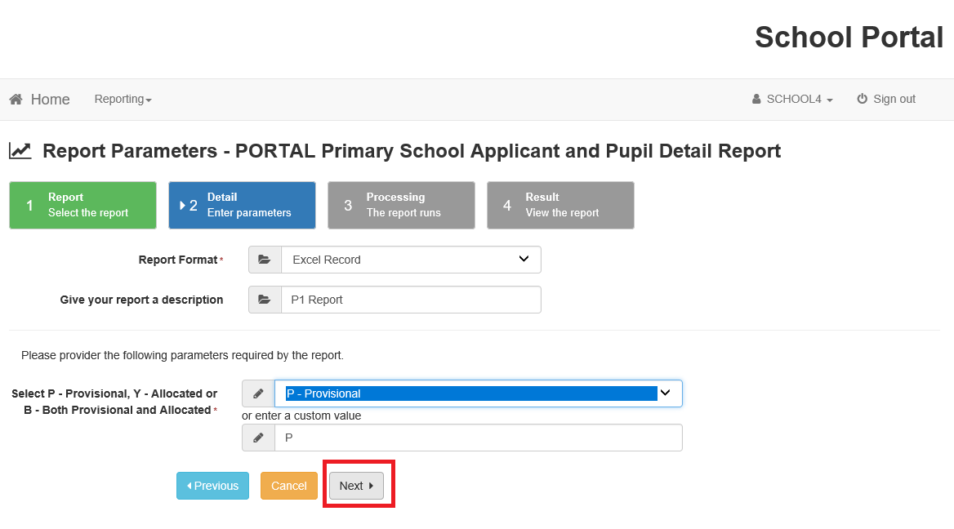

Report executing:-
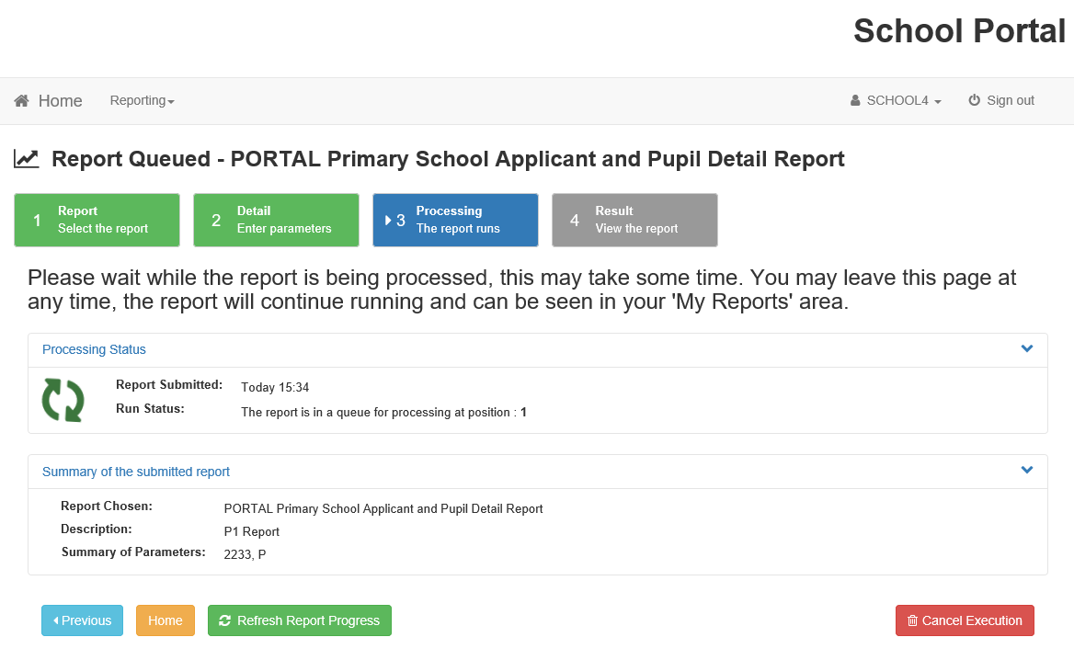

3.11 How do I know the report is ready?
When the report is ready the Refresh Report Progress will change to View Report:- 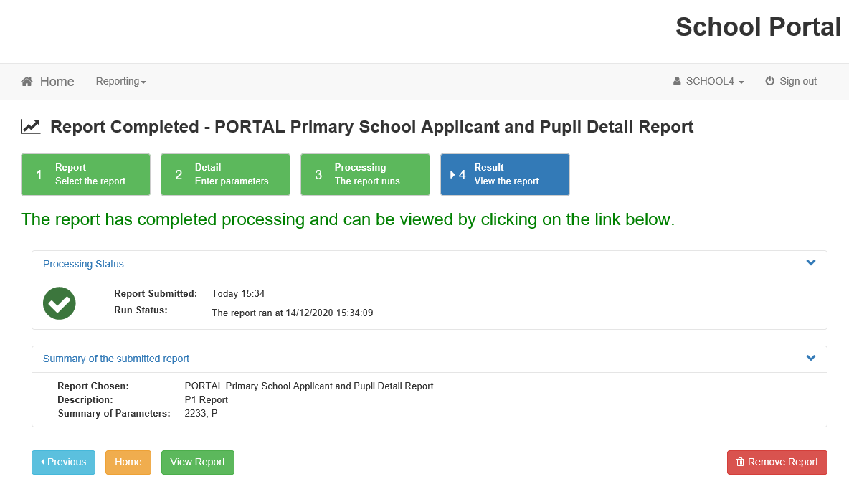

3.12 How do I view a report?
Click on View report to download into MS Excel. Select the ‘save as’ option to save the MS Excel report. It is recommend that you save it (‘save as’ with a date reference for future use). You can show/hide columns as appropriate.
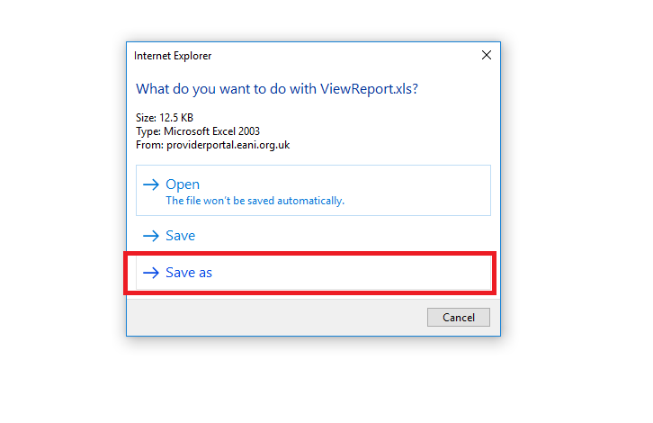
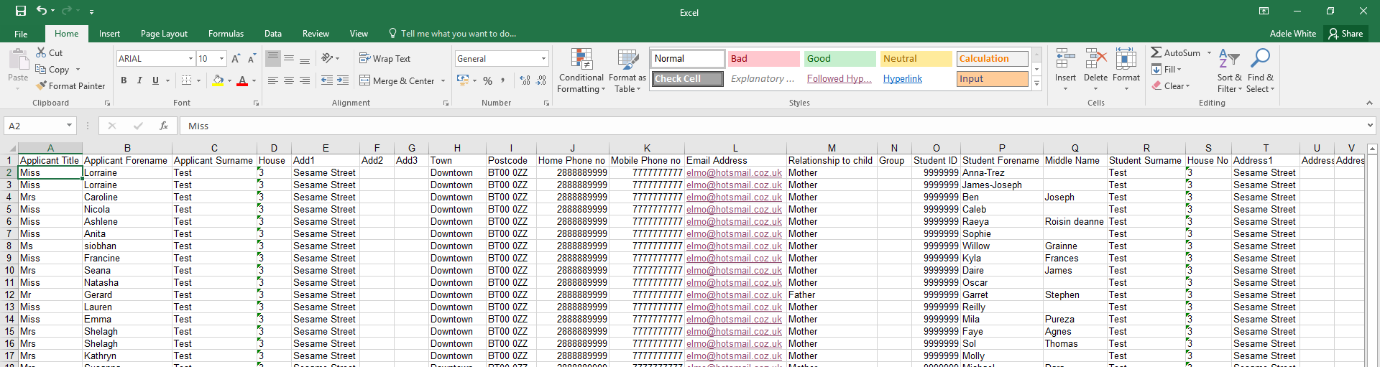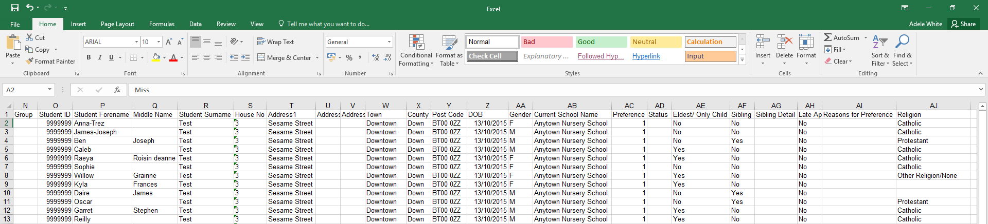

3.12 How do I select an individual application?
The Individual Report is designed to be ran as a pdf. The user can leave the student ID ‘0’ to print all applications or can enter an individual student ID which they will find in View Applications. The individual report is the same for Primary and Pre-school.

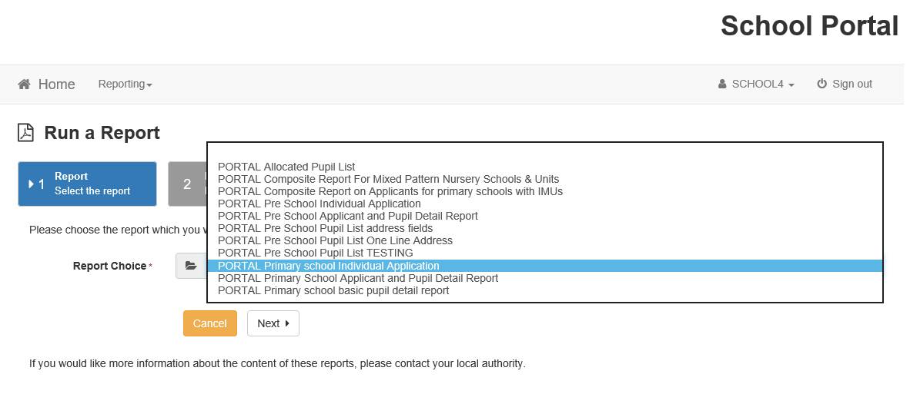

Click ‘Next’ to run the report. The report can then be viewed and opened/saved as required.

3.13 Viewing Previous Reports
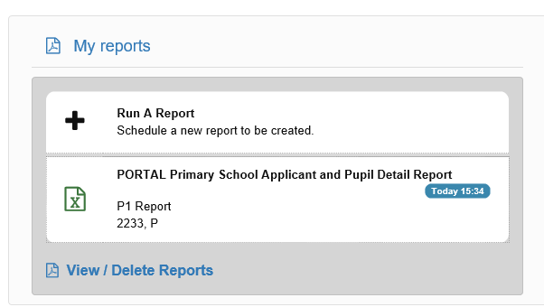

At any time you can view previously ran reports by clicking on the ‘Reporting’ tile which opens ‘My Reports’ and at the bottom of the list you have the option to View/Delete all reports created.

Section 4 - PROCESSING APPLICATIONS

4.1 How to action applications

When the school portal becomes ‘live’ there will be a drop down menu to allow setting to change the applicant status from ‘Provisional’ to ‘Allocated’ or to ‘Refused’. 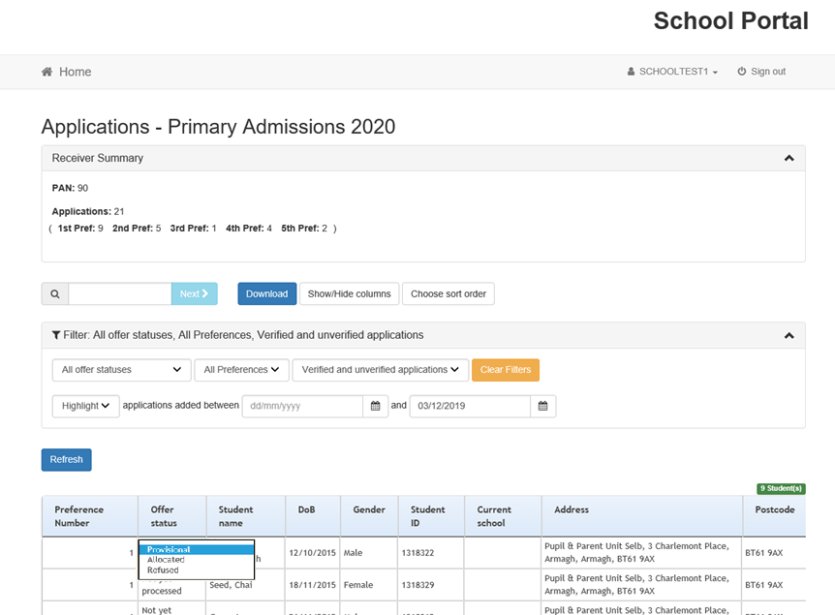

4.2 Filters and Columns
The visible applications can be filtered by a combination of categories including Offer Status and Preference Number. These filters combine, so selecting ‘Allocated’ in the Offer Status filter and ‘1’ in the Preference Number filter will show only applications which are both ‘Allocated’ and a Preference ‘1’ for the school.

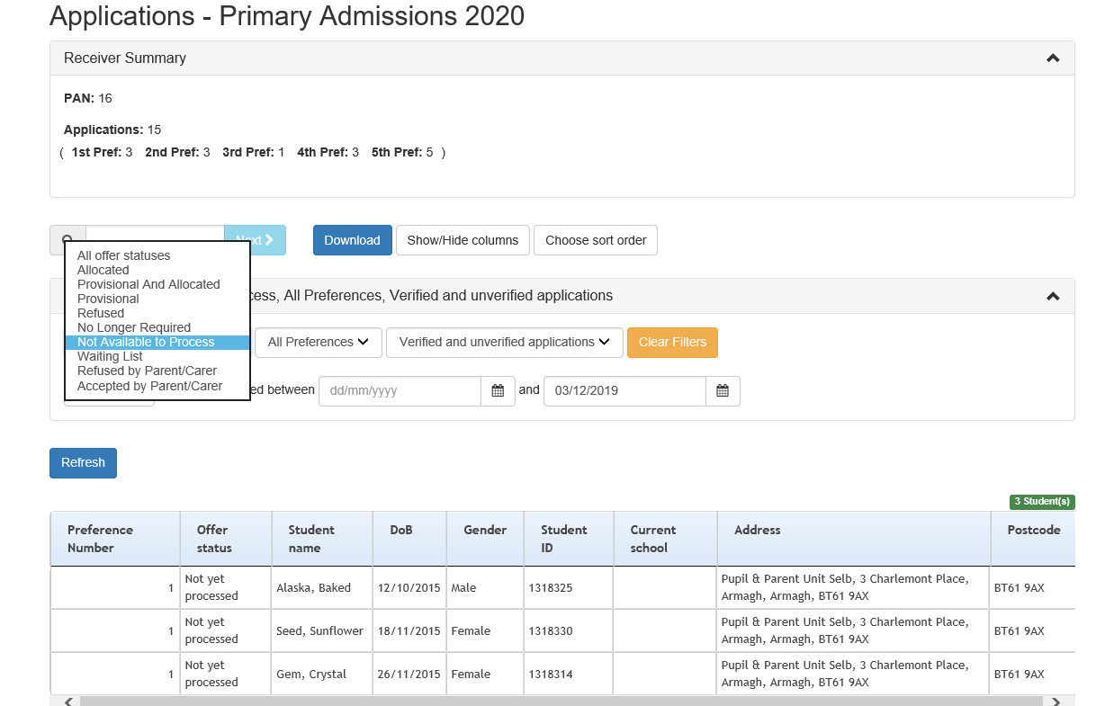

4.3 Showing and Hiding Columns
The visible columns can be set to the Show/Hide facility columns functionality, settings will be remembered for each user.

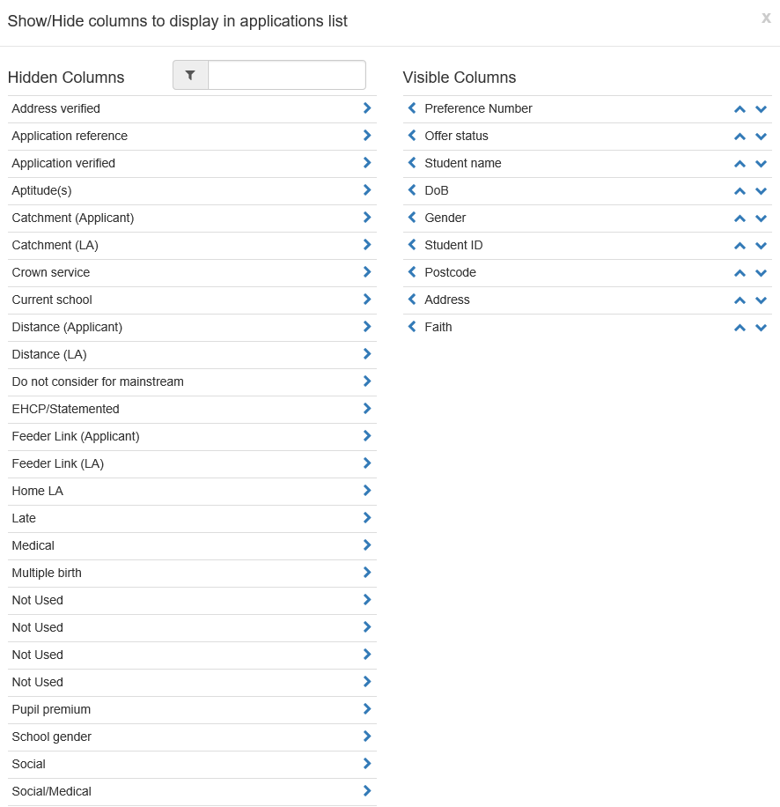
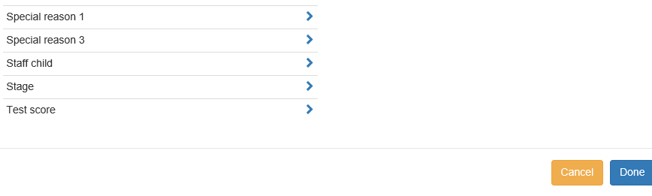

The EA school portal will not use the following fields from the above report:

Address Verified
Application Reference
Application Verified
Aptitude(s)
Catchment (Applicant)
Catchment (LA)
Crown Service
Distance (Applicant)
Distance (LA)
Do not consider for mainstream
EHCP/Statemented
Faith
Feeder Link (Applicant)
Feeder Link (LA)
Home LA
Late
Medical
Multiple birth
Not Used 1,2,3,4
Pupil premium
School gender
Social
Social/Medical
Special Reason 1,3
Staff Child
Stage
Test Score
NB: The ‘Faith’ (Religion) column will appear on integrated school portals and reports only.
If you use distance as part of your admission criteria, the school portal will not calculate this for you. You need to utilise the methodology outlined in your published criteria.

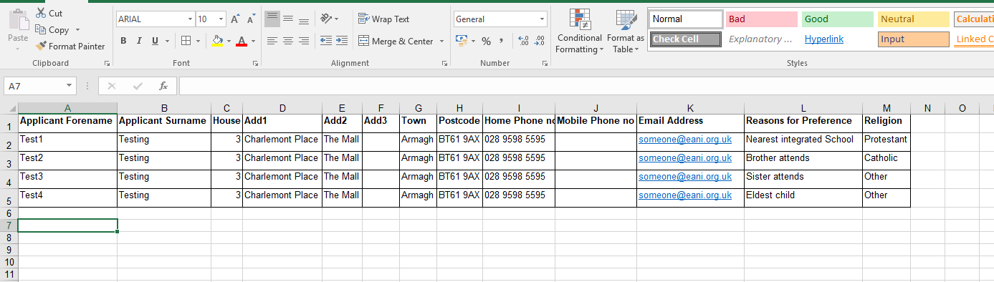

4.4 How do I sort the order of applications?
The sort order of the applications on the screen can also be configured using the ‘Choose Sort Order’ functionality.
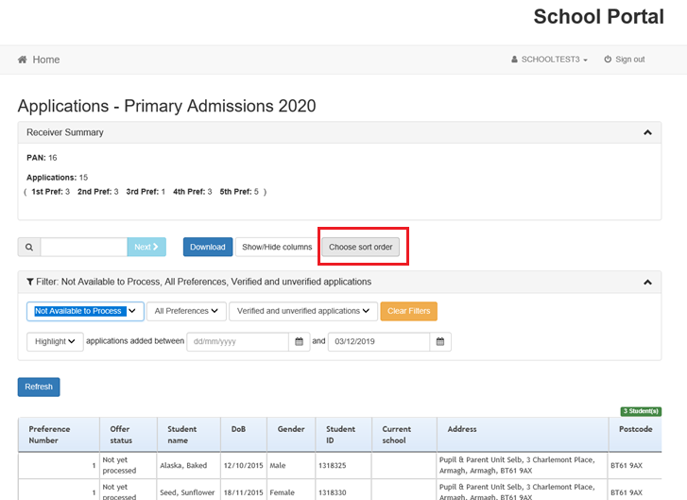

(Please refer to previous screen for fields not used.)

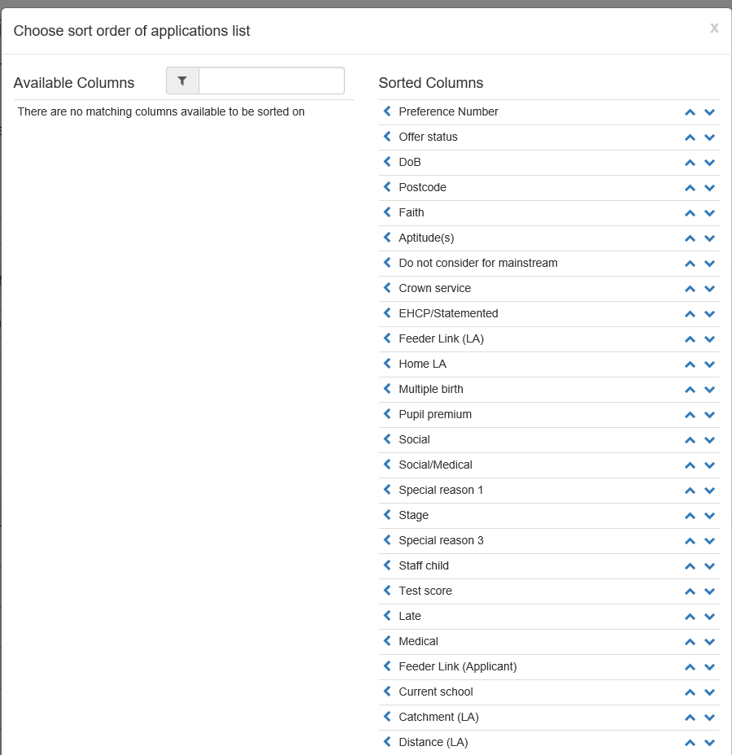
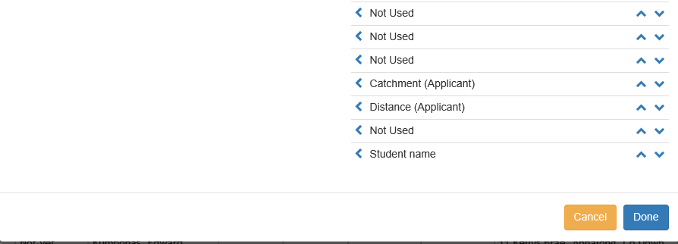

4.5 Offer Status Details
There are 5 offer statuses within the School Portal – only 2 are actionable by schools.

Offer Status | School Able to change Offer Status | Meaning
Provisional | Yes | The child’s application can be responded to by this school.
Allocated | Yes | The child is being offered a place at this school.
Refused | Yes (If a higher preference school hasn’t set the application to allocated). | The child’s application has been refused by this school.
No Longer Required | No | The child’s application no longer needs to be considered by this school (generally because they have been allocated a place at a higher preference school).
Not available to process | No | The child’s application is not available to be responded to by this school. This may be because higher preference schools are still considering the application, or the process of responding to applications has not yet begun.

Following closure of the Citizen Portal all primary and target age pre-school applications will have a status of provisional against their first preference.
NB: Underage applications to nursery schools/units have not been set to provisional on closure of Citizen Portal, these will become active for the opening of Stage 2.
Offer Statuses will change over time, so this screen should be reviewed regularly. It is possible for an application, which was previously ‘No Longer Required’ to become ‘Provisional’ if a higher preference pre-school/school changes their response to the application. This status may also be used if an application is withdrawn e.g. a child becomes statemented during the period of the admissions procedure.

4.6 Allocating/Refusing Applications
Pre-schools/Schools should either allocate or refuse an application via the drop-down menu in the Offer Status Column following application of the published admission criteria if the school is oversubscribed.

The ability to respond to applications can be turned off by the Education Authority, in this scenario the drop down control will not be available, although the Offer Status will still be shown (e.g.) at close of procedure to prevent further changes.
FOR PRIMARY SCHOOLS ONLY
In the School Portal you can allocate places in excess of the PAN provided. You are able to
accept up to a maximum admissions number as set by DE (only schools within their enrolment number) or you have a DE approved Temporary Variation for 2021/22.
NB: If you are requesting a Temporary Variation please do not complete the outcome for the requested applicants on the School Portal until the Department of Education has confirmed agreement to the TV request.

4.7 Keying application details to SIMS (Schools with access to C2K)
Development of the new Document Upload Hub has taken priority over the integration of the application details captured in the Citizen Portal and the school SIMS system. As a result, this facility will not be offered this year and schools can, if they wish, proceed with the manual input of new entrants’ data as soon as it is received.

Guidance on the new Document Upload Hub is available in the Digital Resource Hub.

