Special Educational Needs Inclusion Service
Down syndrome
Structured activity tasks


- Structured activity tasks are visually supported activities which encourage independence
- These tasks work well for children with Down Syndrome as they build upon their strength as visual learners
- Tasks promote building blocks to independent learning opportunities which reduce pressure on the child as tasks are familiar and non-challenging
- Tasks can be produced to support individual needs/ preferences

What is a structured activity task?
This is a task that can be completed independently by the child by using visual supports to show how the task is to be completed. Tasks presented to the child are familiar and non-challenging so this reduces the tendency of opting out, distraction behaviours and non-compliance in task completion.

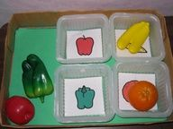

Why use structured activity tasks?
These tasks promote independence, reduce the fear of the unknown, can support positive behaviour management and increase productivity.

What should be included?
Tasks used should be tasks your child can complete independently. Structured activities should;
- Have a clear beginning and end
- Provide visual clarification of what is required in the task
- Remove the need for verbal directions
- Increase independence
- Allow for the learning to be generalised between settings
- Teach a particular skill
- Reduce anxiety and increase understanding

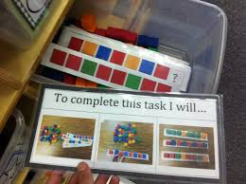

What is required in a structured activity task?
- your child works from left to right
- only provide tasks which your child can complete independently
- all the materials your child needs to complete the task should be available at the independent activity system area

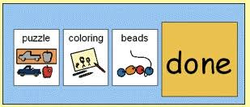

Types of tasks
Think about the tasks your child is good at e.g. counting, fine motor tasks, puzzles, dot-to-dots, word search, matching, sorting, shape, time etc.
The internet is full of ideas for tasks using resources which you may have at home try Pinterest or Twinkl for lots of ideas.

Use practical resources you have at home e.g. matching pairs of socks, sorting buttons into colours, matching lines on cards with the same colours of pegs, posting blocks into an empty fabric softener container.

Introducing structured activity tasks - Getting started
- Collect containers e.g. shoe boxes, cereal boxes, trays, baskets or folders. These are going to be used to contain tasks.
- Provide a selection of tasks for the young person to complete independently. Remember the aim is independence therefore provide structured tasks which are non-challenging, these tasks should be practising a skill which your child has already developed as tasks are set up for complete success.
- Place all the materials your child needs to complete a single task in your preferred container.

Step 1

Checking for Independence
Check for independence by presenting the task in a structured way, try not to sit beside your child or give too many verbal instructions – remember the structured task should speak for itself.

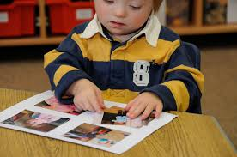

Key tips
- If instructions or prompts are required, ensure these are simple and supported with signing/ symbol/visual.
- Try to reduce prompts each time you present the same task. If you need to sit beside your child add some distance each time you present the same task.
- On completion of the task praise your child for trying and/or success e.g. ‘good matching’ ‘good sorting’ etc.
- Try not to overwhelm your child; use backward chaining initially if necessary.

What is backword chaining?

Backward chaining is breaking the task down into steps. Complete all the steps of the task except for the last one for your child. Now you need to teach your child the last step. Practice this step until your child can do it without your help. Now complete all the steps except for the last two for your child and so on until the child can complete all of the steps.

- Once you have a few tasks which your child can complete independently without prompts or someone sitting beside them, you are ready to introduce one independent task!

Step 2

Introducing one independent task
Identify a clutter free area for the young person to complete independent tasks. Only the task which is to be completed and the motivator should be in the area.

What to do
- Place all the materials your child needs to complete a single task in your preferred container and place container in chosen area.
- Give your child a verbal instruction supported by a First and then visual.
- Child independently completes the single task
- Childs receives motivator
- Adult gives child praise on completion of task.

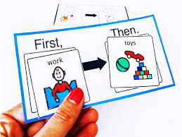

- Photos/ symbols or words can be used to support structured activity tasks depending on your child’s understanding. For access to symbols please visit https://www.twinkl.co.uk/resource/us-t-c-006-editable-ks1-visual-timetable

Tasks can also be created for older children to promote domestic, vocational and independent living skills, please see a few examples below.

Setting the table
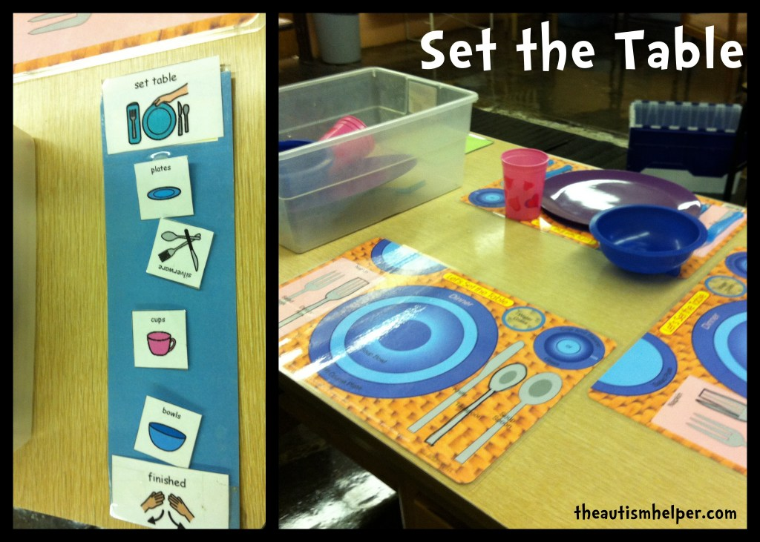

Sorting cutlery and utensils
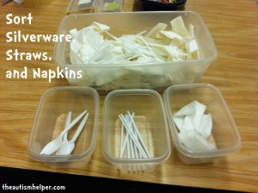

Matching socks
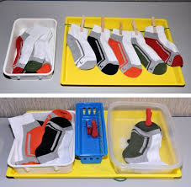

Sorting clothes by colour

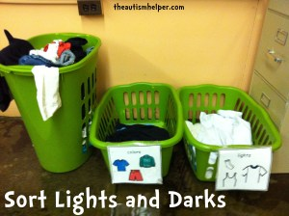

Sorting rubbish into correct recycling bins
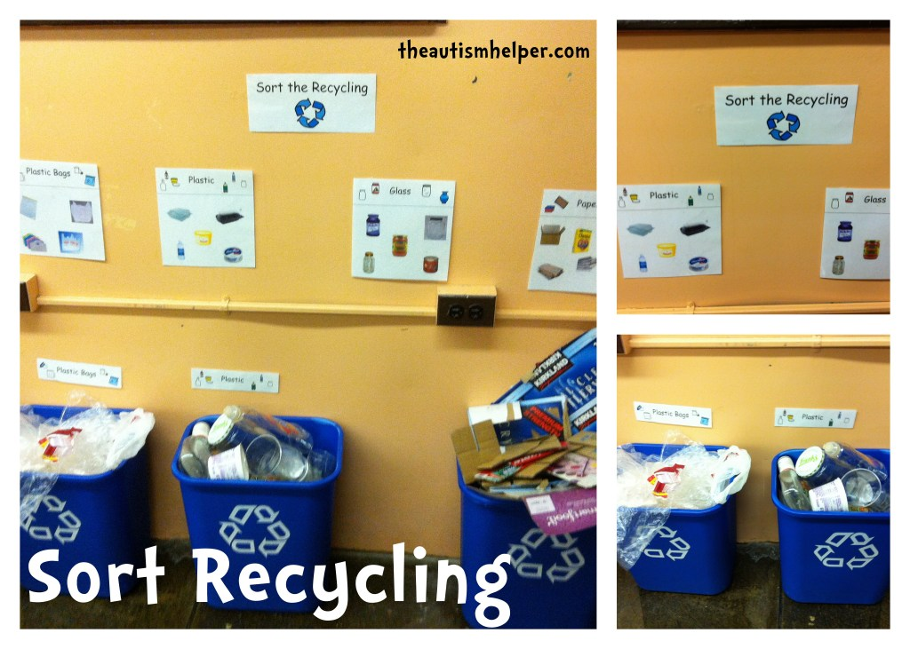

Completing laundry tasks
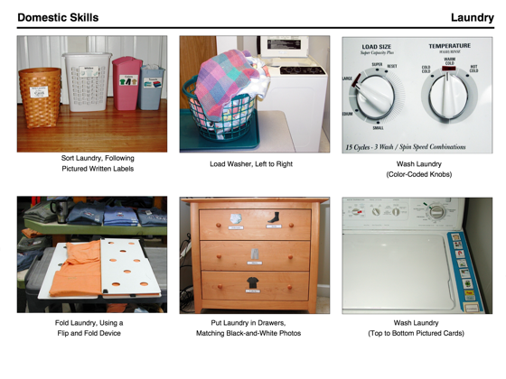

Useful websites

- https://www.twinkl.co.uk/search?term=now+and+next+board
- https://www.childcareland.com/free.html
- https://www.integratedtreatmentservices.co.uk/resources/speech-and-language-therapy/ and click on visual support
- https://teachingautism.co.uk/diy-task-boxes-to-make-at-home/

Additional ideas can be found on social media platforms such as
https://m.facebook.com/groups/301306666568425/?tsid=0.04552195808046178&source=result
https://www.pinterest.co.uk/sw-shell.html
https://www.pinterest.co.uk/janeroach1/tasks-galore-asd/

Some key word suggestions are below which may aid when searching for resources online; workbox tasks, structured work systems, independent work tasks, structured tasks, activity tasks.
There are some resources below that you may wish to print to aid in setting up a visually supported structured task. Alternatively an app is available which supports scheduled tasks visually and verbally on a mobile platform meaning schedules can easily be created or changed “on-the-go”. The app can be purchased in the app store.
For more information on this app please visit the link below
http://autismapps.org.au/organisation-and-independence/ftvs-hd-first-then-visual-schedule-hd/

Resources



First | Then

