
Special Educational Needs Inclusion Service
Down syndrome

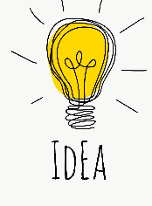
Supporting Positive Behaviour
- Behaviour problems are not an inevitable feature associated with Down syndrome; most young people with Down syndrome are capable of behaving in an age-appropriate way.
- Learning age appropriate social behaviour is as important as academic learning
- Have HIGH expectations of young people, and expect them to behave well.
- Reward positive behaviour!

Typical teenage behaviour
Mood swings, pushing boundaries, tiredness, feeling confused, crushes, first loves and spending ages in the bathroom… Whilst these changes may occur a little later than in people without Down syndrome, young people with Down syndrome will essentially be just like any other teenager. Sex and relationships, wanting independence, good personal hygiene, needing personal space and building good self-esteem are all issues that you will need to think about as your young person grows up

Socially appropriate behaviour is one of the major influences determining:
- Whether you can form successful relationships (personal and professional)
- Whether you are accepted or rejected by peers
- Living and working situation
- Social integration
- Quality of life

Influences on behaviour

- Temperament and personality
- Parent management styles and expectations
- Emotional climate – feeling safe, feeling loved and valued at home, feeling liked and respected in school and community settings
- Ability to understand what is expected in a situation
- Ability to communicate effectively
- Reactions of others to behaviour

Identify causes of behaviour
If a young person is displaying a negative behaviour, which needs to be changed, it is important to try and work out why they are behaving that way. Remember that they are trying to communicate to you through their behaviour. This can make it easier to deal with difficult behaviour. Behaviour is a form of communication. Negative behaviours may be:

- Attention seeking
- To get out of doing something (escape/avoidance)
- Requesting something
- A sensory need/overload
- Expressing anxiety
- Communicating emotion or pain
- Misunderstanding instructions
- Forgetting what he/she has been told

One way to begin to understand what your young person is trying to communicate is by keeping a behaviour diary. Keep a note of when and where they exhibit the challenging behaviour, what happened beforehand and what the consequence of this behaviour was. Patterns of negative behaviour may help you to understand how to begin to tackle the problem.

Look to the future

Day to day handling of inappropriate behaviour can be a daily challenge however keep your eye on the long term goals. The effort and consistency with behaviour today will have long term impacts for the future such as increasing independent living skills and building social skills. Keeping focused on the future can really help getting through the frustrations of today.

Ideas to encourage good behaviour at home

Have High Expectations

Having high expectations of young people and expecting them to behave in an age appropriate way will encourage good behaviour.

Some examples of behaviour that would be expected from young people in post-primary school include;
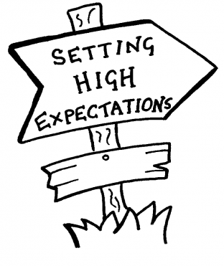
- Sitting at the table during dinner
- Helping with household chores
- Keeping their room tidy
- Following a hygiene routine
- Being respectful towards family members

Every person is different but keeping those behavioural expectations high will really help in promoting lots of positive behaviours.

Promote self-esteem
Many young people struggle with self-esteem to a certain degree and your young person may also have begun to notice the differences between themselves and their peers. Developing a healthy self-esteem can help them understand and accept who they are as a person, rather than seeing only ‘Down syndrome’. Some ways to promote self-esteem are:

- Emphasise that although they may struggle with some things, they are a unique person with their own talents, strengths and personality.
- Highlight the things they can do rather than the areas they find difficult.
- Support your young person to take as much control over their own life as possible. Help them make as many of their own choices and decisions as they can.
- Encourage friendships, independence and social interaction with people their own age.
- Have positive role models.
- Support your young person to develop friendships with peers with learning disabilities and without learning disabilities. Having a mixture of friendships, including with people with learning disabilities, can help your young person accept and feel happier with who they are.

Encourage independence
Behaviour issues can be related to independence skills and self-help. Independence needs to be promoted at school and at home throughout the teenage years. Encourage independence through teaching life skills. Young people can be taught how to:
If we are given the chance to help others (rather than always being on the receiving end), then we can feel equal, important and valued. If we are given responsibilities, we have the chance to make a genuine contribution.

- Prepare food
- Set the table
- Wash/dry dishes
- Use the washing machine
- Help with the shopping
- Follow a hygiene routine
- Look after their own money
- What to do in an emergency

Ideas for teaching life skills:
- Break each skill up into smaller sections
- Do one small part of the skill to begin with e.g helping to cut the vegetables
- Everything doesn’t have to be learnt all at once
- Watch others doing the skill
- Use pictures or videos to support the learning
- Remind them they may still need support sometimes

When the life skill has been learnt it can be beneficial to give the young person responsibility for that particular skill e.g it is their job to set the table each day before dinner.

Something all parents do is provide opportunities for their children to become independent. Making choices is part of this and needs practicing. Starting to make choices from an early stage can help encourage future independence in life and allows a person to feel in control of their life and in control of what happens to them. Simple things to help encourage independence include:

- choosing what to eat or wear
- what shampoo to use or toothbrush to buy
- what film to watch together as a family
- Choosing to do maths or literacy work first

Set routines
Give young people clear routines e.g. in the morning, at mealtimes and bedtime.
Routines are important because they can:
- Give young people security
- Teach young people self-discipline
- Eliminate power struggles
- Help young people to understand concepts and language of time
- Help young people to understand what is expected of them
- Help parents to maintain consistency in expectations

Young people with Down syndrome are strong visual learners, so visuals are often helpful for them to learn a routine. Lots of visual routines can be found online, however, young people usually respond much better to a personalised visual routine, using photographs of them in their own surroundings. This is much more meaningful.

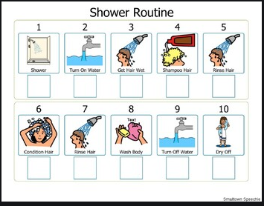
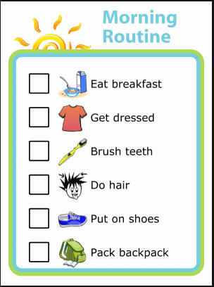

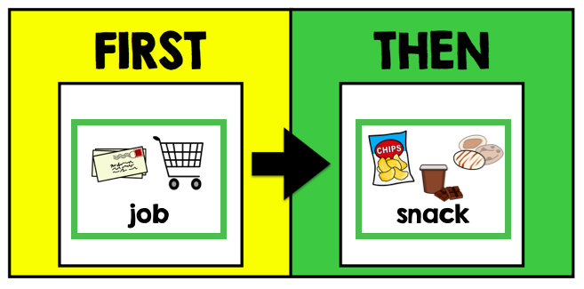
Implementing a first and then board at home can be a good motivational tool for tasks, for example, First Tidy your room, Then Television.



Model good behaviour
Young people with Down syndrome will often imitate the behaviour of those around them. Therefore it is important to be a good role model for your young person and demonstrate the behaviour you expect from them. Ways in which you can model good behaviour:
- Eat healthy and exercise daily
- Be a good listener
- Be positive
- Set goals
- Show encouragement

Support health and wellbeing
Having an unhealthy lifestyle can have a negative impact on health, leading to weight gain, health problems and negative behaviour. Young people with Down syndrome can find it difficult to think about long term consequences and therefore may not understand the importance of making healthy choices about their diet. Young people with Down syndrome often like routine and can struggle with large changes, so making small changes to a person’s daily routine regularly will improve their long term eating habits. Some simple ideas include:
- 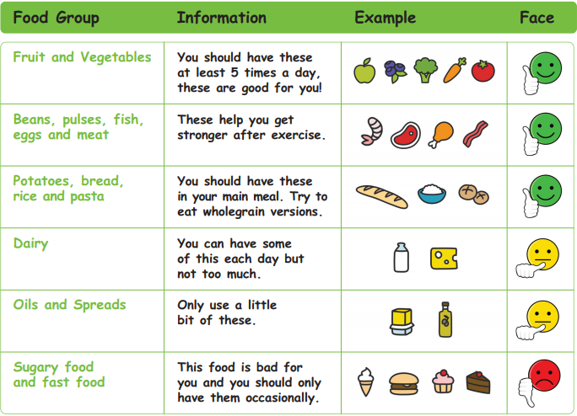Eat a rainbow – eat one vegetable from each colour of the rainbow e.g red peppers, blueberries, carrots etc
- Food swaps – sweet potatoes instead of new potatoes, breadless burgers
- Plan ahead – think of healthy recipes before you do your shopping

Daily exercise is also an important aspect of a healthy lifestyle. Exercise CAN be fun! You could try:
- Aerobics
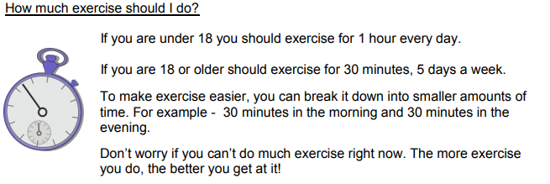
- Cycling
- Dance
- Walking
- Yoga

It may seem an obvious point but poor physical health can impact adversely on a person’s mental wellbeing. Young people with Down syndrome may struggle to verbally express pain or illness and it stands to reason that if you are feeling unwell or in pain for a period of time, but find it hard to express this, you might then start to feel upset, anxious or have low moods.

Those around the young person with Down syndrome may have to look for other non-verbal clues that indicate that he/she is unwell (e.g. changes in mood, routine and behaviour).
Some ways to foster good mental health include:
- Encouraging their unique interests and talents or relative strengths
- Involving them in life planning
- Teaching new information and skills so they do not have to, and do not make mistakes
- Making sure they are getting a good night’s sleep.
- Prepare them for expected life events and changes

Support good communication

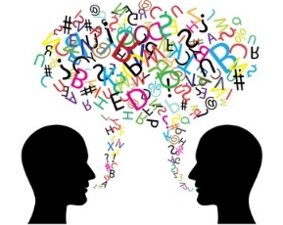
Using clear, simple unambiguous language when giving instructions will help to overcome a range of speech and communication difficulties. Keep instructions simple. Direction should be very specific and be directive; don’t make it a request.

For example;
Don’t say “Can you go and get your coat or we will all be late?”
Do say “Get your coat now, thank you”.
Don’t say “I have already told you twice to go and put on your shoes, if you go and put on your shoes now then we will able go out for a walk to the park”.
Do say “Please put on your shoes now”.

Young people will often try to communicate though their behaviour, offering alternate ways to communicate can lead to a reduction in frustration motived behaviours.

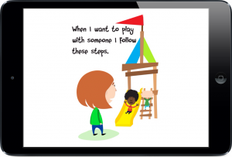
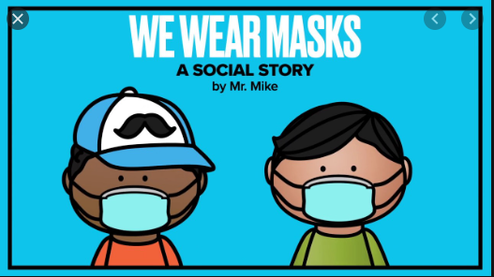A social story is a small booklet or app with visual cues which explains what to expect in a particular situation. You may outline clearly how you expect the young person to behave. Again, photographs are usually best.

Support social skill development

Try to ensure young people have plenty of opportunities to socialise and interact with peers. This may be through family connections, friends or local groups and activities. They should be encouraged to practice skills like greeting one another, listening, taking turns, initiating and engaging in conversations, brainstorming ideas, expressing opinions and solving problems together.

Use the language ‘Your turn!’ and ‘My turn!’ If necessary, you can use a turn-taking visual to reinforce this concept.
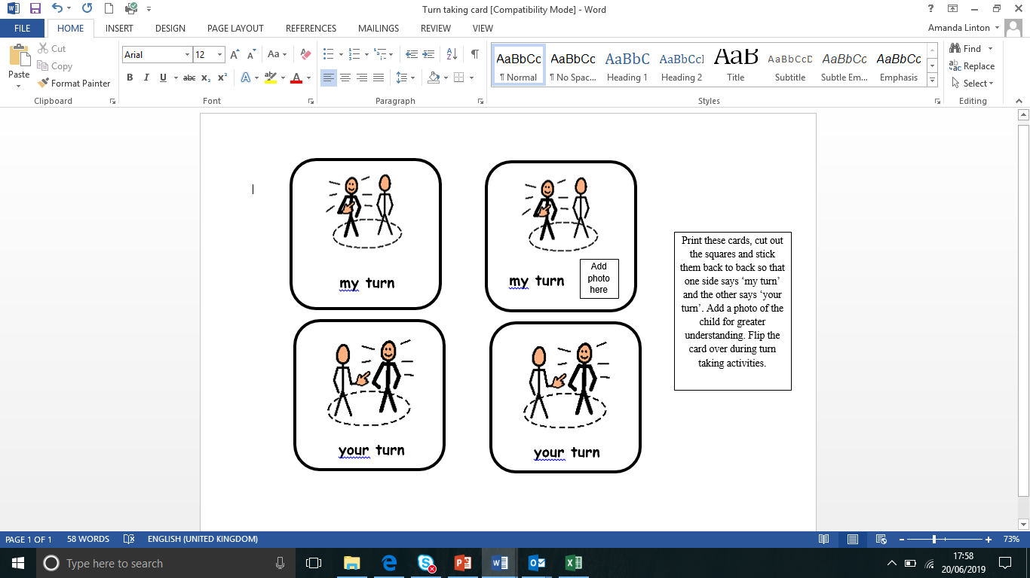
You can personalise the ‘my turn’ card with a photo of your child.

Pick a social skill you would like to teach them (e.g. taking turns, sharing, manners, greetings, recognising feelings in self and others). Then follow these steps:
- Tell them why this skill is important
- Break the skill down into easy small steps
- Show them the skill in action
- Practice the skill in the safety of your own home
- Give your child positive feedback and praise; correct them gently if necessary
- Launch! Practice the skill in public

Adolescence
Young people with Down syndrome will experience the physical, hormonal and emotional changes that come with growing up. It’s very important to help your child understand these changes, so make time to help them understand what is happening with their body and their feelings. Your young person may also begin to have more of a desire for independence and want to ‘push the boundaries’. This is normal – but it doesn’t mean you need to put up with bad behaviour. Try to give them more independence, allowing them to make their own choices as much as you can, but let them know what the rules are and the consequences of breaking them. Ensure you discuss friendships and relationships as well as more tricky subjects such as sex, sexual health, and family matters as well as personal and social skills.

Positive reinforcement

Praise
All young people will engage in behaviours they know they will be rewarded for. It is important not to give lots of attention to challenging behaviours while good behaviours go unrewarded.
Take the time to plan in advance which behaviours you want to see more of and ensure to offer immediate rewards – be consistent!

How to offer praise;
- Use specific language (“Wow! You finished setting the table!” not “Good job!”)
- Young people need to know exactly what it was that they do right so that they can do it again in the future
- Use an enthusiastic / upbeat tone of voice
- Smile!
- Couple with non-verbal praise, too (fist bumps, high 5s, clapping,)

Suggestions for non-verbal praise:
- High fives
- Smile
- Thumbs up
- Pat on the back
- Wink
- Fist bump

Reward charts

A reward chart which is supported by visuals will get the best results. Use pictures of the young person engaging in the desired behaviour, such as doing their numeracy/literacy work or setting the table for dinner. It’s important to have the chart displayed in an area where the young person can see it clearly such as on the refrigerator.
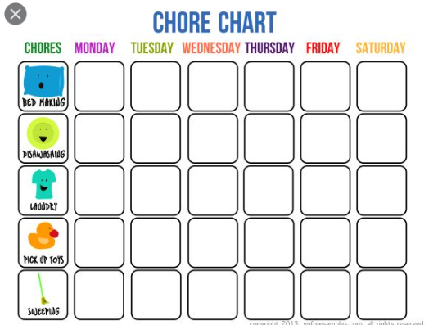

Young people with Down syndrome are motivated by success and demotivated by failure therefore when creating the chart set goals which are achievable.
It’s important that the young person becomes engaged and invested and young people respond best to positivity.

Ensure success through:
- Only giving stars when deserved
- Always giving stars when deserved
- Never take stars away
- Don’t forget about the star chart when things are going well
- Don’t give up on the reward chart when things are going not so well!

Planned ignoring
Sometimes young people will act in certain ways to gain attention. The power can be regained by the parents by ignoring these types of behaviours though the process of Planned Ignoring.

Behaviours which are harmful to the young person, others or property should NEVER be ignored.

Bullying and cyberbullying
Cyberbullying is bullying that takes place online. Unlike bullying in the real world, online bullying can follow the young person wherever they go, via social networks, gaming and mobile phone
No single sign will indicate for certain that a person is being bullied, but watch out for:
- belongings getting 'lost' or damaged
- physical injuries, such as unexplained bruises
- being afraid to go to school, being mysteriously 'ill' each morning, or skipping school
- not doing as well at school
- asking for, or stealing, money (to give to whoever's bullying them)
- being nervous, losing confidence, or becoming distressed and withdrawn
- problems with eating or sleeping
- bullying others.
Young people who are bullied:
- may develop mental health problems like depression and anxiety
- have fewer friendships
- aren't accepted by their peers
- are wary and suspicious of others
- can have problems adjusting to school and may not do as well.
Some actions you can take to protect your young person against cyberbullying include:
- Teach them about online safety – not sharing personal info, speak to an adult if they are unsure about anything online, show any nasty messages they receive to an adult, never agree to meet someone they don’t know
- Talk about bullying and cyberbullying
- Let them know who to ask for help
- Report bullying on social media and gaming platforms
- Talk to their school

Further advice and information can be found on Down syndrome UK website

General Top Tips:
- Stay Calm
- Notice positive behaviour
- Ignore negative behaviour as much as possible
- Use distraction/redirection
- Encourage independence
- Be consistent
- Account for developmental rather than chronological age
- Separate immature behaviour from deliberate challenging behaviour
- If you are getting stressed or frustrated take a break/change person dealing with the behaviour (if possible)
- Smile and be enthusiastic
- Give positive praise “Well done”, “Nice One”, “Good work”
- Make eye contact
- Get down to the person’s level
- Do not shout
- Be clear and use simple words

