Mnemonics
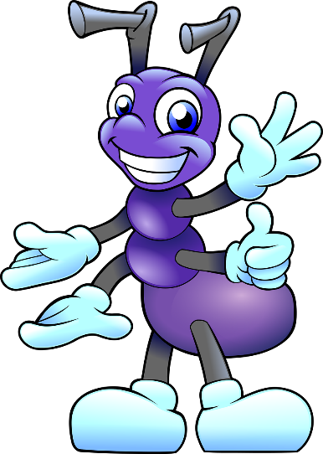
Any
Ants nip you

Many
Many Ants nip you

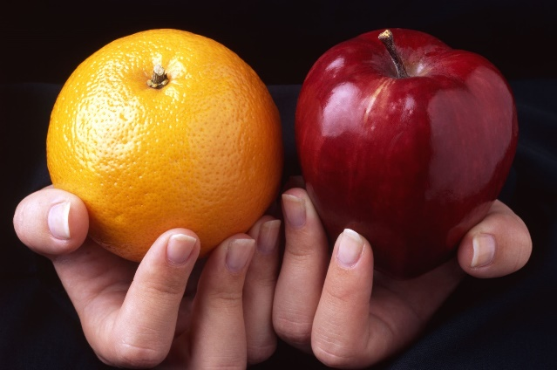
Fruit
Fruit U and I eat fruit

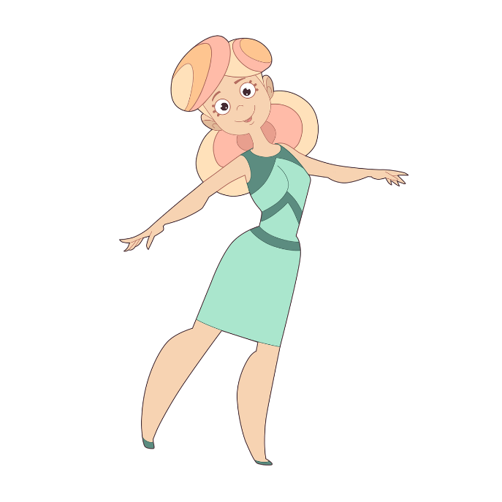
Said
Sally Anne is dancing

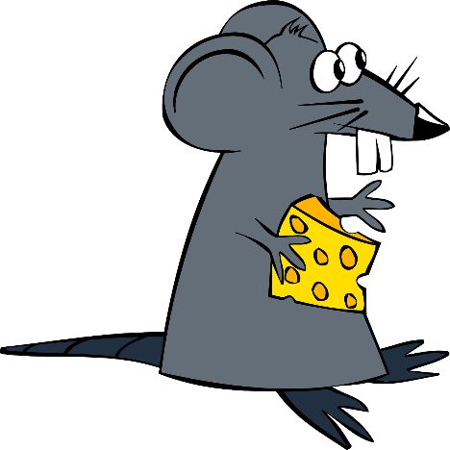
Separate
There is a rat in separate


Huge
Huge is a big hug with an e


Secretary
A secretary keeps a secret


Piece
A piece of pie

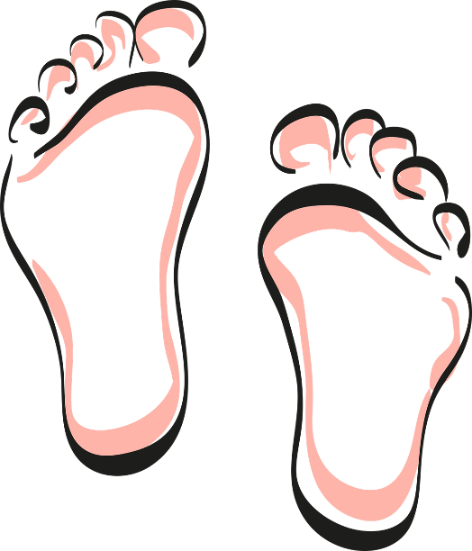
Eight
E I’ve got hairy toes

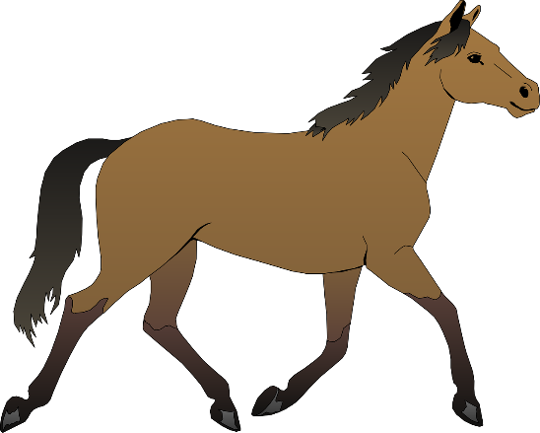
Though
T h o u greedy horse

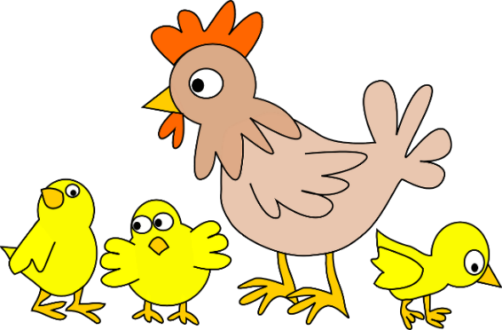
When
W and hen makes when

