Mnemonics

said  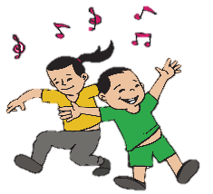  Sam And I dance. | because    Big elephants can always understand smaller elephants.

where  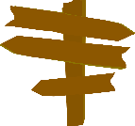  Here is a word in there and where. | hear  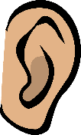  You hear with your ear.

Should could would  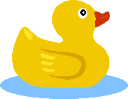  Use O U lucky duck to help remember ‘ould’ words. | what  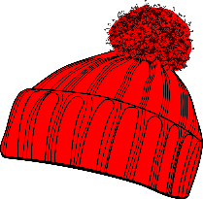  There’s a hat in what.

right light night

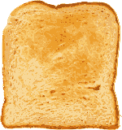

Use I’ve got hot toast to help remember ‘ight’ words.

Look | Look closely at the word. What do you notice?
Say | Say the word carefully. Look at the word as you say it. Listen to the sounds.
Trace | Trace over the word.
Cover | Cover the word.
Write | Write the word. Say the word as you write it. Does it look right? If not – try again.
Check | Check the word.  If it is correct – well done!  If not – try again.
Remember – to be a good speller you need to LOOK closely, SPEAK clearly and CHECK carefully!

Date: ________________________
Read then trace over | Copy and say aloud | Cover and Spell | Close eyes and spell

Draw a picture to remember the word.
Use the word in a sentence.
1:___________________________________2:___________________________________3:___________________________________4:___________________________________

