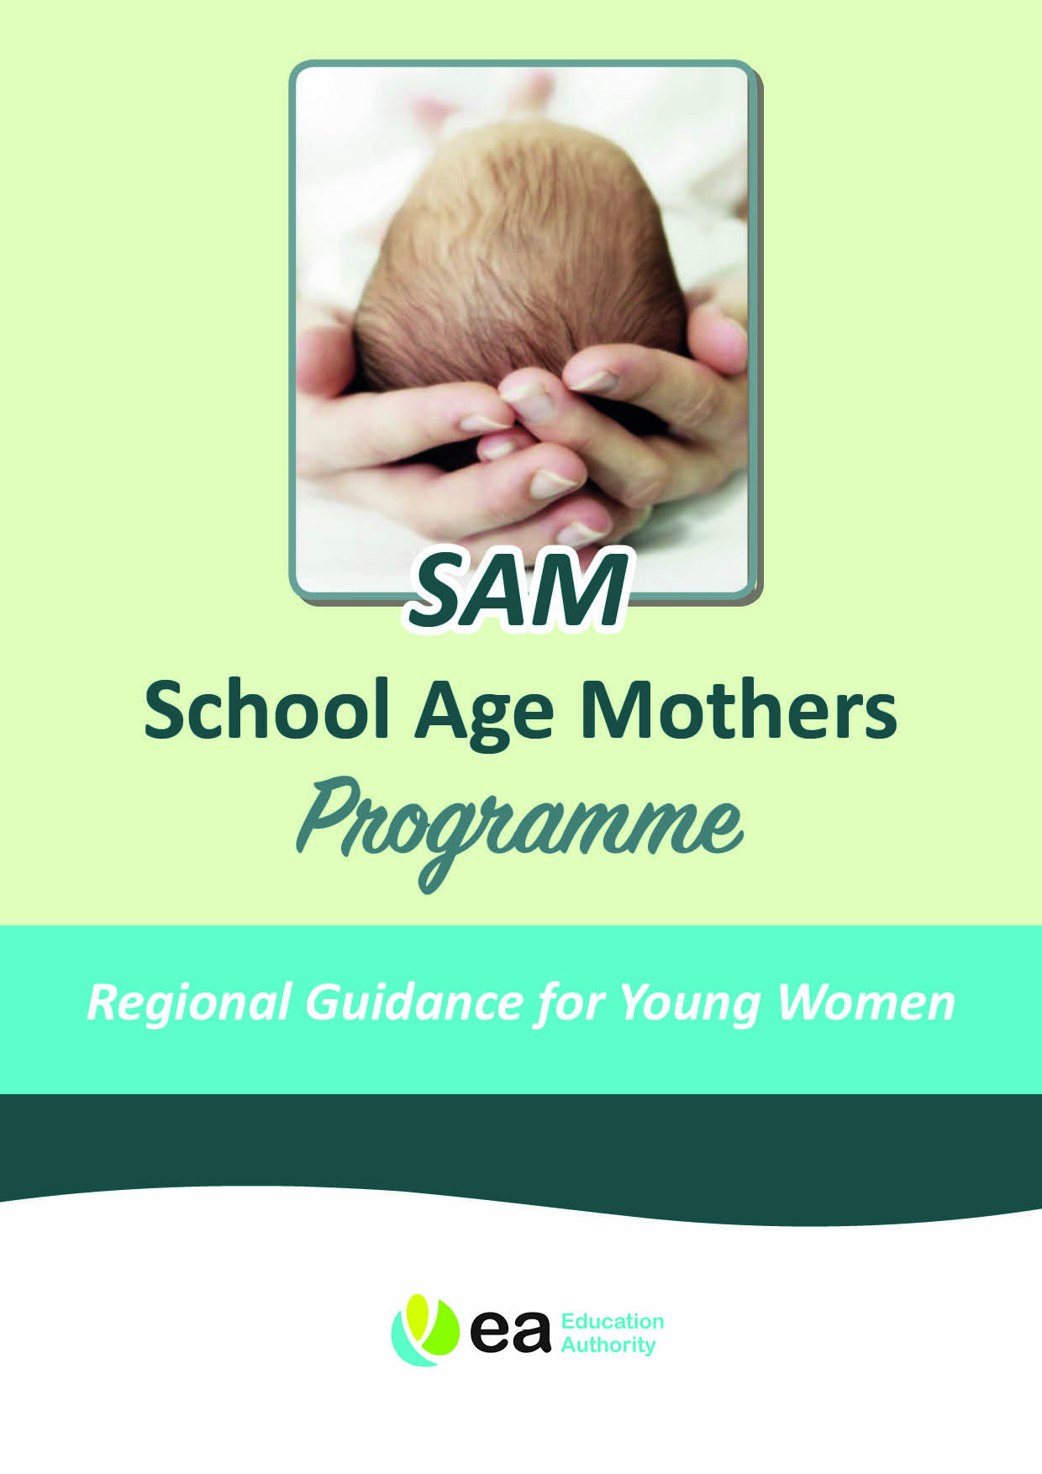

SCHOOL AGE MOTHERS (SAM) – AN INTRODUCTION
Support from the School Age Mother (SAM) Programme is available for girls of compulsory school age and those in sixth form education, in school.

What is the School Age Mothers (SAM) Programme?

The SAM programme provides young women with advice and support that will help them to make informed decisions about how they want to continue their education. The service can also assist young women to find out about:

- Assistance with childcare to enable them to continue their education

- Antenatal & postnatal care

- Healthcare

- Benefits advice

- Personal and social development

- Careers advice

- Parenting skills and childcare.

Some of the support provided by the programme may be provided through individual contact or through group work sessions with other young women in the same situation. Transport, childcare and lunch will be provided for these sessions.

Aim

To ensure young people of school age who are pregnant or have children have equal access to educational opportunities enjoyed by all young people and have the support required to enable them to access education.

Role of the SAM Coordinator

The role of the SAM Coordinator is to assist young people in partnership with schools and other services to achieve their full potential. The SAM Coordinator will:

- provide individual support for each young woman referred to the service;

- provide group support as appropriate;

- ensure that information is disseminated to local groups involved directly with young parents;

- support young women access childcare and transport costs which are funded by the Department of Education;

- liaise with schools and young women to develop Individual Education Support Plans to meet the needs of young women; and

- support young women access tuition where appropriate.

Role of the School

If a young woman should become pregnant or have a baby while of compulsory school age, advice and support is available from the School Age Mothers Coordinator within the Education Authority (EA). It is important that schools refer all young women within mainstream school including young women over compulsory school age.

Young women are expected to continue to attend school for as long as they are medically fit to do so and to return to school after the birth of their child. The school should provide support, make necessary adjustments to timetables and the school uniform code, should this be required. School Age Mothers Coordinators are there to work with school in developing Individual Education Support Plans.

The school will be required to provide the School Age Mothers Coordinator with Registration Certificates in relation to funding for childcare and maintain contact with the programme if they have any concerns about the young person.

Who can access the service?

The service is open to all young women attending school who are pregnant or have a baby and live in Northern Ireland. (See list of School Age Mothers Coordinator for your local area for contact details). Young women can be referred to the programme when they find out they are pregnant or if they already have a baby.

We, as School Age Mothers Coordinators, understand the importance for all mothers, to develop a close relationship with their baby; positive attachment encourages infants to grow up feeling safe to play and explore, develop healthy relationships with others and learn.

We aim to support young mothers to achieve this, whilst meeting their own developmental needs. This includes completion of their education in an environment which is supportive, consistent and stimulating.

Referral Process

Referrals can be made directly to the School Age Mothers Coordinator and can be made by other agencies that are in contact with potential participants. Young women can self-refer.

Childcare Costs: Arrangements from 1 July 2016

The Education Authority has a scheme to assist School Age Mothers who need help with funding childcare. This funding is to help you to stay in education. To be considered for help with childcare fees an EA SAM Coordinator must complete an assessment. The SAM Coordinator will visit you at your home to complete this assessment.

What help is available towards Childcare Costs?

Fees:

- Assistance will be provided on the basis of actual costs of childcare to a maximum of £165 per week, to cover the hours for which childcare is required, including approved exam/study time.

- EA will only make payments to registered childminders, nurseries or crèches.

Deposits:

- Deposits to secure places will be paid in-line with the provider’s terms and conditions, to a maximum of £300.

Retainers:

- Retainers for summer holidays, up to 31 August, are only available for young women who are returning to school, or moving to college at the end of Year 12. If a retainer is paid during summer holidays you may be able to use the placement for agreed hours. This should be negotiated between the SAM Coordinator and the childcare provider. Applications to Further Education must be in place and will be verified by SAM Coordinators.

- Retainers are not available for the period between sixth form and university.

- All payments are paid directly to the childcare provider.

Transport:

- Transport may be available to support you with getting your child to the childcare provider and then onto your education placement. Your SAMs Coordinator can provide you with further details.

- You must inform your transport provider if you do not require this service.

- It is your responsibility to ensure that the baby is carried in the appropriate car seat.

- Transport is available during term time only. During all school holidays it is your responsibility to make your own transport arrangements.

Your local SAM Coordinator is:

Name:
Address:
Tel No:
E-mail:

Your Responsibilities

- It is your responsibility to attend your education placement.

- Your SAM Coordinator will monitor your attendance and will contact you should there be any concerns. The childcare placement will be reviewed, or stopped if you do not attend regularly.

- You must inform your childcare provider if your child is not able to attend due to illness.

- You must inform your childcare provider if you are going on holiday.

- The EA will only pay the hours agreed with your childcare provider. If you are late to pick up your child, or need to have extra hours, you will need to pay for this yourself.

- If you wish to change your childcare provider it is your responsibility to inform, in writing, both the childcare provider and the EA. This must be in line with the terms and conditions of the childcare provider, eg there may be a period of notice of one month.

- We have asked your childcare provider to inform the SAM Coordinator if there are any child protection concerns about you or your child. We have also asked that they inform you that they have concerns and that they will be contacting Social Services and the SAM Coordinator.

- Your childcare provider may have a contract that they will ask you to sign. It will set out terms and conditions that are in place to protect you and your baby.

I confirm that I have received and understood the Childcare Costs Guidelines.

Signature:

Name:

Date:

Parental signature for young women still of compulsory school age.

Signature:

Name:

Date:

