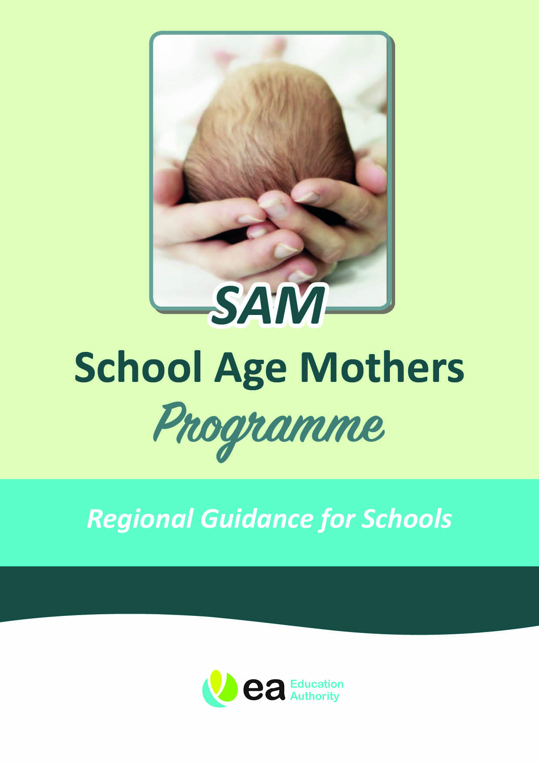


SAM – AN INTRODUCTION

Support from the School Age Mother (SAM) Programme is available for girls of compulsory school age and those in sixth form education.

Context

Any young woman who becomes pregnant while still attending school may require additional support and resources in order to enable her to continue her education. While becoming a mother is certainly a life changing experience, it does not need to become a life determining one.

The Education Authority in Northern Ireland are committed to ensuring that support is available not only for the young women and their families but for the schools with which they are studying. The School Age Mother (SAM) Programme has been in place across the five EA Regions since 1999 to oversee the support provided for the young women, and to provide advice and guidance as required.

What is the SAM Programme?

The primary aim of the SAM Programme is to support young women of school age who are pregnant or who have become mothers, to continue their education with as little disruption as possible. In many cases it is possible to support the young women to continue their chosen course of study at their own school by making a few reasonable adjustments, and facilitating time off as required. Many young women stay in school until a few weeks before the baby is born, and return within three to six weeks after the birth.

This however, is not possible for every young woman, and the Education Authority (EA) is committed to ensuring that their educational needs can still be met. Should a young woman be unable to attend school during pregnancy, or return to school once the baby is born, it may be possible for EA to provide education through alternative arrangements.

Who is this guidance for?

This guidance aims to assist schools with planning and agreeing appropriate support mechanisms for School Age Mothers from initial response through to helping the young women to manage once the baby is born. It has been developed from the observations of schools, recommendations from the School Age Mothers Steering Group and support of the EA. It is based on feedback from school aged mothers on what works and on current research on Maternal Mental Health.

Supporting School Age Mothers is in many ways an extension of the pastoral care responsibilities already undertaken by the school, though it is important to recognise the unique needs of young women as they prepare for and subsequently learn to manage motherhood.

What Support is available?

The role of the SAM Coordinator within the EA is to minimise any adverse effect that becoming a mother may have on the young woman’s ability to fully engage in education; and to ensure that each young woman receives an appropriate level of personal support. This entails working with the young women, their parents/guardian and the wide range of professionals from both the educational and health & social care environments.

Supporting young women to remain in School (The preferred option wherever possible)

The SAM Coordinator can:
- Assist the school to develop appropriate policies and guidance to support both the staff and the young woman.
- Visit each young woman at home or at school to discuss the support available.
- Facilitate the implementation of a structured Individual Education Support Plan for each school age mother.
- Signpost regarding benefits advice and/or careers advice.
- Make a referral for short term home tuition during the young woman’s absence from school (according to Exceptional Teaching Provision).
- Offer access to various peer support provisions, including their nearest SAM Programme (where available).
- Provide further supports in response to the young woman’s changing needs.

Supporting young women who are unable to remain in School

The SAM Coordinator can:
- Organise sessions for the young woman through their nearest SAM Programme to address academic and personal development needs.
- Explore any assistance available to transport the young woman to and from their educational placement and childcare provider when this is deemed essential.
- Ensure that childcare and transport is available for the young woman to attend SAM Programme events.
- Signpost regarding benefits advice and/or careers advice.

Referrals

Referrals can be made for young women up to and beyond compulsory school age, at any point in the school year or stage of pregnancy. A prompt referral is recommended in order to ensure that the young woman can access all the support to which she is entitled. Meeting with the SAM Coordinator provides the opportunity to discuss individual needs and allow for appropriate signposting.

The SAM Coordinator can signpost on how to access advice on benefits and the possible financial implications for the family.

Referrals to the SAM Programme can be made by the School, the young woman herself, another family member or a relevant health & social care professional. Referrals can be made to the SAM Coordinator.

Achievements/Outcomes

To monitor the effectiveness of the SAM Programme and to ensure continuous improvement and support for School Age Mothers, the Department of Education requires collection of qualitative and quantitative data. With the consent of pupils, the SAM Coordinator will request exam results from schools. All data will be anonymised.

School Aged Fathers

There may be instances where the partner of the young woman/baby’s father is in school. The SAM Programme is unable to offer specific support for young men. It would be helpful if the school would make the SAM Coordinator aware if this situation arises. They may be aware of other sources of support.

POLICY PREPARATION TEMPLATE

The following Policy Preparation Template is included to assist Schools in considering processes that they may wish to adopt when they have a school age mother. Please contact your SAM Coordinator if you have any questions regarding this process.

A. Initial Response

The response a young woman receives when she first breaks the news of her pregnancy may well determine whether or not she feels it will be possible for her to stay in school. Teachers may be apprehensive about exactly what to say and do and the school may choose to encourage the young woman to approach a designated teacher, such as the Pastoral Care Teacher. The initial challenge is to make this information available in a sensitive and appropriate manner.

1. If a student in the school discovers that she is pregnant, to whom should she disclose that information and how might she know to whom she should speak?

2. What should be the first response of that teacher?

3. Who else needs to know and at what stage?

4. What information is available for the young woman in terms of support available for her through the school?

5. What support will be available for the young woman to manage the reactions of others?

B. During Pregnancy

Pregnant school girls may require some concessions to support them to remain in school as long as possible. Key areas may include:

- Reduced attendance in the later stages of pregnancy
- Adaptations to school uniform
- Exam concessions if the young woman is expecting her baby close to exam dates
- Home tuition or school support with coursework
- Transport support close to her due date

- Who will be the link teacher for the young woman during her pregnancy?

- How regularly should this teacher meet the young woman?

3. What reasonable adjustments might need to be made in terms of uniform, attendance, transport and exams?

4. Is a more specific needs assessment required?

5. What contact will the school maintain with the young woman when she goes on her maternity leave, in order to facilitate her learning during this period and subsequent return to school?

C. After the baby is born

Continuing education while raising a new baby requires commitment. The encouragement of schools and their staff has helped to contribute to increased numbers of School Age Mothers completing their education and moving successfully on to next steps.

- How soon might the young woman return after the baby is born?

2. What concession might be made for the young woman on her return?

GOOD PRACTICE GUIDANCE

BREAST FEEDING

“Emerging evidence suggests that breastfeeding has a positive impact on mother-baby relationships: breastfeeding releases certain hormones which promote maternal feelings and behaviour. Strong early relationships and a stable and loving environment are all conducive to babies’ healthy emotional, social and physical development, through production of the hormone oxytocin. Oxytocin acts like a fertiliser for the brain, promoting the growth of neurons (brain cells) and the connections between them, enabling babies to grow into secure, happy children.” (The Baby Friendly Initiative UK)
This good practice guidance was set up to support School Age Mothers and Schools and is based on previous examples of good practice across EA.
Going back to school may be the first time a young woman has been separated from her baby. Continuing to breast feed helps to keep close the mother and baby relationship that has been built up, providing the baby with extra comfort and security. Enabling mums to continue to breastfeed supports them in managing the school day.
Continuing education while raising a new baby requires commitment. Positive encouragement from schools gives School Age Mothers the confidence to continue their education and move successfully to the next stage of their career path.
By acknowledging the courage of any young woman committed to raising her new baby whilst continuing her education, young mothers report feeling accepted and motivated to succeed, therefore, we would encourage schools to make every effort to meet the very specific needs of the young woman whilst endeavouring to facilitate her re-integration in every possible way.

Support Guidance
If a young mum wishes to continue breast feeding a review of the Education Support Plan should be held before her return to school. The plan will need to consider the following;
- The young woman may need a phased return to school. Any changes in attendance times or patterns will need to be agreed and monitored on a regular basis.
- It is also recognised that a very young baby’s needs may change significantly from day to day. The school should be as flexible as possible and supportive as is practicable to changing or unexpected circumstances.
- The school should allow flexibility to allow the young mum permission to leave class to express milk when required.
- The provision of a clean, warm and private/secure space for expressing milk. The room should have an electrical outlet, access to a sink and a fridge. This should include space where she can store equipment. The toilets are not suitable to use for this purpose.
- A key contact person who the young woman can talk to if any issues arise.

