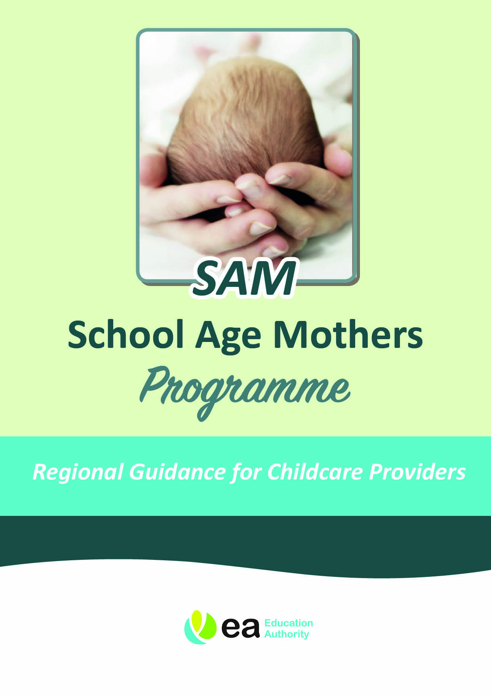


Childcare Costs: Arrangements from 1 July 2016

What is the School Age Mothers (SAM) Programme?

The SAM Programme supports pregnant teenagers and young mothers to remain at school to complete compulsory schooling and where appropriate up to age 19 years. The SAM Programme is managed by the Education Authority (EA). We offer a holistic model of support to enable school age mothers to get the best out of their education while bringing up their child. A wide range of different supports are offered, including assistance towards childcare costs.

Who can avail of assistance with childcare costs?

Assistance with childcare costs is provided to young women where applicable and is subject to the following conditions:

- Under 19 years at the start of a course of study in a school or under 19 years and committed to returning to school once the baby is born.

- An appropriate assessment must be completed; including confirmation that childcare is required to enable the young women to continue with studies in school.

- Childcare providers must be registered by the Health & Social Care Trust with appropriate public liability insurance in place.

- Continued support with childcare costs is dependent on the young women attending school on a regular basis.

What funding is provided towards childcare costs?

Assistance with childcare costs is provided through the Education Authority.

From 1 April 2016, the following costs are covered under current arrangements:

- Assistance will be provided on the basis of actual costs of childcare up to a maximum limit for each child.

- Deposits to secure places will be paid in-line with the provider’s terms and conditions.

- Retainers for summer holidays, up to 31 August, are only available for young women who are returning to school, or moving to college at the end of Year 12. If a retainer is paid during summer holidays you may be able to use the placement for agreed hours. This should be negotiated between the SAM Coordinator and the childcare provider. Applications to Further Education must be in place and will be verified by SAM Coordinators.

- Retainers are not available for the period between sixth form and university.

How will payments be made?

The Education Authority will pay the childcare provider directly. This is normally done on a monthly basis upon receipt of an invoice made out to the EA and accompanied by the monthly time sheet. All invoices must clearly state the name of the mother, the baby and the period covered by the invoice.

If the placement is terminated prematurely, the EA will honour any existing notification agreement, in line with the childcare provider’s normal contractual arrangements.

Your local SAM Coordinator is:

Name:
Address:
Tel No:
E-mail:

DECLARATION BY CHILDCARE PROVIDER

I confirm that I have received a copy of the details of the SAM Programme arrangements for assistance towards the costs of childcare.

I agree as part of my contract with the Education Authority to provide childcare to do the following:

- To notify the SAM Coordinator immediately if there is any change in my registration status as a childcare provider;

- To maintain appropriate public liability insurance;

- To comply with relevant health and safety and safeguarding regulations;

- To provide all information required necessary to assist in prompt payment;

- To communicate any alterations in my service promptly to the young woman and SAM Coordinator;

- To notify the EA immediately when the young woman withdraws her child(ren) and forward a copy of any letter of termination from the family;

- Both parties to provide 4 weeks’ notice of termination of contract; and

- To inform the SAMs Coordinator if there is any childcare protection concerns with the young person or child. We would also ask that you inform the young person that you have concerns and that you will be contacting Social Services and SAM Coordinator.

Name:

Address:

Tel No:

Email:

Signature:

Date:

