

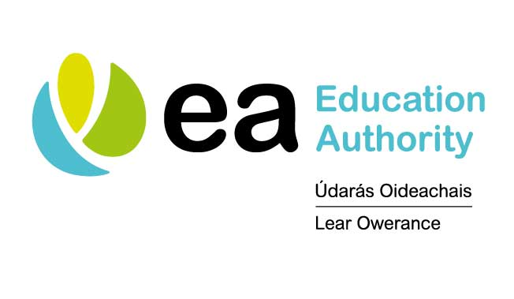

Austism Advisory and Intervention Service

Getting Tested for Coronavirus
Visual Supports

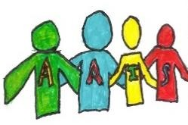

Why do I need a Coronavirus test?

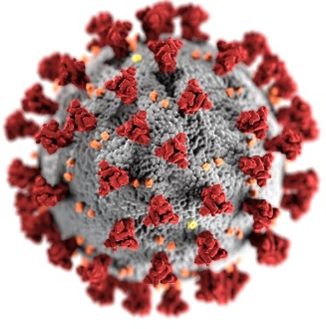  People get tested for coronavirus to help keep them safe and to stop the spread of the virus.  1 | Many children and adults are being tested for Coronavirus. Some children and adults are being tested even though they don’t feel sick.  2  TESTING  CENTRE
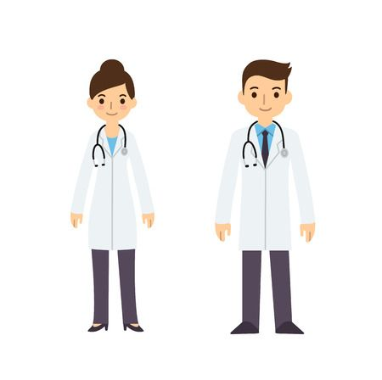  The doctor will decide if I need a test. This is ok.  3 | 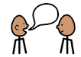  If the doctor decides I need a test I will try not to worry. If I am worried I can talk to an adult.  4
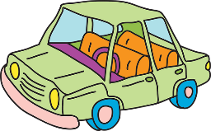  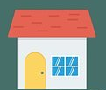  Sometimes the coronavirus test can happen at home and sometimes people have to travel to a testing centre. An adult will tell me where I will get my test. This is ok.  TESTING  CENTRE  5 | 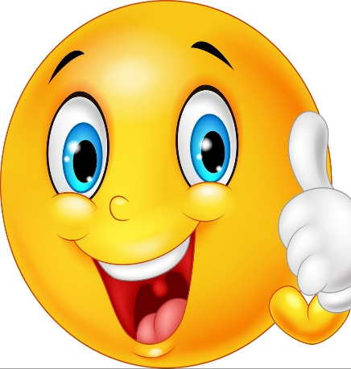  I am happy when I keep myself and others safe.  6

What happens during a Coronavirus test at a testing centre?

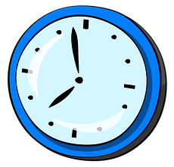  When I arrive at the testing centre, it might be busy. I will wait in my car with an adult.  1  TESTING  CENTRE  This is ok. | 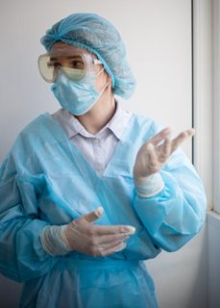  There will be lots of doctors and nurses. The doctors and nurses will be wearing protective clothing e.g. masks, visors and aprons.  2  This keeps me safe.
The doctor or nurse might ask me and the adult some questions and then they will begin the test.  3  ??? | 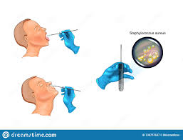  The test is usually quick, the doctor will rub a swab on the back of my throat and another swab on the back of my nose.  4
  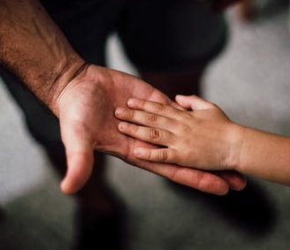  It shouldn’t be sore but it might make me feel a little uncomfortable. If I feel uncomfortable during the test I can hold an adults hand and think about my favourite things.  5 | 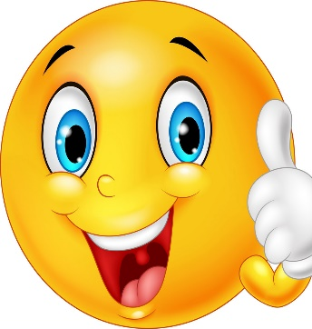  The doctor or nurse will send my swabs to the lab to check if I have Coronavirus.  6  The test is finished.  I am proud when I can do tricky things that help me stay safe.

Getting a Coronavirus Test at a Testing Centre

Drive to test centre

Wait for test
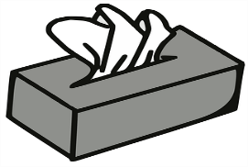
Blow nose
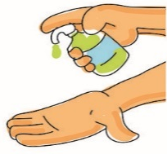
Clean hands
Get throat swabbed
Get nose swabbed
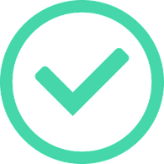
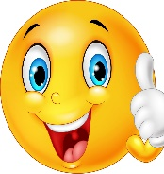
Finished. Well Done.

What happens during a Coronavirus test at home by a professional?

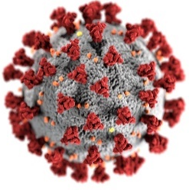  Sometimes people need to get tested at home.  1  ?  A doctor will send nurses to my house to help me get tested at home.  This is good. | One or two nurses will visit my house.  2  The nurses will be wearing protective clothing e.g. masks, visors and aprons.  This keeps me, my family and the nurses safe.
The nurses will ask me and the adult some questions and then they will begin the test.  3  ??? | The test is usually quick, the nurse will rub a swab on the back of my throat and another swab on the back of my nose.  4
It shouldn’t be sore but it might make me feel a little uncomfortable. If I feel uncomfortable during the test I can hold an adults hand and think about my favourite things.  5 | The nurse will send my swabs to the lab to check if I have Coronavirus. The test is finished.  6  I am proud when I can do tricky things that help me stay safe.

What happens during a Coronavirus self-test at home?

Sometimes people need to get tested at home. A doctor will send my family a testing kit.  1  ? | 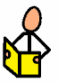  When the testing kit arrives an adult in my family will follow all the instructions carefully.  2  Coronavirus Testing Kit
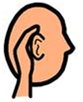  I will listen carefully and follow all the instructions the adult tells me.  3 | The test is usually quick, the adult will rub a swab on the back of my throat and another swab on the back of my nose.  4
It shouldn’t be sore but it might make me feel a little uncomfortable. If I feel uncomfortable during the test I can hold an adults hand and think about my favourite things.  5 | My family will send my swabs to the lab to check if I have Coronavirus.  6  The test is finished.  I am proud when I can do tricky things that help me stay safe.

Getting a Coronavirus Test at Home

Blow nose
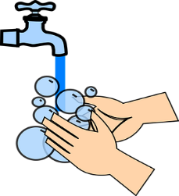
Wash hands
Get throat swabbed
Get nose swabbed
Finished. Well Done.

Waiting for Coronavirus test results

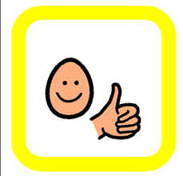  Once the test is finished, it may take a few days for the results to come back. This is ok.  1 | 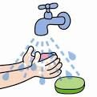  I will stay at home to wait for the results. It is important that I continue to help stop the spread of the virus by washing my hands regularly.  2
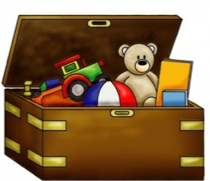  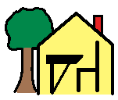  When I am at home I can do home school work, play with my toys and/or watch TV. An adult will take care of me.  3  Home School | 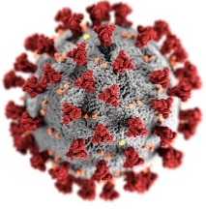  An adult will find out my test results. If the test shows I have coronavirus, I do not need to worry. The doctor will tell me what to do. It is important that I stay at home until the doctor say it’s ok to go back to school.  4
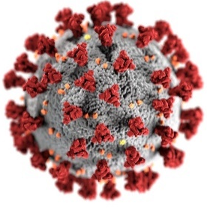  If the test shows I do not have coronavirus I can go back to school. It is important that I continue to wash my hands regularly.  5 | I am proud of myself when I follow the doctor’s advice to help keep me and everyone else safe.  6

