BSA Resource Pack

For pupils with

Williams Syndrome


Contents

- Cover page
- Contents page
- Definition of Williams Syndrome
- Information for Teachers
- Recommended strategies and activities to use with pupil with WS
- Advice for staff

What is Williams Syndrome?

Definition

Williams Syndrome is a rare congenital disorder that occurs randomly and affects around one in 18,000 people in the UK. It is non-hereditary and causes distinctive facial characteristics and a wide range of learning difficulties. Infants often have delayed development and can develop physical and mental health problems, including anxiety and depression in later life. WS people tend to be talkative and excessively friendly towards adults.

People with WS share certain facial similarities, typically including a wide mouth, with a pronounced bottom lip; an upturned nose with flattened bridge; slightly high, rounded cheeks; irregular and/or widely spaced teeth; starburst eyes; and a squint.

https://williams-syndrome.org.uk/what-is-williams-syndrome-6-2/

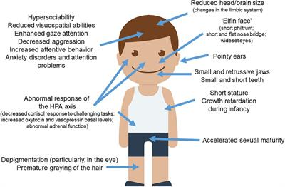

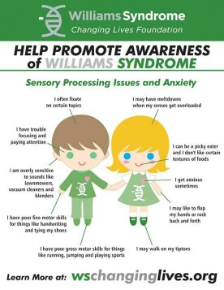

Information for Teachers on Williams Syndrome:

- https://williams-syndrome.org/sites/williams-syndrome.org/files/WSA%20Information%20for%20Teachers%202012.pdf

- https://williams-syndrome.org/teacher/educational-strategies

- https://williams-syndrome.org/teacher/information-for-teachers

Recommended strategies:
Each pupil with WS may have their own distinct needs but the strategies below worked well for one particular pupil with WS and behavioural issues.

Praise and reward works extremely well. Using reward chart in the short term helped understand and set boundaries and expectations. It also helped encouraged independence and resilience in the long term. Children with Williams Syndrome need clear explanation of expectations, boundaries and rules – the key here is consistency. A short concise list of individual rules for their desk worked well. with 3-4 reminders on it such as: put hand up to speak to the teacher, ask if need to leave classroom or need help with their work, to ignore distractions. Children with WS find it very hard to focus and keep concentration for any length of time so work may need broken down into smaller chunks, with encouragement to block out the distractions in what is going on around them worked well over time. In class they may find it difficult to listen to long explanations from adults so 1-1 adult may need to break instructions down into simpler information.

Pupils with WS tend to come across very strong verbally and show great understanding but when it comes to doing the task may find it difficult as understanding may not there. They have a fantastic memory and will recall random facts and experiences with ease. This may help with learning spellings and maths but may find discussions harder.

Activities to use with pupil:

Pupils with WS may come across very confident but underneath may lack self-esteem and understanding of the topic being discussed. Using reflective conversations, social stories, books on understanding feelings/emotions, empathy, role play situations to gain understanding, positive affirmations and calming music, sensory toys. Pupils with WS usually have special gift for music.

Think about using a Reward chart to begin for behaviour if needed. Then move on to developing understanding through 1-1 work on areas for development. Can be done alongside using Reward chart.

Anxiety plays a huge role in the life of pupils with WS. Alongside separation anxiety and attachment issues. Being positive, happy, engaging works well alongside clear instructions. Issues that may present could be around BSA leaving the room and when will return. Breathing strategies can be taught and used daily, positive affirmations can also be used to boost self-esteem.

www.relaxkids.com have great resources on children’s mental health, relaxation and anxiety techniques.
www.relaxkids.com/calminthechaos
www.relaxkids.com/backtocalm
www.relaxkids.com/calendar

Advice for school staff:

Williams syndrome is quite a complex disorder. There are many areas that it can affect and may need detailed 1-1 work to improve. Children with WS love adult attention, they are loyal to a fault, see everyone on the same level, language skills may be fantastic but when given a task may struggle as understanding may not be there. Pupils with WS work extremely well when praised and will work for this. Boundaries may be an area that needs planning for. Try using school map and marking out in red the areas that are out-of-bounds, orange and green marked on appropriately too. The traffic light system works well for this and for the reward chart. Mark Green if behaviour is ok between certain timeframe- morning and break, Break and lunch and lunch and home. Amber and red used as well with the aim being on achieving as many greens as possible.

Heart problems

May need to consider monitoring activity levels – can record daily physical activities which may include time spent on activity, physical reaction to it. Areas for school concern may include being active in the playground and PE as running may induce sweating profusely after a very short time or heart racing very fast. Adjusting programme to suit their needs such as completing just a few minutes if able, speak to parent to find out the guidance from their doctor/consultant on how much they can do. May need 1-1 supervision during these times as well as monitoring behaviour and activity levels. They may need help with getting changed – fine motor skills may be poor, independence skills may need developed through 1-1 activities and practice at everyday tasks – buttoning coat, pencil control, scissor control.

School trips – think about distance covered, climbing steps, water breaks, bus, noise levels, needs constant supervision to avoid over doing it, anxiety, wandering off, taking to strangers as no stranger awareness, may tell life story/personal details to anyone, again loves adult attention.

Attachment/separation anxiety

Children with Williams Syndrome usually have Hyperacusis – they hear everyday noises at an extremely higher level to the point that they cannot deal with it. Loud noises/voices & classroom noise levels and finds fire drills & loud drills very hard to manage. Work on giving notice for these coming up and maybe plan for having to leave the room. (if need to) They may be able to build up sensitivity to noise over a period of time. A plan may need to be agreed by teacher, child & parent to agree a way forward. Eg.) if noise gets too much then they can leave the room. This helps the child have less anxiety around loud noises and they will know there is support in place for when they need it. This article highlights the impact of loud noises and shows traits of high emotional intuition that can be seen in children with WS. https://www.npr.org/templates/story/story.php?storyId=126396171&t=1590587040080
Structure and boundaries – may find it hard to cope with change to this so may need to give notice to any changes. Social Skills may be an issue – work on building turn taking, sharing, listening to other pupils ideas as well as their own – group work may be an issue so turn taking on smaller scale to practice and gain experience. Possibly look at connecting pupil to yard buddies or give responsibility to them to look after younger pupils. Have support networks within the school that they can go to and feel listened to.

Concentration on task may be quite difficult to do. Tasks broken down into small chunks, lots and lots of encouragement and praise – stickers work great for this. Fine motor skills may be an issue so lots of activities around this – colouring in, holding pencil, scissor control jigsaws, buttoning own coat, build up to being able to reach level of independence. Reading long texts may be very difficult so may need to cover text with page and work through small sections.

Areas for focus –

Transitions

Class - To prepare for the day ahead it may be helpful to speak with pupil first thing in the morning and again before home time to check in with how they are feeling. Building this into the daily routine may help focus better on the day ahead. It may also give an opportunity to release built up emotions from incidents they have held onto from previous days at home or school. Sometimes it may be that they do not fully understand their thoughts or feelings around this incident and this may produce outbursts or frustrations further down the line that are linked to these previous incidents. By talking about it in the morning before class starts helps the pupil to move on from past incidents and feelings associated with it. It helps to start the day afresh.

Canteen – inform canteen/supervision staff on pupils needs as the pupil has moved into a different routine. Lining up may cause frustration, noise levels may be too much – headphones may be considered for canteen, assemblies, trips/visitors. One-one activities and social stories on following instructions and how to line up correctly may help with this. Social skills may be also an issue in the canteen. Fire drill may cause some distress especially due to the noise and if away from key worker. Constant supervision may be needed (if possible) to help deal with situations.

Playground – social skills - building up understanding of rules and routines of being outside and freedom from the classroom. Activity levels may need monitored and supervision required. Pupil may feel they are everyone’s best friend but find it hard to maintain friendships. Reflective conversations afterwards when calmer work best again some 1-1 time to help understanding re: social skills, taking responsibility for actions.

Swimming – changing facilities may cause safeguarding issues if need 1-1 support in changing rooms, fine motor skills in getting changed and dressed again. May take longer to get changed – may need to leave pool few minutes earlier to get changed in time. Listening to BSA, teacher, lifeguard and following routines when at pool may be an issue.

Anxiety - Children with WS may need 1-1 work on thinking realistically or logically to help anxiety as there may be a tendency to think worst case scenarios/exaggerated thoughts especially to global or world events, car accidents, traffic jams. This is a trait of WS. Statements such as ‘will this actually happen? What are the chances of this happening? What is likely to really happen? They may need 1-1 time out to process information or talk through what realistically could happen. Reassurance and support may help to settle thinking. They may need time out of the classroom to talk to BSA on a 1-1 basis to help return to calm and ready to re-enter the classroom.

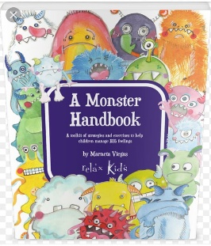

https://williams-syndrome.org.uk/
https://www.williamssyndrome.ie/

