BSA RESOURCE PACK

SUPPORTING ADOLESCENT LEARNING

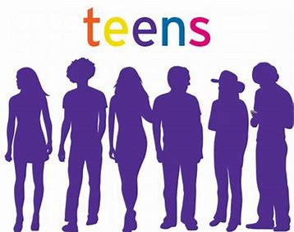

What is Adolescence

- Adolescence is the time in a young person’s life between childhood and adulthood. Adolescence starts when a person is about 12 years old and ends at about the age of 19. A person in this age group is called an adolescent, or a teenager.

- Adolescence is a time of great change. Adolescents experience changes in their bodies. They also experience changes in their emotions, or feelings, as well as their thoughts and beliefs. They often see the world differently, and they act differently than they did when they were children.

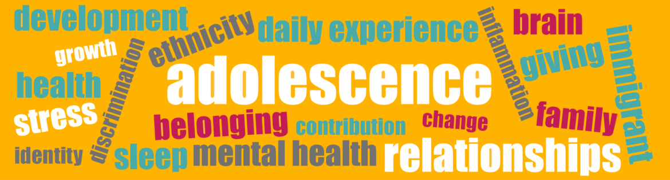
WHAT CHANGES TO EXPECT

- PHYSICAL - the reproductive system develops. The reproductive organs are the parts of the body that allow men and women to make babies. Girls’ and boys’ bodies change in different ways. Boys grow facial hair, and their voices deepen. They also develop stronger muscles. Girls grow breasts and wider hips, and they start having menstrual periods. This means that they are able to become pregnant.

- EMOTIONAL - Adolescence is an exciting time. It is also a time that can be very confusing. Boys and girls become much more interested in each other. At the same time they may worry about their appearance, and they are sometimes easily embarrassed. During adolescence, most boys and girls care a lot about what other adolescents think of them. They may also be very concerned with how they fit into their world. Often adolescents choose to spend time with their friends rather than with their families.

- INDEPENDENCE - As adolescents grow emotionally, they begin to take on new responsibilities and gain new freedoms. They act and think more independently. They also start to find a balance between family and friends. These changes mean that adolescents are on their way to becoming adults.
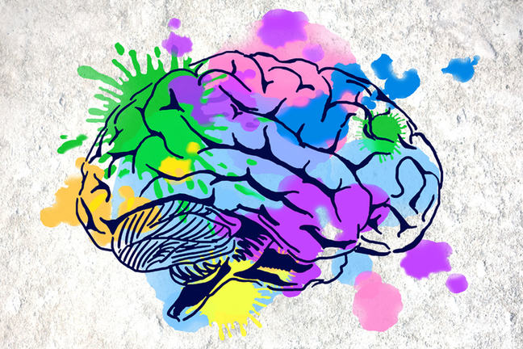

Brain Development
- Your brain is unique to you and your brain (cognitive) development is unique to you
- Cognitive processes: thinking, reasoning, remembering, perceiving. - are all part of your development.
- Being able to self reflect, understand and learn from your behaviours is vital to positive development

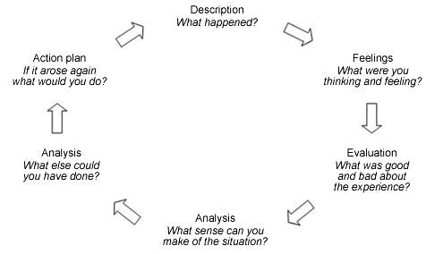

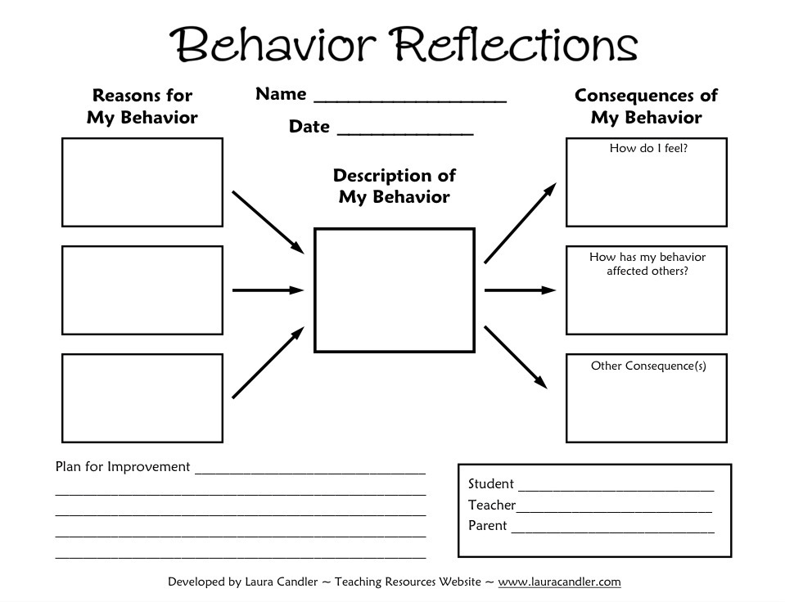

SOCIAL & EMOTIONAL WELLBEING

- Social and emotional wellbeing refers to the way a person thinks and feels about themselves and others. It includes being able to adapt and deal with daily challenges (resilience and coping skills)

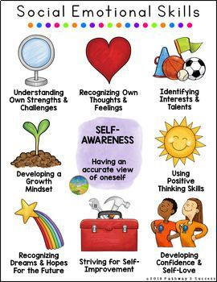
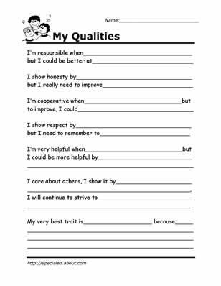

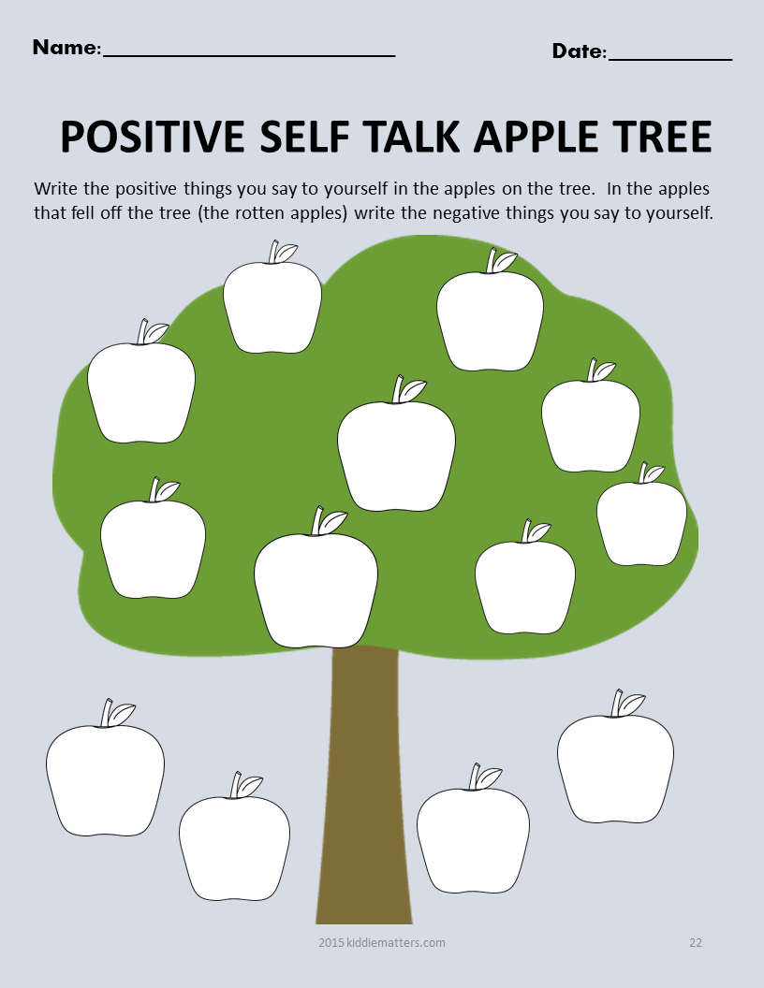

CONNECTIONS

- Mind maps can help visualise the connections between all the developments you are experiencing
- Physical development: eg, weight gain,height, puberty
- Social development: eg, new behaviours, takes risks, a need to feel a sense of belonging among peers
- Emotional development: eg, easily irritated, easily stressed, easily angry, feeling depression without a cause, self-esteem, coping skills
- Cognitive development: eg, able to think independently from others, expresses curiosity of things that interest them, voices opinions.

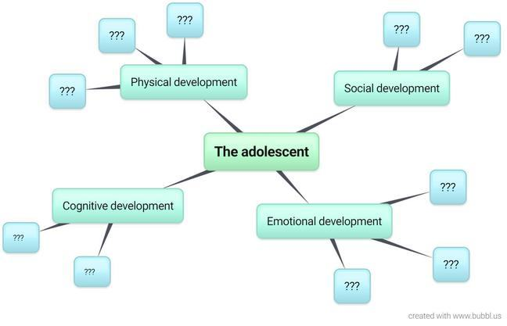

- Try making your own unique mind map!
- Remember no-one has the same brain as you! You are unique to you!
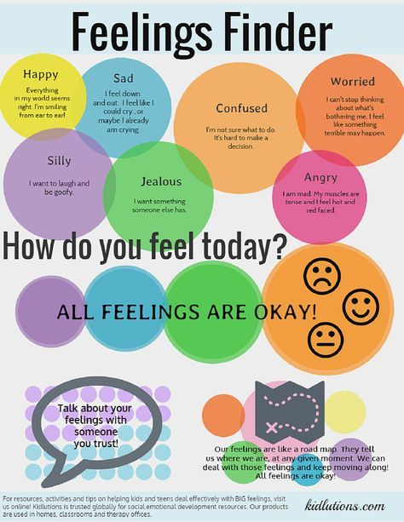

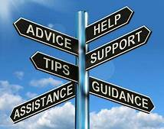

WHO CAN HELP

- So – who can help through these fascinating, confusing and wonderful years
- Parents
- Teachers
- Support assistants
- Youth workers – ie youth club leader
- Friends
- All these people can help you or direct you towards any help you need – the key thing is to TALK!

APPS & LINKS

https://www.camhs-resources.co.uk/apps-1


https://www.camhs-resources.co.uk/websites


https://youtu.be/s9EEee1s74k


Take some time and watch the utube video, then have a browse through some of the websites and apps above

