Behaviour Support
2020
Post Primary
Strategies to improve Health, Well- Being/ Resilience/Self-Esteem

Contents

- Health & Well-Being
- Behaviours/ low self –esteem & anxiety.
- A good support network
- Resources
- Strategies & Calming exercises
- Coping skills
- The Power of Yet & Growth Mindset
- Resilience
- Stress in teenagers
- Ways to help teens with stress.
- Useful Websites

Why is Health & Well-Being important for learning?
There is a link between health & well-being and positive academic performance.
During adolescence pupils are noticing, assessing and making judgements on what is normal- from their peers, home life, media & their own experiences.
Some of the factors that impact well-being are:
- Lack of proper food & sleep- unhealthy body/tired/unable to concentrate & learn in school.
- Lack of exercise, unhealthy body impacting mental health.
- Substance abuse, smoking & drinking affects concentration, memory/attention and can result in depression and risky behaviours in students.

Behaviours displayed by young person with Anxiety/Low Self-Esteem.
- Have a negative self- image.
- Lack confidence.
- Feel lonely and isolated.
- Find it hard to make and keep friendships, may feel victimised by others.
- Tend to avoid new things and find change difficult.
- Can’t deal well with failure.
- Tend to put themselves down and might say things like ‘I’m stupid’ or ‘I can’t do that.’
- Constantly comparing themselves to their peers in a
negative way.
- Never proud of what they achieve and always think they could have done better.

A good support network
School can address some of these issues by providing a young person with multi agency support & the option of a designated safe space to go to when overwhelmed.
- Staff/SENCOs and BSA/Classroom assistants to work alongside professional outside agencies to form a safety network to help a pupil cope with & access school.
- Parents/Caregiver also needs to support the pupils needs & provide a link of open dialogue to school- problems at home can ‘spill’ into school life and school needs to be made aware of any upheaval in the pupils life.
- Use of a home/school diary/phone call or update needs to be consistent to keep everyone aware of changing situations in pupils’ home life /school ,this would avoid any breakdown in communication & misunderstanding.
- Find new ways of engaging pupil for example a link to school Hub/safe zone or similar quiet space to do work for a while to settle before returning to class.

A good support network continued…

- If pupil wants to talk or offload concerns /worries they must be listened to in a non-judgemental way by their supporting
assistant or class teacher.

- Allow the pupil to have a ‘voice’ and give time for them to express themselves without interrupting.

- Respect should be shown and in doing so modelling good behaviour /showing pupil they are valued as a person and their well-being is supported.

- Help pupil to find a solution /introduce a strategy they might like to try which could help.

- Disclosure of harm to themselves/ or by another person should be immediately reported to Child Protection in school (Pupil should be reminded that anything they say is confidential but a disclosure of harm by someone else /or self-harm will be passed on to a member of Child Protection as a duty of care/ to keep them safe.)


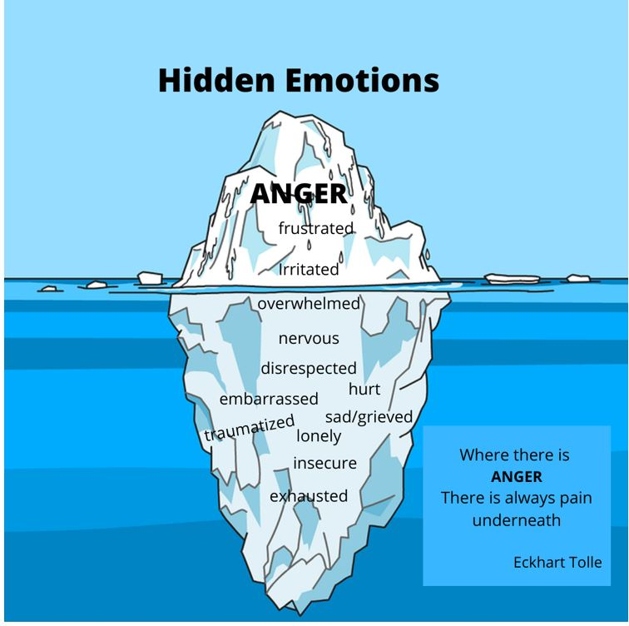

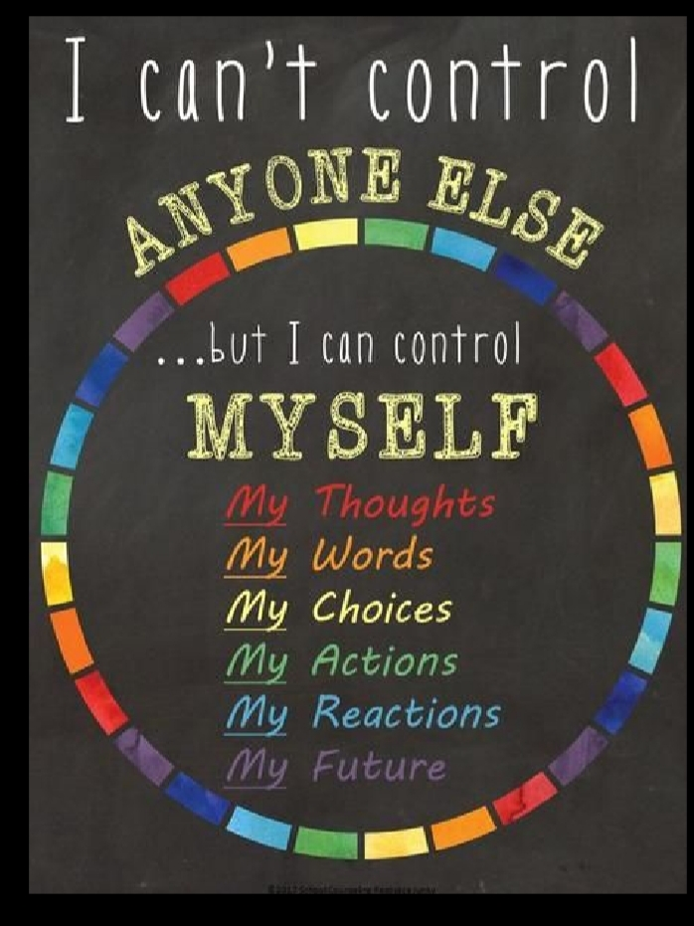
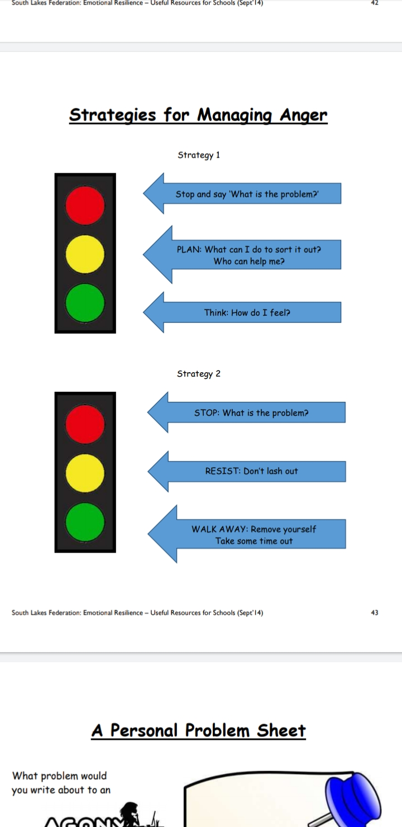


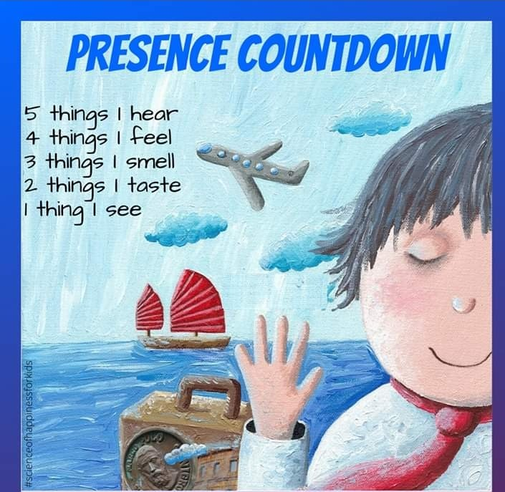

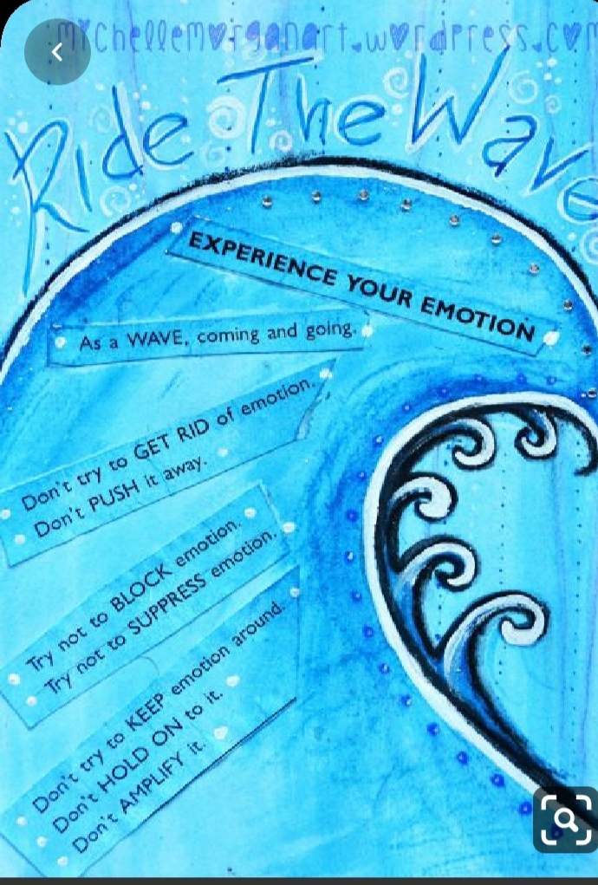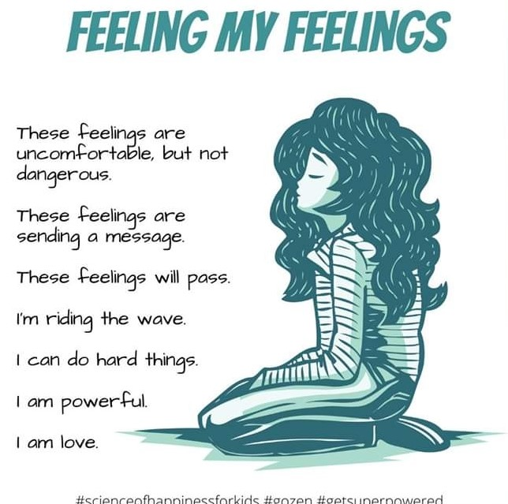

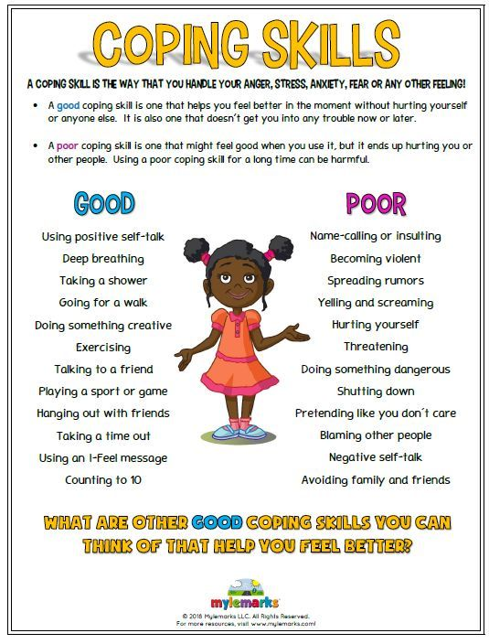

The Power of Yet
Develop a Growth Mindset, instead of saying ‘I can’t do that’-
Learning to use the word YET to change a negative statement into a positive. --‘ I can’t do that YET’
I am not good at this - I am not good at this YET, but I will learn.
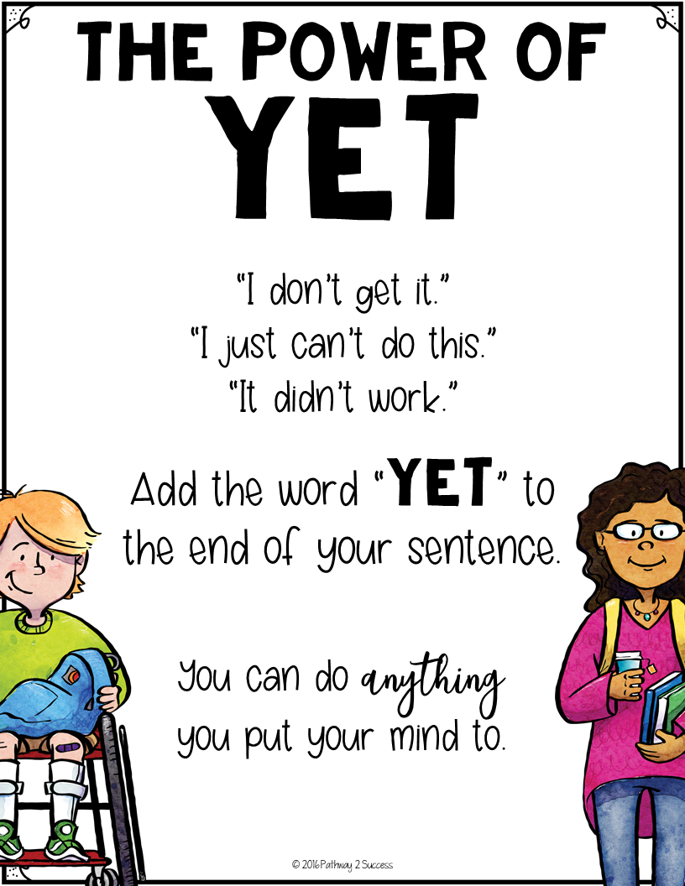


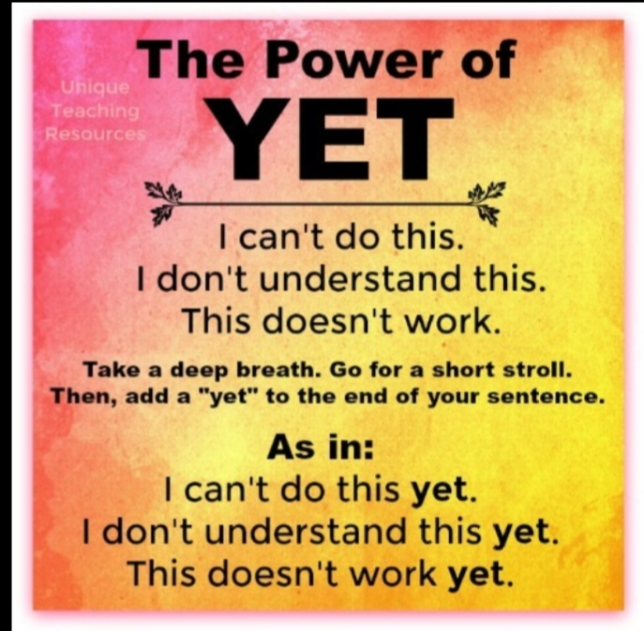
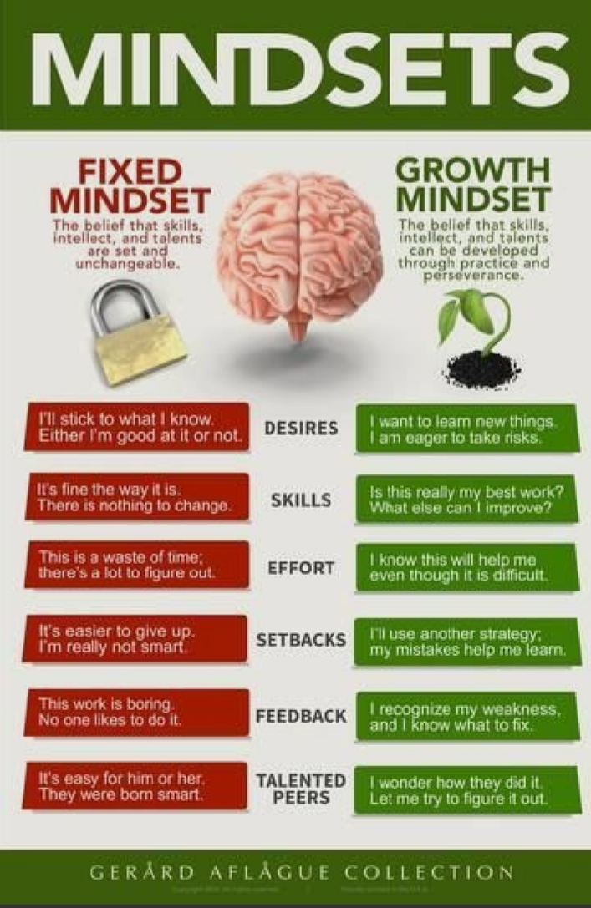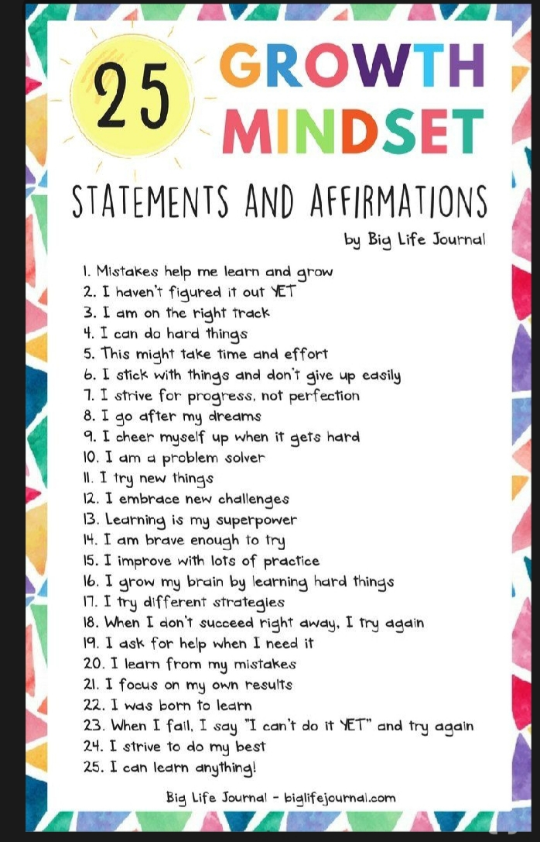

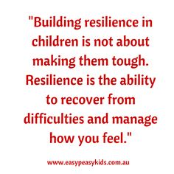

Resilience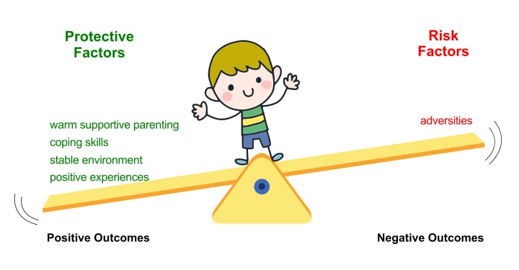

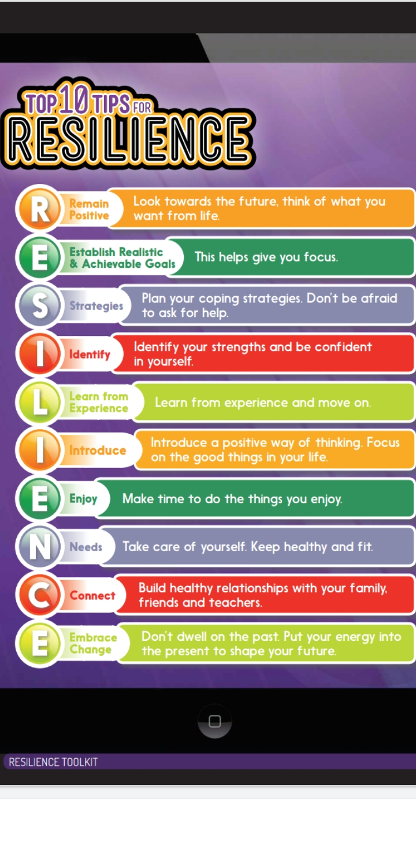
Stress in Teenagers
Most teens experience more stress when they perceive a situation to be dangerous, difficult or painful and they do not have the resources to cope.
Sources of stress for teens include:
- School demands and frustrations.
- Negative thoughts or feelings.
- Problems with friends and /or peers.
- Chronic illness or severe problems in their family.
- Unsafe living environment/neighbourhood.
- Death of a loved one.
- Having too high expectations /taking on too many activities.
- Separation/Divorce of parents.
- Family financial problems.

Overload of Stress in teens
- Anxiety, withdrawal, aggression, physical illness.
- Poor coping skills such as drug/alcohol use.

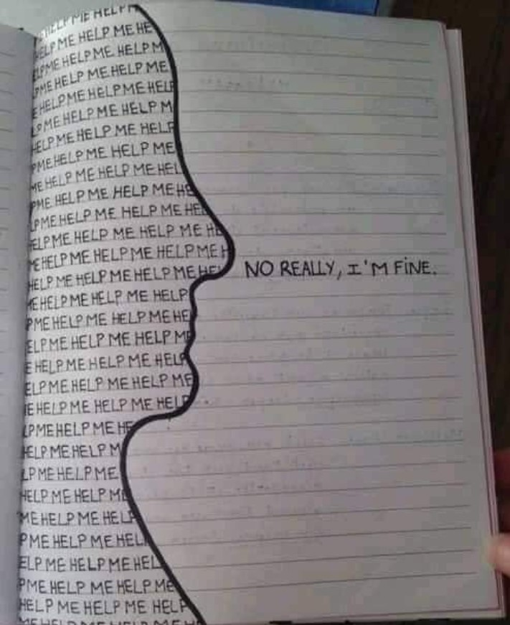
Ways to help teens with stress
Listen carefully to teens and watch for overloading.
1. A break from stressful situations-activities like listening to music, talking to a trusted adult, drawing or writing about problem.
2. Decrease negative self-talk for example ‘My life will never get better’ transformed to ‘ I may feel hopeless now, but my life will probably get better if I work at it and get some help’.Teach Growth Mind set & Yet statements.
3. Learn practical coping skills for example, break a large task into smaller, attainable tasks.
4. Helping teens build a network of friends & trusted staff members who they can turn to for support & provide a safe space in school to go to if overwhelmed ( Timetabled breaks throughout the day if needed & time to offload before starting the school day.)
5.Parental/caregiver support of involvement in sports or other social activities to decrease feelings of isolation and provide teen with relaxation to improve mental health.
6. Access to helpful websites such as Young Minds & outside adolescent mental health teams( Care givers also need information on how best to support their teenager cope with stress.)
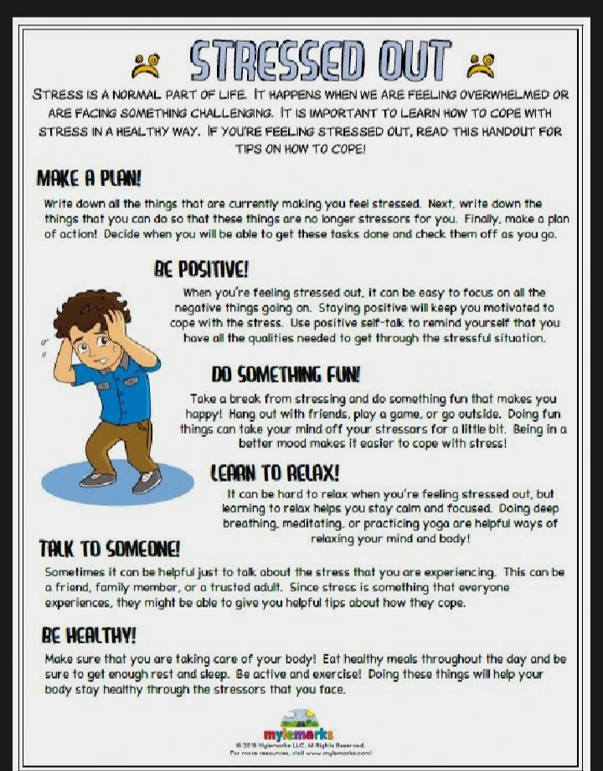

Help lines for Young people & Useful Websites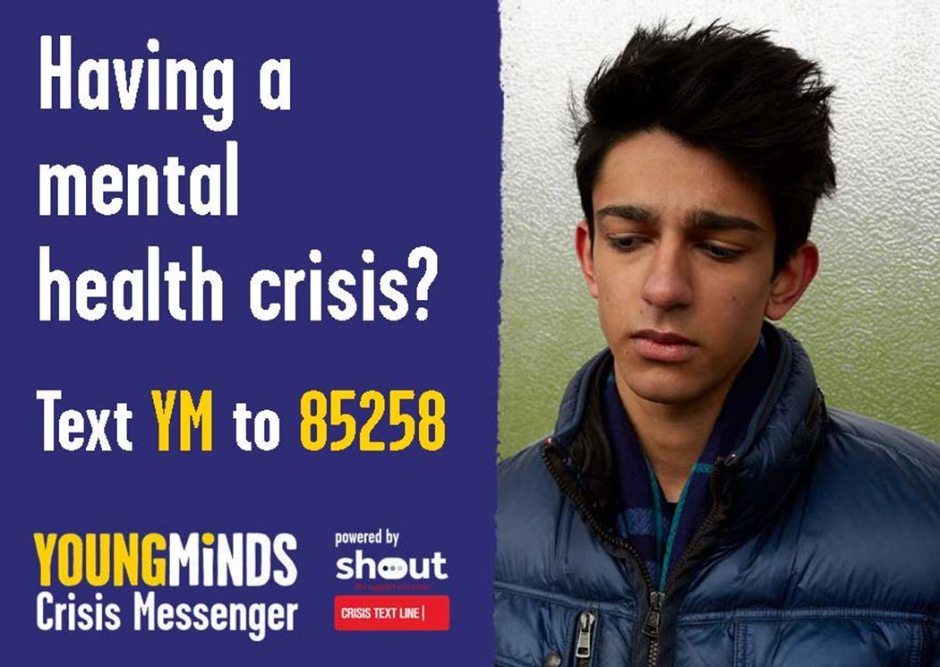
youngminds.org.uk
www.wellbeing-glasgow.org.uk
www.mygroupguide.com
KAN- Emotional-Resilience-toolkit-pdf
https://gozen.com/printables
e book download-free online resources- Resilience workbook for teens by Cheryl M Bradshaw
Developing Resilience – Author Stacy Zeiger
www.bounceforward.com/why-resilience
wholeperson.com/pdf/TeenResiliency.pdf
www.actionforhappiness.org
copingskillsforteens.com

