
What is resilience?
Building Resilience

A Support Pack for Post-Primary Pupils

Developmental Psychologist Anne Masten describes resilience as ‘Ordinary Magic’, meaning that in many cases resilience isn’t born out of something particularly earth shattering but everyday stuff.
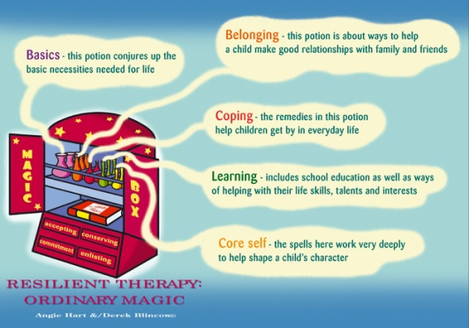
Some think of resilience as Bouncing Back, Bouncing up or Bouncing forward.

Doing better than you think given the circumstances. Beating the odds.


Resilience Quotes

“I am not afraid of storms for I am learning how to sail my ship.“ - Louisa May Alcott

“It is difficult to make people miserable when they feel worthy of themselves”
Abraham Lincoln

“Mistakes are proof that you are trying”
BigLifeJournal.com

“Success is not final, failure is not fatal, it is the courage to continue that counts”
Winston Churchill

“If you find a path with no obstacles it probably doesn’t lead anywhere”
Frank A Clark

“As much as talent counts, effort counts twice”
Angela Duckworth

Resilience Factors
Table 1: Risk and protective factors that are believed to be associated with mental health outcomes (Mental Health and behaviour in schools DfE 2014)
 | Risk Factors | Protective Factors
In the child | • Genetic influences  • Low IQ and learning disabilities  • Specific development delay or neuro-diversity  • Communication difficulties • Difficult temperament  • Physical illness  • Academic failure  • Low self-esteem | • Secure attachment experience  • Outgoing temperament as an infant  • Good communication skills, sociability  • Being a planner and having a belief in control • Humour  • A positive attitude  • Experiences of success and achievement  • Faith or spirituality  • Capacity to reflect
In the family | • Overt parental conflict including domestic violence  • Family breakdown (including where children are taken into care or adopted) • Inconsistent or unclear discipline  • Hostile and rejecting relationships  • Failure to adapt to a child’s changing needs  • Physical, sexual, emotional abuse, or neglect  • Parental psychiatric illness  • Parental criminality, alcoholism or personality disorder  • Death and loss – including loss of friendship | • At least one good parent-child relationship (or one supportive adult)  • Affection  • Clear, consistent discipline  • Support for education  • Supportive long term relationship or the absence of severe discord
In the school | • Bullying including online (cyber)  • Discrimination  • Breakdown in or lack of positive friendships  • Deviant peer influences  • Peer pressure  • Peer on peer abuse  • Poor pupil to teacher/school staff relationships | • Clear policies on behaviour and bullying  • Staff behaviour policy (also known as code of conduct)  • ‘Open door’ policy for children to raise problems  • A whole-school approach to promoting good mental health  • Good pupil to teacher/school staff relationships  • Positive classroom management  • A sense of belonging  • Positive peer influences • Positive friendships  • Effective safeguarding and Child Protection policies.  • An effective early help process  • Understand their role in and be part of effective multi-agency working  • Appropriate procedures to ensure staff are confident to can raise concerns about policies and processes, and know they will be dealt with fairly and effectively
In the community | • Socio-economic  disadvantage  • Homelessness  • Disaster, accidents, war or  other overwhelming events  • Discrimination  • Exploitation, including by  criminal gangs and  organised crime groups,  trafficking, online abuse,  sexual exploitation and the  influences of extremism  leading to radicalisation  • Other significant life events | • Wider supportive network  • Good housing  • High standard of living  • High morale school with positive  policies for behaviour, attitudes  and anti-bullying  • Opportunities for valued social  roles  • Range of sport/leisure activities

How do you spot Resilience?
Emotionally resilient children are not identifiable at a glance, as few conclusions can be drawn from physical appearances alone. A small child can in fact have greater emotional resilience than a physically strong adolescent.
It is behaviour and expressed thoughts and feelings that give us the greatest insights. A resilient child will have, or have had experience of a consistent, positive parent or care giver. They will present with a reasonable level of self-esteem, confidence and a sense of humour. They will usually have a circle of friends and be regularly attending school.
Schools have a vital role in promoting resilience. A child needs to be having their emotional needs met before they can effectively access learning. Once learning (literacy is a resilience factor in its own right) or doing well on the sports field or at after-school-club, there are opportunities for positive feedback and self-esteem boosting, thereby adding to that child’s emotional ‘piggy bank’. A resilient child, when worried or under pressure, will tend towards problem solving behaviour and be less likely to show extremes of violence or patterns of avoidant behaviour.

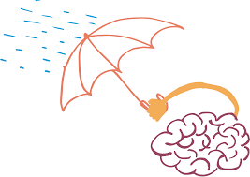


Resilience Resources

I have created a folder on google drive which includes a range of reports, further reading and worksheets on resilience. It is a working document so I will add to it as I find more resources.

https://drive.google.com/drive/folders/1LhQOTqxD-HXdmXujMQlYQXHnZZqmIV_A?usp=sharing

