BSA Resource
Pack

Dealing with Depression and Anxiety in Adolescence


Contents

- What is Depression?
- What is Anxiety?
- What to look out for with Anxiety
- Common Symptoms of Depression
- Your Happy Place
- Your Coping Strategies

What is Depression?

Depression is an illness caused by changes in our brain chemistry. The World Health Organisation says that it's one of the most disabling disorders there is, and it's surprisingly common, affecting one in five women and one in ten men in their lifetime.

While being depressed isn't something you can just ‘snap out’ of, it can be treated. But lots of people who have depression never recognise their symptoms and so don't get the help or support they need.



What is Anxiety?

Anxiety is the feeling of being overwhelmed, such as worry or fear and unease. Feelings can range from butterflies in your stomach to chest pain and shortness of breath. Being a teenager, all these feelings are heightened along with the pressure of fitting in with your peers and mirroring those followed on social media platforms.



Panic Attacks Tension
Trembling
Desperate Jumpy
Scared Chest Pain
Tense
Anxiety

What to look out for…
Headache Fear
Stress
Sweating Phobia
Nightmares Nail Biting

Inside Cheek Biting Difficulty Breathing

Here are some of the common symptoms of depression:

- a feeling of being down in the dumps or really sad for no reason
- a lack of energy, feeling unable to do the simplest task
- an inability to enjoy the things that used to bring pleasure
- a lack of desire to be with friends or family members
- a lack of general motivation
- feelings of irritability, anger or anxiety
- an inability to concentrate a marked weight gain or loss and too little or too much interest in eating
- a significant change in sleep habits, such as trouble falling asleep or getting up
- feelings of guilt or worthlessness
- aches and pains even though nothing is physically wrong
- a lack of caring about what happens in the future
- frequent thoughts about death or suicide.

Where is your Happy Place?

Everyone has their own special place to go when they are feeling down or upset. Some may recognise this as their ‘safe place’ or ‘happy place’. It’s important to recognise when you are feeling overwhelmed and to take a few minutes to yourself.
Where do you feel most comfortable? You may add to the list.

- At Home
- At School
- In your bedroom
- Therapy
- CAHMS
- The Beach
- Out for a Drive

- With Friend
________________________
________________________
________________________
________________________

________________________
________________________

What keeps you calm and relaxed?

Like your ‘safe place’ or ‘happy place’ we all have our things that keep use calm and relaxed.
Of the following what do you feel helps you? You may add to the list.
- Going for coffee

- Going for a walk or Run
- Getting your nails done
- Your mobile phone
- Computer games/ xbox
- Quite time
- Talking to someone
- Being by yourself
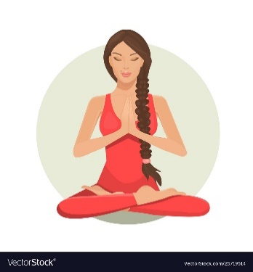
- Listening to music
- Drawing or painting
- Mediating
- Having a nap
- Reading a book
_____________________________

_____________________________
_____________________________
_____________________________
_____________________________
_____________________________

Recommended Strategies when working with an adolescent that has had a break down or isn’t coping within their setting:

- Speak to the pupil quietly and confidently asking if they would like to take a few minutes out of class to calm down.
- Suggest taking a free class or sometime out
- Talk to them by changing the subject
- Talk to them about their interests to distract them
- Suggest taking a walk around the school grounds
- Give them something to work towards or look forward to. (eg. Computer time, mobile phone time or going for a coffee)
- Suggest going to the P.E hall to release their angry by kicking a ball or bouncing a basketball.
- Suggest one of their coping strategies (eg. Reading a book, drawing or painting)

*There are plenty of strategies to use when working with a pupil that has had an anxiety attack, anger or frustration attack etc. It is all about finding out what works for you and your pupil.



