I Can’t Cope!!

A Resource to help with big feelings!



This is a resource pack for pupils whose thoughts and feelings get so big, sometimes they lose control. This booklet contains strategies to help understand and manage those big feelings and cope a little better and feel less overwhelmed.

  - What are big feelings?
  - What happens?
  - How our bodies feel?
  - Recognising how you feel
  - You have a choice!
  - Ideas to make me feel better
  - Practical Tool kit
  - Thinking Tool kit
  - Advice for school staff
  - Appendix

What are BIG FEELINGS?

Anxiety, Fear, Anger, Worry, Guilt, Grief, Low Mood are all ‘big feelings’ for our children to deal with. They affect all parts of the young person’s life, their behaviour, thought process, how they interact with others and daily home and school life.

Big Feelings can stop you doing what you want to do.

They can FREEZE you! And you feel you have no control!



So, what happens??

Think, Feel, Do

What we think about gives us a feeling and those feelings become actions, then we think again and the cycle continues.
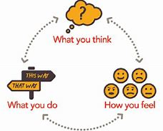

Do you know that a thought it just a thought?

We have millions upon trillions of thoughts a day and just as it comes into our heads it can leave again. We don’t need to stay in the negative thought.
How Our bodies FEEL!



HAPPY

Want to smile
Have Energy
Want to take part
Feel Good



SAD
Want to cry
Heavy Chest
Upset/ turning Stomach



MAD
Hot face
Tight Chest
Tight Muscles
Clenching Fist



WORRIED

Hard to breathe
Feeling Wobbly
Don’t want to do it

Recognising How You Feel

Recognising and naming how you feel (Gender resources in Appendix). This is the first step in moving forward.
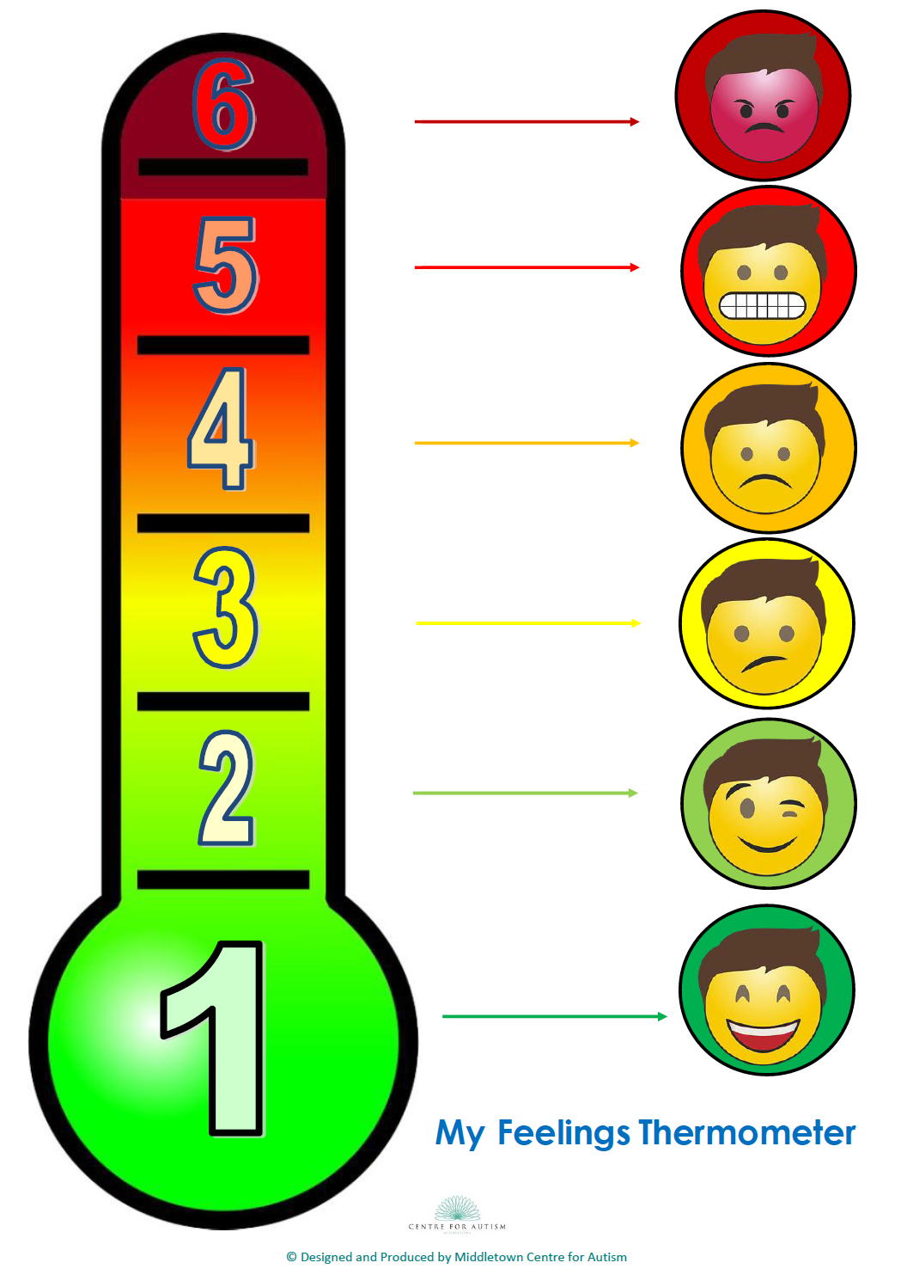

You have a choice!!
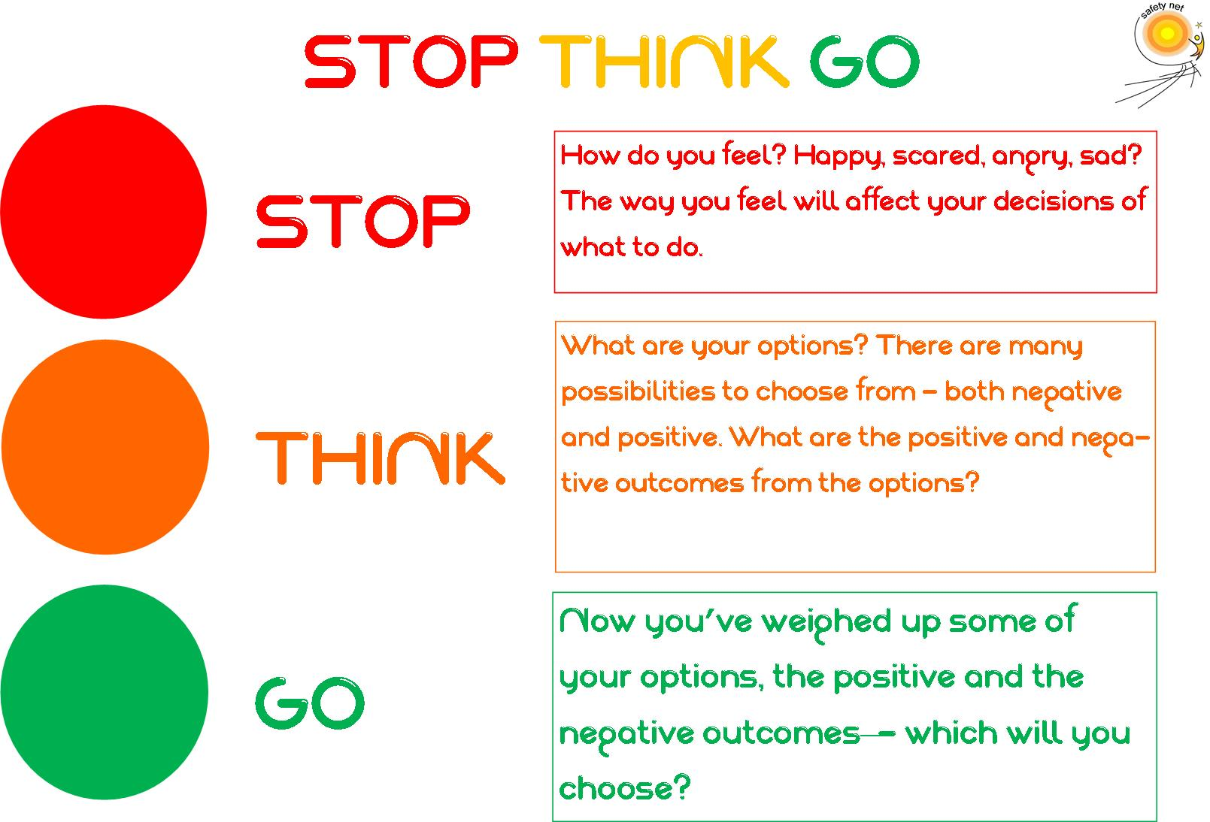

Things to make myself feel better

You need a Tool kit of Ideas. I have split this tool kit into Practical, Group Activities and Thinking.

These are only examples and you can add to the list and make them more personal to you.

Practical Tool Kit

Practical/Physical things I can do

- Eat Well! A healthy body goes hand in hand with a healthy mind – try to record what you are eating – can you make healthier choices?
Monday
Tuesday
Wednesday
Thursday
Friday
Saturday
Sunday

- Take time to relax
Lie down in a quiet room, get comfortable
Take slow deep breaths
One body part at a time, squeeze the muscles as hard as you can, hold it for 2, then release. Do for your:
Feet
Legs
Stomach
Hands
Arms
Face

- Focus Your Brain On Another Activity (read a book, play a computer game, do a puzzle, watch television, chat to a friend)

- Participate in A Physical Activity Or Sport

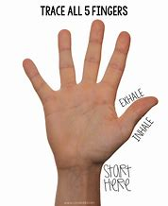
- Use Deep Breathing Exercises

- Imagine Yourself in A Special Place

Get into a comfortable position. Close your eyes. Take 4
nice, deep breaths. Feel your body relax. Now, imagine
yourself floating on an air mattress in the ocean. The
waves are gently rocking you on the mattress. The sun is
shining down on you, making you feel warm and relaxed.
There is a slight breeze, so you don't get too warm from
the sun. If you want to, you can roll onto your stomach.
The air mattress is clear. You are able to see many
colorful fish swimming below you. Once in a while, you
see a turtle pass underneath you. Sometimes they stop
and look up at you, almost as if they are saying hello. You
feel very relaxed. Out of the corner of your eye, you see
something swim towards you. When you turn your head
to look, you see a beautiful dolphin making its way
towards the air mattress. The dolphin stops and looks at
you. It is like he is telling you he is glad you are here and
hopes that you will come back to visit often. You spend a
few more minutes enjoying this peaceful place. When
you feel ready, you can take 4 nice, deep breaths. Then,
wiggle your fingers and wiggle your toes. When you feel
ready, you can open your eyes.

There are many visualisations. If this one is not for you try googling or searching you tube to find one that you like.
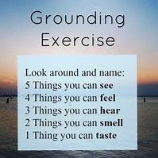
You can also try this Grounding Exercise.

- Think Positively Using Affirmations – these can be used along with happing to reinforce the belief…tap wrist, chest etc. while saying. Space left for you to add your own.

I will stay calm and relaxed

I will try my best and that will be good enough

I Can Do It

I Am Safe

I will do a great job

I have important things to say

I Like Myself

I am proud of what I’ve done

I Am Peaceful

I Am A Winner

I Am Brave

I like my body

I Make Good Choices

I Am Strong

- Find Something Funny That Will Make You Laugh – a few are added – can you think of any?

Look at a funny picture!
Or
Watch a funny movie!

Search Google for funny jokes!

- Write in A Journal

Monday
Something I did well today….
Today I had fun when….
I felt proud when…..
Tuesday
Something I did well today….
Today I had fun when….
I felt proud when…..
Wednesday
Something I did well today….
Today I had fun when….
I felt proud when…..
Thursday
Something I did well today….
Today I had fun when….
I felt proud when…..
Friday
Something I did well today….
Today I had fun when….
I felt proud when…..

- Catcher for practical activities to do with anger and different strategies to help diffuse. This is just an example but can be modified for any feeling. (See Appendix)
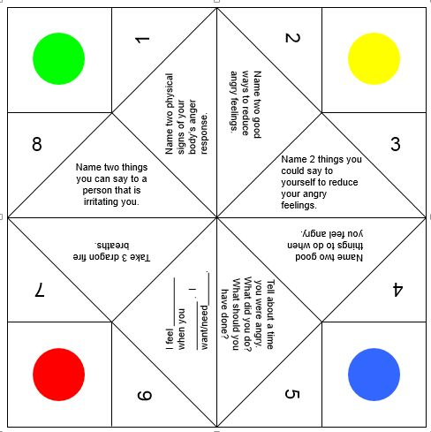

Group Activities Tool Kit – small groups 4-6

My Perfect Day
- Close your eyes and imagine yourself doing your favourite thing. (NO COMPUTERS e.g. Xbox, PS4 etc) Who else is with you? Where are you?
- After you open your eyes, describe below what you saw – use any symbol except words!
- Find a partner and ask your partner to guess what your perfect day would be like by looking at the symbols.

Think Positively
- Divide into groups or pairs.
- Assign each group/pair two topics from the list below.
- Ask students to devise a group strategy for positively coping with each situation.
- Share strategies

Topics
You got a disappointing grade on a test, lower than you thought it was going to be.
Your parents had a fight/argument before you left for school.
You were grounded last night.
Your best friend has just moved away.
Your favourite pet died.
Someone close to you has died.
You did not make the team/club you were trying to get into.
Your best friend got busted for selling drugs.

How do you feel?
- Complete these sentences on your own.
- As a group, discuss your answers

Sentences to complete
- When I’m proud of myself, I_________________________________
- I love____________________________________________
- I am afraid of ____________________________________
- I’m embarrassed when______________________________
- I hate__________________________________________
- I want to be______________________________________
- I am happiest when________________________________

Quiz game – cut out and take turns – puts a positive spin on ‘my day’
Let me know!
- What made you smile today?
- Did anyone do anything silly to make you laugh?
- What was the best thing to happen today?
- Did you help anyone today?
- Who did you sit with at lunch? Did you like your lunch today?
- What made you laugh today?
- What did you not like about today?
- What is something that challenged you today? Something you had to work hard at
- Did anyone get in trouble today?
- Tell me your top 2 things that happened today
- What was the hardest rule to follow today?
- If you could switch seats with anyone in your class who would it be and why?
- What is your favourite part of your school?
- If you switched places with your teacher tomorrow, what would you teach the class?

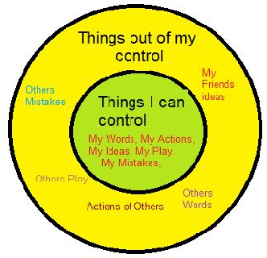
Thinking Tool Kit

We cannot control everything in our lives.
What things can you and can you not control?

Things I CAN’T control

Things I CAN control

Positive Thinking Exercise
Sometimes, our negative thoughts cause us to feel anxious. When we think that we won’t be successful or won’t be able to cope with a situation, then we may become anxious. Changing how we think about situations can help us learn to cope with anxiety. Below are some situations that could cause feelings of anxiety. For each example, list a negative way of thinking about the situation and a positive way of thinking about the situation.

Situation | Negative Thinking | Positive Thinking
You have to take a test

You are going to a new school

You have to ask the teacher a question

You are shy and new people talk to you

You want your schoolwork perfect

You are going to the dentist

You were fighting with your brother or sister before school and got into trouble

Your pet died

Write or draw your own negative thoughts that you have had. Write or draw a positive thought you can say instead.

Negative | Positive
Negative | Positive
Negative | Positive


Self Control

Self control is the ability to control your emotions and behaviours when you get angry. Sometimes we loose self-control when we get mad.
Can you name a time when you lost self-control? ___________________________________________________

When we lose self-control, we sometimes do things that we may not be proud of. Here is a list of the things that people do when they lose control. Check each behaviour that you have experienced when you lose self-control.

- Scream
- Break things
- Hit someone
- Call names
- Take off
- Hurt yourself
- Slam doors
- Threaten others
- Throw things

It is very important that you learn healthy ways to manage big feelings before you loose control. Losing control can get you into lots of trouble, with your parents, teachers and even the Law.

When you feel like you are going to lose it, you could try one of these behaviours instead.

Walk away try to talk it out maturely Take deep breaths
What other things do you think you could do before you lose control?

_______________ _______________ _______________

A big part of growing up is learning to control your emotions in a mature and healthy way. You will earn respect from your parents, teachers and peers.

What if I have no self-control?

If you can recognise the stage that you are going to lose control, you can try a help card. This means you are in control of your feelings and you just need a safe place to vent these.



Advice for school staff

- Get to know what works for your pupil

- Make pupil or BSA aware of any changes to routine as soon as possible

- Check in with the child regularly

- Allow them time out/bubble time with BSA when needed

- Know what may trigger the pupil

- Encourage them to use their unique calming techniques

- Allow pupil to use ‘escape’ card when needed to diffuse and re-enter class when settled

Appendix
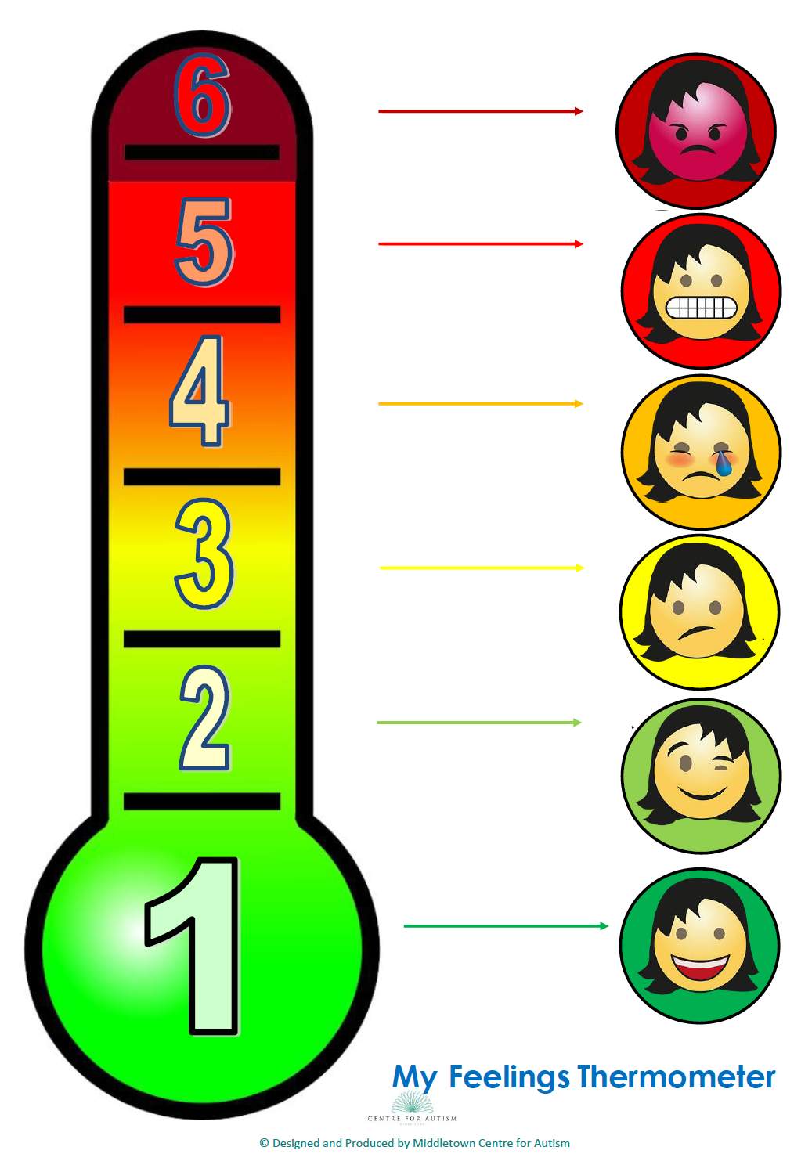

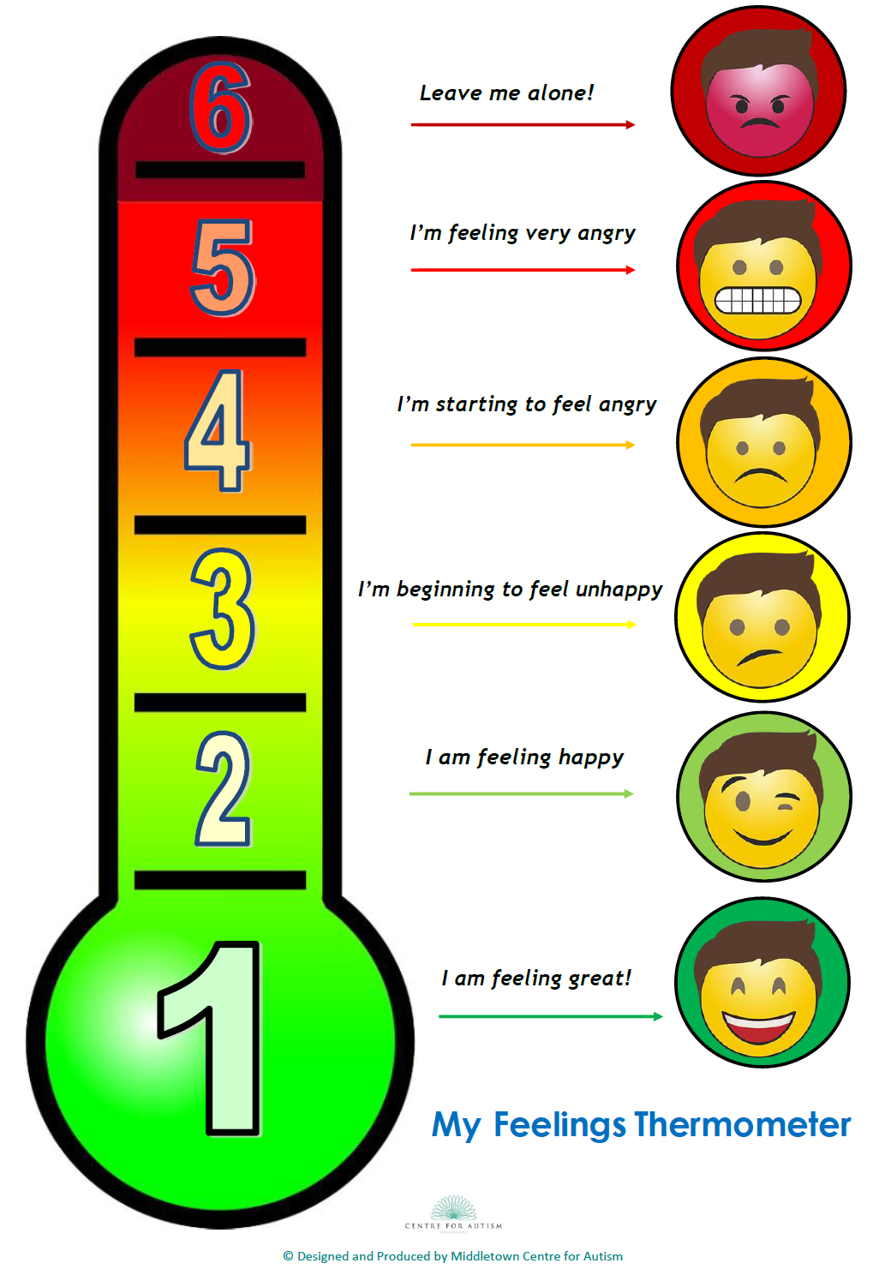

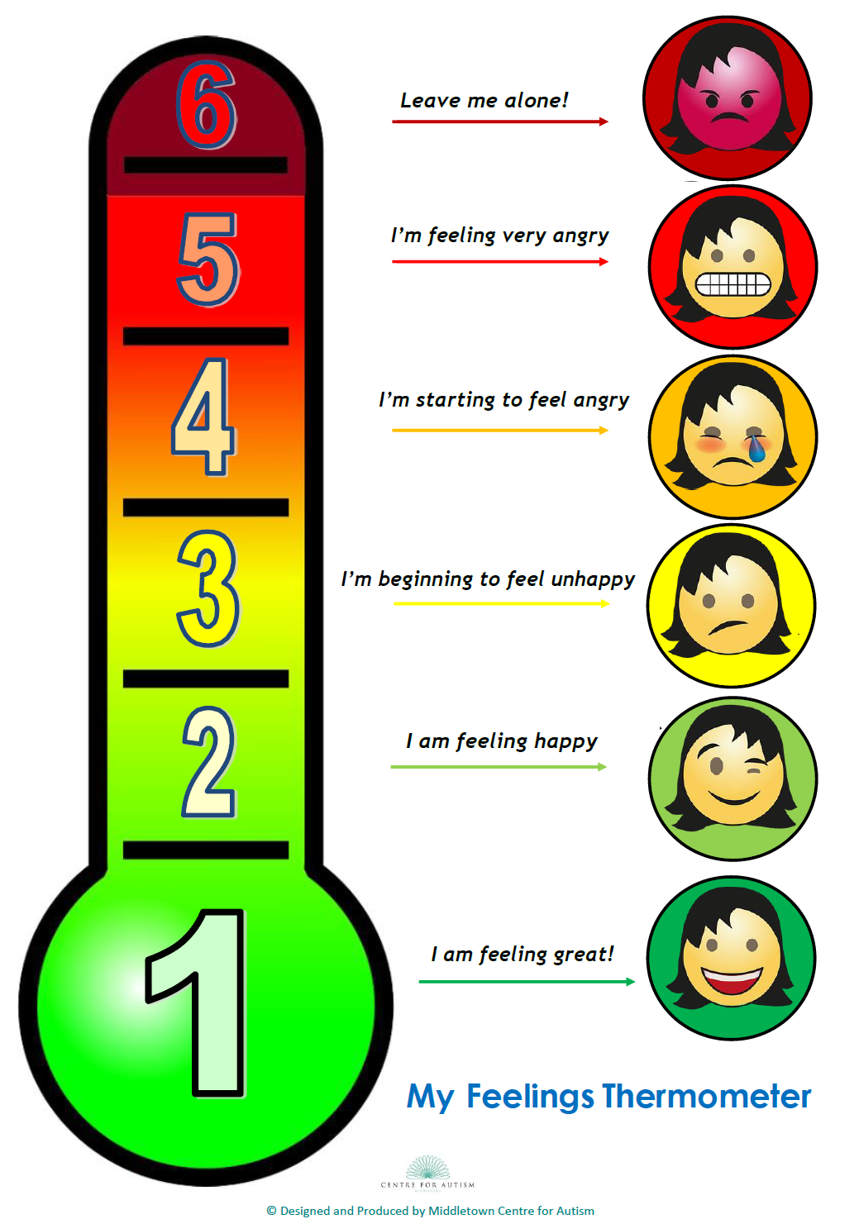

Extra blank catcher


