THOUGHTS
&
BEHAVIOURS

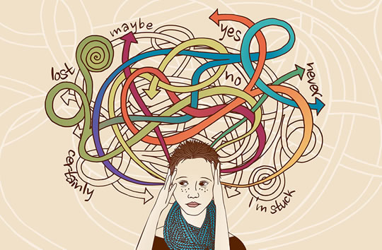

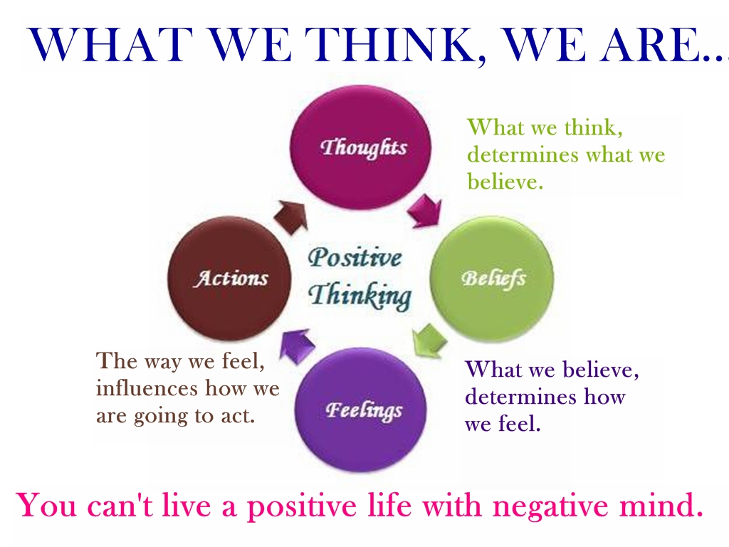

VICIOUS CIRCLE
The way you feel is affected by things that happen to you! Many of these things are outside your control!
Not making the team/being dropped
No money
Kicked off the team
Failed a test
Being bullied
Friends ignoring me
Dumped by boyfriend/girlfriend
Too much school work
Being ill

When you allow them to affect your mood the vicious circle kicks in!

Altered Thinking can set off a chain reaction inside you which affects the way you feel and the way you behave
ALTERED THINKING
Failed a test
“I’m useless”

ALTERED PHYSICAL SYMPTONS
Tense, sore stomach, headache, clammy, fidgety, tired
ALTERED BEHAVIOUR
Staying in bed, no exercise, skipping school, don’t eat right,

ALTERED FEELING
Sad, low, embarrassed, guilty

TIDY/ORGANISE YOUR ROOM


YOUR TURN
Choose 2 recent times when you felt bad – not distressing or upsetting – times when you felt sad, low, angry, embarrassed, stressed

ALTERED THINKING

ALTERED PHYSICAL SYMPTONS

ALTERED BEHAVIOUR

ALTERED FEELINGS

STOP YOUR VICIOUS CIRCLE SPINNING
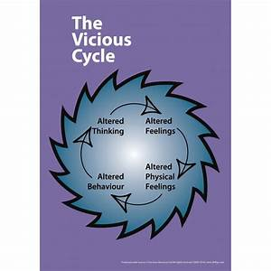
Patterns of thinking, feeling and body reactions tend to repeat themselves again and again, making your circle keep spinning and making YOU feel worse.

Just by acting differently or changing the way you think about one thing can affect all the other things in your circle and make YOU feel better!
MAKE A CHANGE

- YOU HAVE CONTROL
- CHANGE JUST 1 THING
- STOP THE VICIOUS CIRCLE SPINNING
- START TO FEEL BETTER
- TRY THE PLANNING & REVIEW SHEETS
- MAKE A HAPPY LIST – THINGS YOU ENJOY – THINGS THAT MAKE YOU SMILE

DON’T JUST SIT THERE – MAKE A PLAN!!
PLANNING SHEET
DATE:
- WHAT AM I GOING TO DO?


This Photo by Unknown Author is licensed under CC BY
- WHEN AM I GOING TO DO IT?

- WHAT PROBLEMS COULD I ARISE – HOW WILL I OVERCOME THEM?

IS MY PLANNED TASK: YES NO
Q1. Useful for improving my well-being?

Q2. Specific, so I will know when I have done it?

Q3. Realistic, practical, and achievable

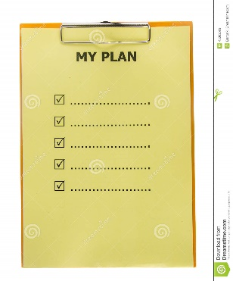


OK – HOW DID IT GO??
REVIEW SHEET
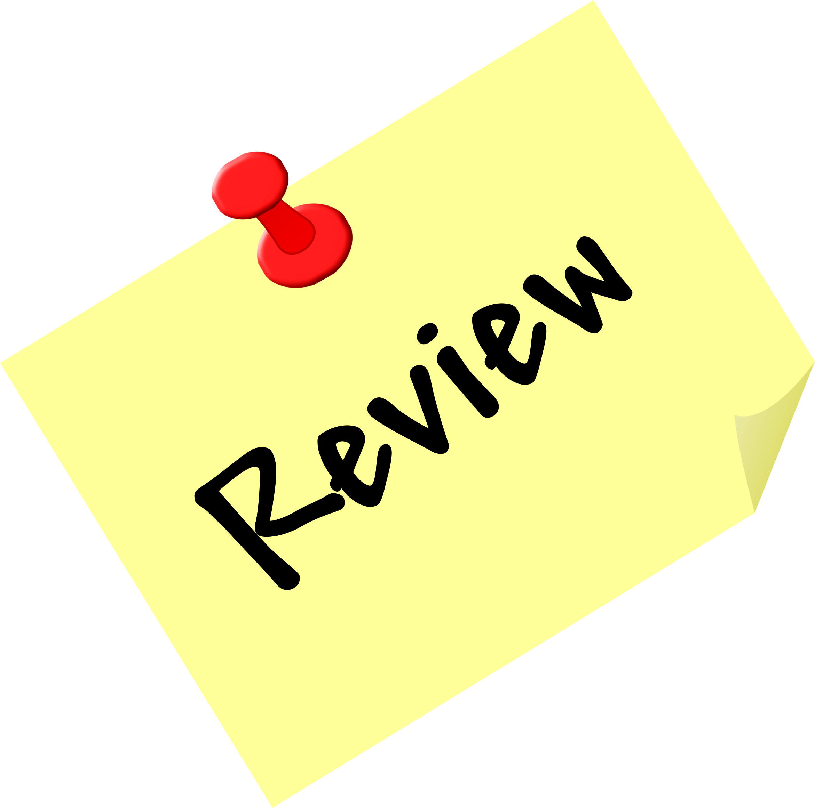

WHAT DID YOU PLAN TO DO?

DID YOU TRY TO DO IT? YES NO

IF YES: IF NO: WHAT STOPPED YOU?
- What went well? - Internal things (forgot, not enough time, put it off,didn’t think I could do it, couldn’t see the point)

- What didn’t go so well?

- External things (other people, work or home issues)

- What have you learned from what happened?

- How could you have planned to tackle these things?

- How are you going to apply what
you have learned?  

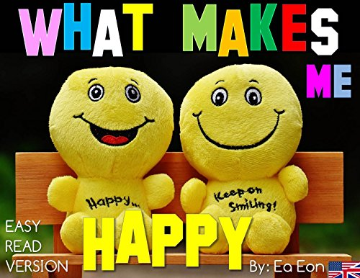

- Write down all the things you have enjoyed, done well or made you feel close to someone
- You can include things which have been ok/not so bad
- What are you thankful for today

TIPS TO HELP YOU FEEL BETTER
GET OUTSIDE MORE
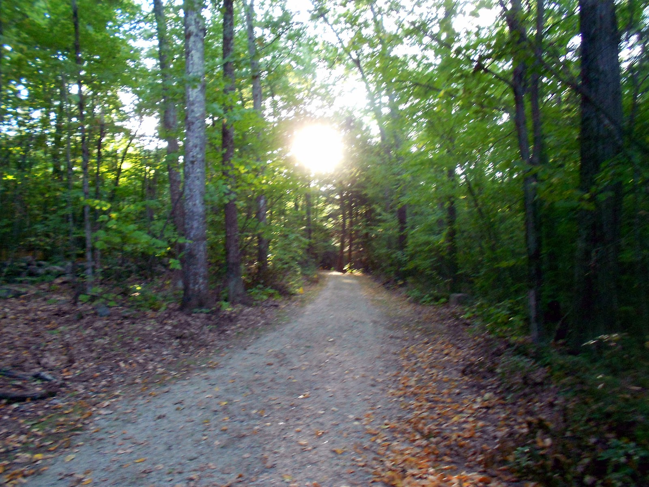
DO SOMETHING FOR SOMEONE ELSE


GET CREATIVE

MAKE A NOTE OF IT

SLOW IT DOWN
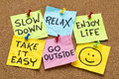
PUT ON YOUR WOW GLASSES

CALL A FRIEND
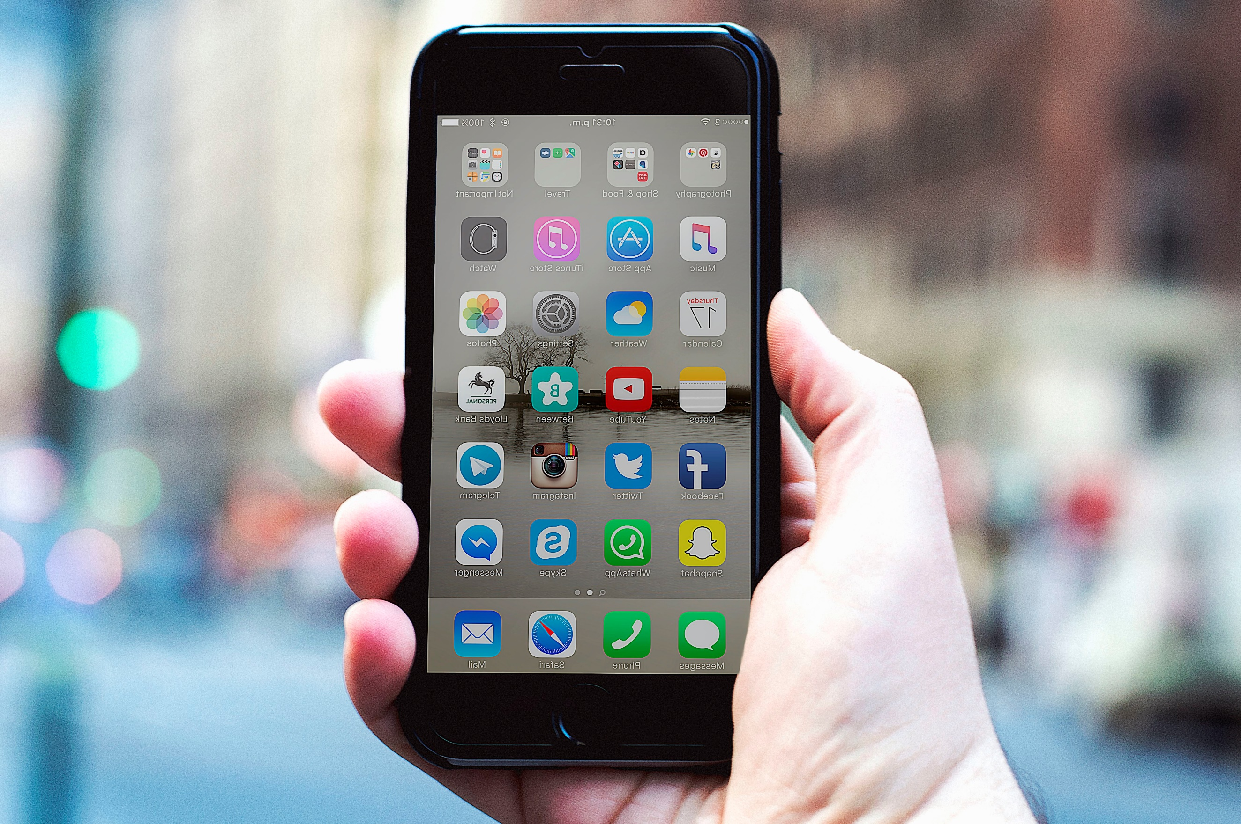
MAKE A HAPPY LIST


EAT GOOD THINGS


