BSA RESOURCE PACK

Dealing with Attachment Disorder

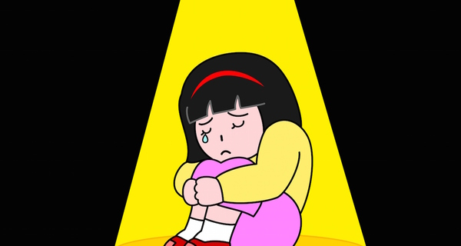
Contents

. What is Attachment Disorder?
. Causes of Attachment Disorder.
. Why is Attachment important?
. Signs of Attachment Disorder
. Attachment Disorder Mind Map
. Strategies to help with Attachment Disorder behaviours?
. Advice for school staff
. Useful websites

What is Attachment Disorder?

Attachment Disorder is the term given to emotional and behavioural problems that can develop in children who fail to form bonds with their primary care provider. This can cause a range of issues, typically affecting mood, following social rules and social relationships due to difficulties in forming an attachment to primary care provider during early childhood.
The causes of attachment are linked to early abuse, neglect, separation from or changes in care provider during early childhood research has shown.
A person’s attachment style is established permanently before the age of three, therefore early interventions are important for the treatment of attachment disorders.

Causes of Attachment Disorder

Children can experience attachment disorders If during the first three years of their life, any of the following occur:
- Mother smoked, drank alcohol or took drugs during pregnancy.
- They are the result of an unwanted pregnancy.
- They suffer physical, emotional or sexual abuse.
- They have been neglected. This can be anything from not having a nappy changed when it is dirty to not being fed when hungry.
- Their primary carer suffers from depression.
- They were separated from their primary carer through the illness or death of a parent, or through being taken into care.
- They suffer from persistent and chronic pain.
- Their primary care providers split up or divorce.
- Inconsistent parenting.
- They are raised in an emotionally empty or negative/abusive environment.

Why is Attachment Important?

Attachment is a deep connection between a child and their care providers.
Children build healthy relationships through observation and the interaction of adults around them. Children who have had problematic relationships in their early years can later face challenges forming relationships.
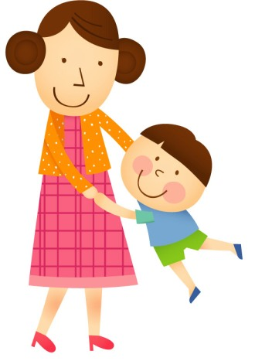

Signs of Attachment Disorder

- Lack of eye contact
- Lacks trust in adults
- Seeming emotionally detached
- Angry or aggressive
- Has difficulty forming relationships with adults and peers
- Lack of remorse
- Manipulative
- Low self-esteem
- Frequently lying
- Cruel and destructive
- Underdeveloped conscience
- Short attention span
- Erratic eating habits

Attachment Disorder Mind Map

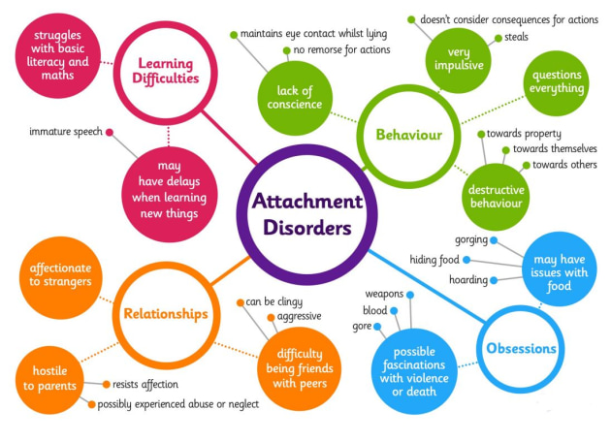
Strategies to help with attachment disorder behaviours?

- you should strive to provide an organised and familiar care routine with clear boundaries. The aim is to help children to feel safe and for them to learn to trust you.

- Children are likely to benefit from following routines and schedules and may feel uncomfortable if you’re not where you are supposed to be.

- Setting boundaries may highlight difficulties but can help the child to feel safe and nurtured when consistently applied.

- Try not to instil discipline during conflicting moments and when disagreements happen. Make it clear you still care about the pupil.

- At times you may feel rejected, unappreciated or as if you’re making little progress.

- Use relaxing strategies i.e. Bubble time, rewards and praise

- Provide calm, structured supervision for these children as much as possible.

- Be consistent, repetitive, and predictable

- Intervene early and intensively

Advice for school staff.

- Observe and learn what works for the child
- Inform child and BSA of any changes to daily routine immediately.
- Engage with the child regularly
- Bubble time with BSA when needed
- Be aware of what may trigger the child
- Encourage them to use their calming techniques
- Allow the use of calming toys/fidgets in class

Useful Websites

www.twinki.co.uk
https//www.aacap.org
https//www.helpguide.org
https//www.goodschoolsguide.co.uk
https//www.attach.org

