A D H D

Attention Deficit Hyperactivity Disorder

Helping children with ADHD includes creating more structure, encouraging routines, and clearly stating expectations of the child.



Contents Page:
- Page 1- Title page/ Introduction

- Page 2- Contents page

- Page 3- What is ADHD?

- Page 4- Students with ADHD

- Page 5- Difficulties within a school setting

- Page 6-8 - Strategies to help children with ADHD

Websites to help gain knowledge with students with ADHD:

Ad·www.langdonuk.org/adhd/symptoms‎

Ad·www.nipinthebud.org/‎

https://www.google.co.uk/url?sa=t&rct=j&q=&esrc=s&source=web&cd=&cad=rja&uact=8&ved=2ahUKEwjpgsL00uLpAhURXsAKHcLJDnEQFjASegQIAhAB&url=https%3A%2F%2Fwww.nhs.uk%2Fconditions%2Fattention-deficit-hyperactivity-disorder-adhd%2F&usg=AOvVaw0eIp-bh4YcSkcsGP4bFqV6

https://kidshealth.org/en/parents/adhd.html

https://chadd.org/about-adhd/overview/

What is ADHD?
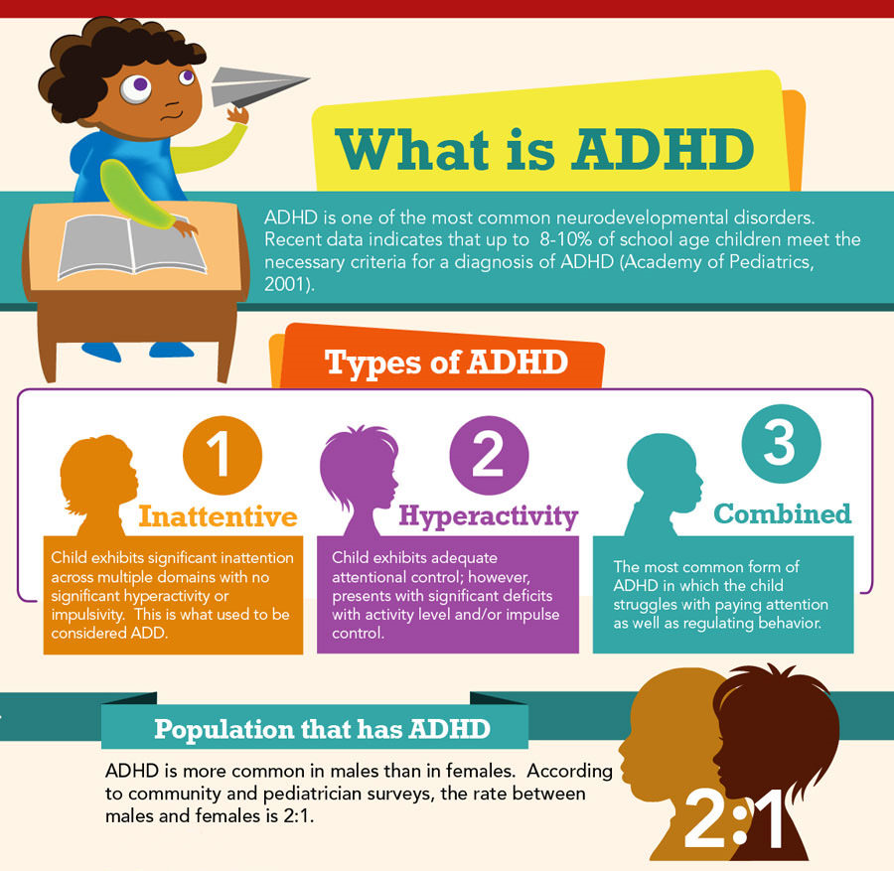

Students with ADHD:

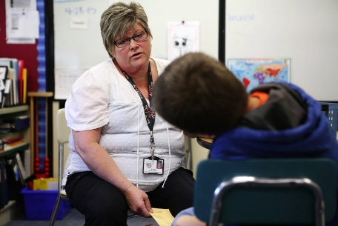
- Demand attention by talking out of turn or moving around the room being disruptive towards other classmates and teachers.


- Have trouble following instructions, especially when they’re presented in a list, and with instructions that require ordered steps, such as long division or solving equations.

- Often forget to write down homework assignments, do them, or even bring completed work to school.


- Often lack fine motor control, which makes note-taking difficult and handwriting a trial to read.

- Have problems with long-term projects where there is no direct supervision.


- Not pulling their weight during group work and may even keep a group from accomplishing its task.

ADHD is a condition where the child has lots of energy and this then affects their concentration in class, they might also find it hard to control what they say and do.


School settings often requires children to:
- Sit still.

- Listen quietly.

- Pay attention.

- Follow instructions.

- Concentrate.

Kids with ADHD would find this very difficult to do in any setting.

Strategies we as BSA’s can employ to help students with ADHD overcome learning challenges and stay focused without disrupting others and succeed in the classroom.

To start with:

- We need a positive attitude ourselves when helping a student with ADHD.

- Make the student your partner by saying, “Let’s figure out ways together to help you get your work done.”

- Assure the student that you’ll be looking for good behaviour and great work and when you see it, reinforce it with immediate and sincere praise.

- Deal with disruptive classroom behaviour immediately.

- Seating. Seat the student with ADHD away from windows and away from the door and any other distractions in the room.

- Student work. Create worksheets and tests with fewer items, give frequent short quizzes.

- Look for ways to motivate a student with ADHD by offering rewards on a point or token system. Even a small break from his/her work and go for a walk can help motivate a pupil and keep them interested.

- Always stay calm and reassure the child you are there to help them.

- Reducing the interruptions of children with ADHD should be done carefully so that the child’s self-esteem is maintained, especially in front of others. Develop a “secret language” with the child with ADHD. You can use flash cards or words you have previously agreed upon to let the child know they are interrupting. Praise the child for interruption-free conversations.


- Use bubble time to let the child calm down, then ask them what made them behave in this way. If they can’t tell you, let them write it down on a piece of paper.


- Provide a stress ball, small toy, or other object for the child to squeeze or play Make sure a child with ADHD never misses break time or lunch time.

- Work along with the teacher so that both of you know what works and doesn’t work for the pupil. If the pupil is having a bad day, make he/she aware of this to save confrontation in the classroom.



