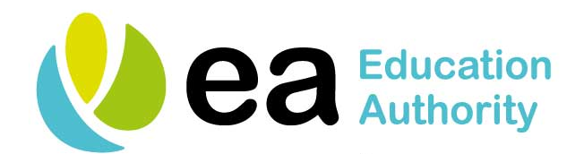


School Age Mothers Programme Referral Form
Referrer: | Date:

Pupil Details:
Name: | Date of Birth:
Home Address: | Telephone No:
 | Mobile No:
Postcode: | Ethnicity :
Parent/Guardian Details:
Name: | Relationship to Pupil:
Home Address: | Telephone No:
 | Mobile No:
Postcode: | Parents email:
Is parent/guardian aware of pregnancy? | YES | NO

Expected Date of Delivery/or Baby’s Details:
Expected Date of Delivery:
Name of baby: | Baby’s Date of Birth:
Name of G.P.:

School Details:
School: | Year Group:
School Contact: | Attendance Percentage:
Has the young person been made aware of the SAM Programme? | YES | NO
Has the young person been made aware of the referral? | YES | NO
Can the SAM Coordinator contact the young person directly? | YES | NO
Social Services Advised? | YES | NO
School Email Address:
Additional Information from School:

Signed: Date:
School Representative / Role: ________________________________________________________________
Contact details for School Age Mothers (SAM) Coordinators overleaf.

Contact Details for School Age Mothers (SAM) Coordinators

Name | EA Office | Address | Email and Telephone Number
Adele Fulton | Ballymena | Cullycapple Primary School,  32 Mullaghinch Road,  Aghadowey,  Coleraine,  BT51 4AP | 028 7086 8588  0773 9976 804  Adele.Fulton@eani.org.uk
Yury Fleming | Ballymena | Loughview Regional Office,  2-6 Jordanstown Road, Newtownabbey,  BT37 0QF | 028 9086 2624  0773 9976 781  Yury.Fleming@eani.org.uk
Lisa Grimley | Armagh | Education Welfare Office,  25 Railway Street, Armagh,  BT61 7HP | 028 3752 3158  0774 8962 439  Lisa.Grimley@eani.org.uk
Janice Stewart | Omagh | Derry District Office,  35 Foyle Street , Derry  BT48 6AL | 028 7127 2321  0782 6866 481  Janice.stewart@eani.org.uk
Deboragh Gormley | Belfast | Education Welfare Office,  40 Academy Street,  Belfast,  BT1 2NQ | 028 9023 6817  0780 5667 007  Deborah.Gormley@eani.org.uk

