
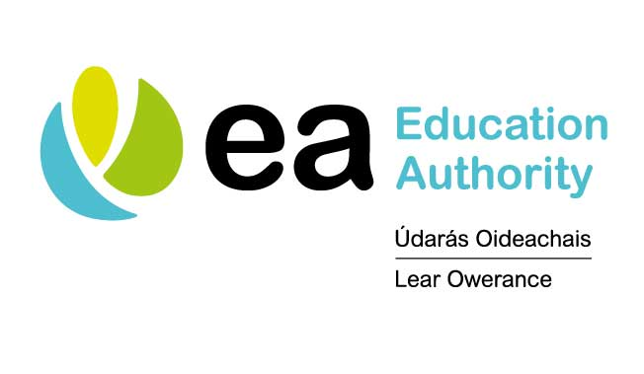


Planned Intervention Programme
Application Form 2020
Guidance Notes are available at www.eani.org.uk/plannedintervention and must be carefully read before filling in this form.

Please note there have been significant changes this year to meet the needs of working within the Covid 19 pandemic.

More than one application can be submitted per organisation, but separate application forms are required for each proposed programme. Each programme must be for a different group of young people.

Please answer each question in the box provided and follow the word count guide. We will not consider any words over the word limit.

If an application is deemed incomplete or does not fulfil the requirements of the programme, it will be rejected.

THIS FORM WILL NEED TO BE DOWNLOADED FROM THE EDUCATION AUTHORITY (EA) WEBSITE, COMPLETED AND THEN SUBMITTED BY EMAIL or POST.

RETURNING YOUR APPLICATION
Applications should be returned to the Education Authority by the closing date of
23rd June 2020, at 16:00

Applications may be submitted by email or post. The form may be signed digitally or by typing in the applicant’s name with the email address used as proof of identity. However, if a letter of offer is awarded, the original signature of the person identified in the group contact details section, must be provided.

Applications should be returned by email to plannedintervention@eani.org.uk or by post to:
Planned Interventions
Education Authority Youth Services, Dundonald
Grahamsbridge Road
Dundonald
BT16 2HS

APPLICATIONS RECEIVED AFTER THE CLOSING DATE/TIME WILL NOT BE CONSIDERED.

SECTION 1
GROUP CONTACT DETAILS
Group/Lead Organisation Name
Please confirm you are registered with the Education Authority | Yes/No
Address and postcode of organisation

District Council Area
Contact Name
Position
Address for Correspondence |  | Post Code:
Telephone Number: |  | Mobile:
Social media address:
Email Address:
Name of programme leader:

Telephone number:

Council Area: Please tick | This should reflect the council area of the PARTICIPANTS
Antrim and Newtownabbey | Fermanagh and Omagh
Ards and North Down | Lisburn and Castlereagh
Armagh City, Banbridge and  Craigavon | Mid and East Ulster
Belfast City Council | Mid Ulster
Causeway City and Glens | Newry, Mourne and Down
Derry City and Strabane

SECTION 2
Name of programme

Proposed Programme start date? (day/month/year)

Please note activity may commence from 1st July 2020

Programme end date? (day/month/year)

Please note all activity must be completed by 30th September 2020

Provide details of all the organisations/groups involved in DELIVERY of the programme.
A letter/letters of support from partners will be required if an application is successful

Name of group/organisation and type of organisation |  | Contact details – Telephone number and email address |  |  | Role in the project
Numbers of young people and leaders involved in the project:

Please note, groups numbers are a minimum of 3 and a maximum of 10 young people. See guidance notes page 12.

Number of participants | 10-13 years old |  | 14-16 years old | 17-19 years old |  | 20-25 years old | Total Participants
Number of participants |  |  |  |  |  |  | Max = 10
Number of Project leaders and assistants | Paid (either by funding or directly from Employee) |  | Voluntary | Under 25 years –leaders/assistants either in a paid or voluntary role |  |  | Total Programme leaders and assistants
Gender of participants | Male |  |  | Female |  |  | Total
Programmes can run on a cross community basis to include participants from both Catholic and Protestant communities, and single identity basis. However, proposals which include participation from other communities including ethnic minority communities and those of different racial backgrounds are encouraged. The programme must illustrate how it meets the criteria for funding and demonstrate how the set outcomes will be achieved.

SECTION 3 - Classify the programme’s target area (please tick only one)
Area/s not noted for sectarian activities/civil disorder/significant anti-social behaviour
Area/s of recently identified sectarian activities/civil disorder/ significant anti-social behaviour
Area/s of high sectarian activities/civil disorder/ significant anti-social behaviour
Severely heightened sectarian activities/civil disorder /interface/hotspot/ significant anti-social behaviour
Please outline the evidence for the choice of classification by providing a clear rationale.

The requirement for Planned Intervention is:

‘young people in interface areas and areas where there is the potential of heightened social unrest during contentious periods over the summer, particularly on weekends and evenings’

Describe how the target area(s) meet this requirement?

Applicants are expected to provide relevant data to show the need within their target area.
Please see guidance notes page 12

Max 200 WORDS

SECTION 4 - Recruitment: detail how specific participants will be identified i.e. those most at risk of becoming involved in sectarian activities, civil disorders and other crimes, and recruited to the programme.
Young people recruited to the programme must be at risk as described above. Please provide a profile of the young people to be recruited, with the partners and organisations who will assist with this.

Please see guidance notes pages 12

Max 200 words

Section 5 - Planned Intervention Programme Outcomes
A number of set outcomes are required from the Planned Intervention Programmes, as illustrated in the Table below.
Youth Intervention Programme Outcomes
Outcome 1 | Reduction in number of crime and antisocial behaviour incidents in the areas where the young people live.
Outcome 2 | Reduction in the number of young people engaging in risk taking behaviours.
Outcome 3 | Increase in the % of young people who think favourably about young people in the other community. (demonstrated by their ability to talk openly with others about their sense of identity, culture and traditions)

5. Please detail how this programme will meet each of the outcomes detailed above. The present circumstance will require that the programme is creative and accessible for the young people.

Please see guidance notes page 13 for support

Max 200 Words

SECTION 6 – Costs (Please see guidance notes page 14)
Please note that information supplied in this form will be uploaded onto the Government Funding Database for public access, if successful.
Provide a full breakdown of the costs requested from the Planned Intervention Programme
(Guidance Notes: Funding and Eligible Costs)

Note: a maximum amount of £6 000 may be requested.

Cost Heading | Detailed Breakdown/ calculation of cost | Total £
Staffing
Programme Costs | £75 per young person only
Final Total |  | £
Total amount being requested from this programme: |  | £
SECTION 7
I/We certify that the above information is correct. I/We agree to:
- submit a report and financial statement, including relevant receipt, by the 31 November 2020. If this is a joint initiative a representative from each group to sign below.
- ensure that safeguarding guidelines are adhered to, and appropriately dealt with.

Signed:
Name:
Position:
Date:

Note:

The information provided on this form may be made available to other departments/ agencies for the purpose of preventing or detecting crime.

