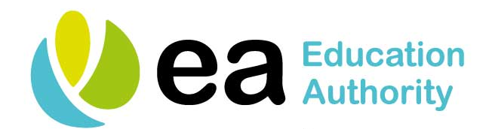

CENTRALISED HEALTH RAISING AWARENESS SESSIONS FOR SCHOOLS - 2019/20

DATE | VENUE
Thursday 22 August 2019 | Armagh Teachers’ Centre
Friday 23 August 2019 | Dungannon Teachers’ Centre
Tuesday 27 August 2019 | Newry Teachers’ Centre
Wednesday 28 August 2019 | Armagh Teachers’ Centre
Thursday 29 August 2019 | Dungannon Teachers’ Centre
Monday 16 September 2019 | Armagh Teachers’ Centre
Monday 23 September 2019 | Newry Teachers’ Centre
Monday 21 October 2019 | Dungannon Teachers’ Centre
Monday 03 February 2020 | Armagh Teachers’ Centre

