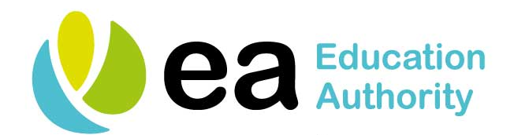

CENTRALISED HEALTH RAISING AWARENESS SESSIONS FOR SCHOOLS - 2019/20 PROGRAMME

TOPIC | TIME
Asthma Awareness | 9.30 – 10.15
Tea/Coffee | 10.15 – 10.35
Food Allergy Awareness | 10.35 – 11.30
Anaphylaxis Awareness  Use of Auto-Injector | 11.30 - 12.30
Lunch Break | 12.30 – 13.00
Diabetes Awareness | 13.00 – 14.15
Epilepsy Awareness and Administration of Emergency Medication | 14.15 – 15.45

