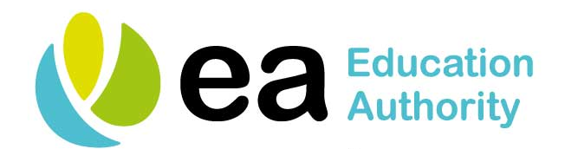

Circular No: 2019-05-03A

To: ALL SCHOOL PRINCIPALS

21 May 2019

Dear Colleague

Re: Centralised Health Raising Awareness Sessions’ Schedule – 2019/20

The Education Authority wishes to confirm details of Centralised Health Raising Awareness Sessions for 2019/20. The purpose of these sessions is to increase awareness of the various conditions listed below and to provide teachers with advice on how to recognise deterioration in a child’s condition as well as contact arrangements with staff from the Southern Health and Social Care Trust (SHSCT).

The five sessions provided on each raising awareness day include:

- Asthma Awareness
- Food Allergy Awareness
- Anaphylaxis Awareness – Use of Auto-injector
- Diabetes Awareness
- Epilepsy Awareness and Administration of Emergency Medication

The sessions will be facilitated by SHSCT staff at a range of venues throughout 2019/20 and the Education Authority has been informed that it is therefore unlikely that additional school-based sessions will be accommodated. Please find attached the schedule for 2019/20; you may find it beneficial to prioritise the school’s Special Educational Needs Co-ordinator and other relevant teaching staff based on the individual health needs of your school population.

The programme for each day's raising awareness sessions, along with power-point presentations and notes are accessible on the Education Authority website at www.eani.org.uk/chat. Please advise all participants that information packs should be downloaded and brought to the raising awareness sessions as these packs are not provided on the day.

Registration for the relevant day and/or sessions should be confirmed as soon as possible by e-mailing Marie Cairns at marie.cairns@eani.org.uk. The Education Authority would be grateful if any staff who are registered but unable to attend would advise Marie, by e-mail, accordingly. Staff not registered cannot be accommodated.

There will be access to tea and coffee in the morning and during the lunchtime break however participants are requested to bring their own mid-morning break and lunch. Also please note that no mileage or substitute cover will be provided by the Education Authority.

Schools are encouraged to avail of these raising awareness sessions. The Education Authority wishes to advise that School Nursing is not available outside these raising awareness sessions but is available for advice and support, if required. The Lead Nurse for School Nursing has emphasised that it is important that schools contact the School Nursing Team if a child is newly diagnosed with an allergy, and presents in school with an adrenaline pen, so that an action plan can be put in place.

The Education Authority would be grateful if you would share the content of this letter with all staff who are registered to attend these raising awareness sessions.

Yours sincerely

Cherry Crozier
ASSISTANT ADVISORY OFFICER
SPECIAL EDUCATION

Encs

