Area Code (Oracle) = Department Code (School)

Please see notes at end (pages 4-7) re using the Area code in iProcurement

The Area code has been set up in Oracle to facilitate raising requisitions and monitoring expenditure at department level within schools.

The Area (Department) code can be used to identify the school department you require a requisition to be coded to, such as the English department, Primary 1, Mrs Smith, etc.

If no department is required the default Area code 0000 will be used when raising a requisition. You cannot use area codes 9995 to 9999 for delegated requisitions.

There are currently 100 Area (department) codes setup within Oracle (contact ifs.queries@eani.org.uk if more are required). These codes are generic, in that they have been set up as numbered departments, as schools do not have a common departmental structure. Schools can assign Area codes to departments at their discretion – see examples below. The department allocated to an Area code can be different in every school. Each school should maintain their own internal list of the departments assigned; this list will be known to the school only and will not be held at HQ.

The Area code is ready to use once you decide how many your school wishes to use and your internal descriptions; iFS do not need to be informed.

Example 1:

Area Code | Area Code Description | School Internal Description
1001 | Department 1 | ENGLISH
1002 | Department 2 | MATHS
1003 | Department 3 | FRENCH
 | Etc

Example 2:

Area Code | Area Code Description | School Internal Description
1001 | Department 1 | PRIMARY 1
1002 | Department 2 | PRIMARY 2
1003 | Department 3 | PRIMARY 3
 | Etc

Example 3:

Area Code | Area Code Description | School Internal Description
1001 | Department 1 | MRS SMITH
1002 | Department 2 | MR JONES
1003 | Department 3 | MISS WHITE
 | Etc

School Reports

All spend against the Area codes will be detailed in the school reports. In relation to the B&E (both versions) and the DTR allow the reports to complete first with the default parameters, then select the relevant Area code from the available picklist and click on Apply.

The Encumbrance & the Requisition reports both provide Area detail as well.

Invoices

Invoices related to goods requisitioned on iProcurement should be sent directly to the Accounts department in Dundonald by the supplier. If the supplier sends such invoices to the school, you should forward to Accounts in Dundonald, highlighting the PO number and that it is an iProcurement order. Do not attach an FMS coding slip.

If you want an area (department) code included on any non iProcurement invoices, add the area code to the coding slip and it will be processed by your local Accounts.

Function Code

Please note, when raising a requisition the default function code 00000 should always be used unless it is for a special initiative. In such instances the function code required should be provided by the HQ section funding the initiative.

Please contact iFS ifs.queries@eani.org.uk Tel: 028 9056 6478 if you require any further information.

Area Code | EA Area Description | School Internal Description
1001 | Department 1
1002 | Department 2
1003 | Department 3
1004 | Department 4
1005 | Department 5
1006 | Department 6
1007 | Department 7
1008 | Department 8
1009 | Department 9
1010 | Department 10
1011 | Department 11
1012 | Department 12
1013 | Department 13
1014 | Department 14
1015 | Department 15
1016 | Department 16
1017 | Department 17
1018 | Department 18
1019 | Department 19
1020 | Department 20
1021 | Department 21
1022 | Department 22
1023 | Department 23
1024 | Department 24
1025 | Department 25
1026 | Department 26
1027 | Department 27
1028 | Department 28
1029 | Department 29
1030 | Department 30
1031 | Department 31
1032 | Department 32
1033 | Department 33
1034 | Department 34
1035 | Department 35
1036 | Department 36
1037 | Department 37
1038 | Department 38
1039 | Department 39
1040 | Department 40
1041 | Department 41
1042 | Department 42
1043 | Department 43
1044 | Department 44
1045 | Department 45
1046 | Department 46
1047 | Department 47
1048 | Department 48
1049 | Department 49
1050 | Department 50

Using the Area Code in iProcurement

For full instructions on raising requisitions see iProcurement Requisitioner School User Guide on the EANI website

Entering the Department (Area) Code

Option 1: Recommended

After selecting all the items required click on View Cart and Checkout. The Shopping Cart screen opens. Enter the Area Code required into this screen (i.e. overwrite the default)

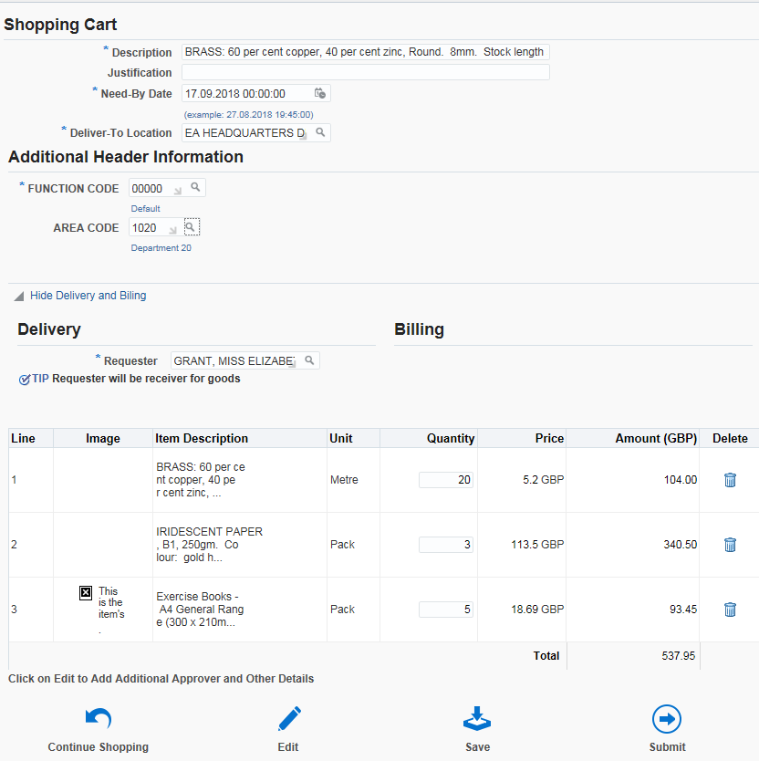
Area Code

Click on Submit (or Edit if you need to change something, e.g. Approver)

Option 2: Use if you have forgotten to use Option 1
If you have proceeded to the Edit and Submit Requisition screen or saved your requisition without entering the department code in the Shopping Cart screen you must enter the codes as follows:
Navigate to the Edit and Submit Requisition screen

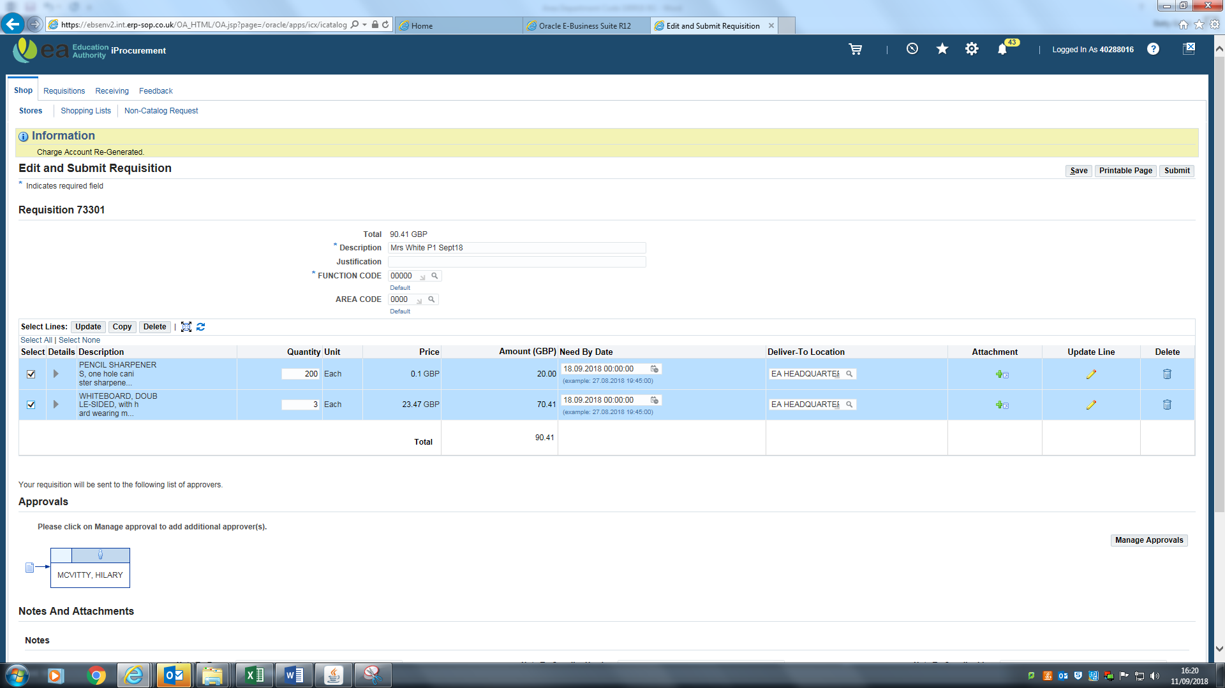
Codes entered here in this screen will NOT take effect
Click on the pencil symbol for the line required to be amended or changed.
If more than one line needs to be changed click on the tick box to the left of all the lines that need amended or changed. Click on the update line pencil on the first (top) line.
The Update Line screen opens. Scroll down to Billing. To enter the Area code click on the magnifying glass to the right of the code combination line to be amended.
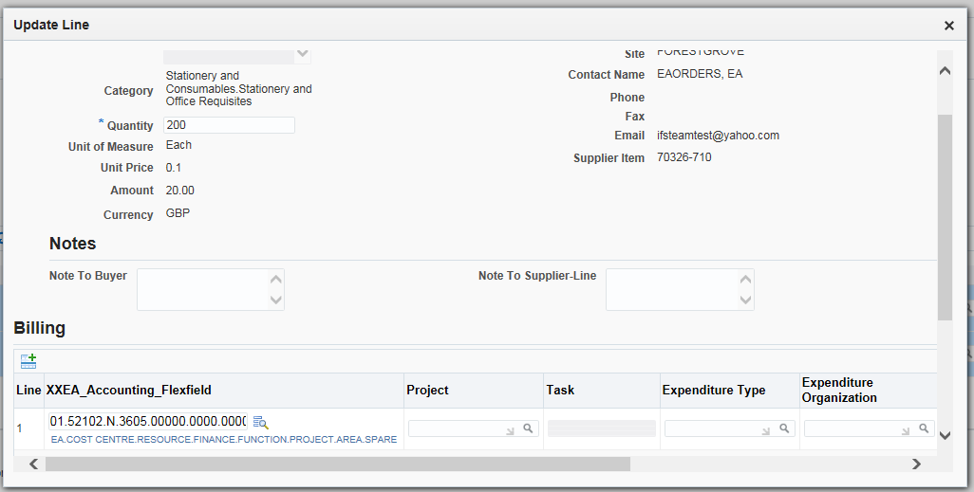
The Search and Select: XXEA Accounting Flexfield screen appears. Overwrite the default code in the Area field and click on Create. This will create a valid code combination. Click on Select
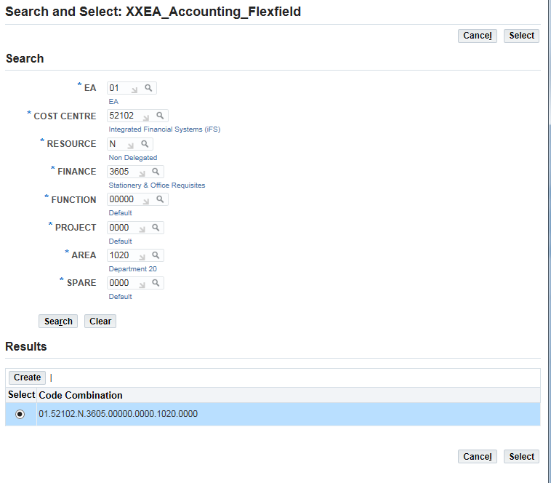

If correct codes are now in place, click on Apply
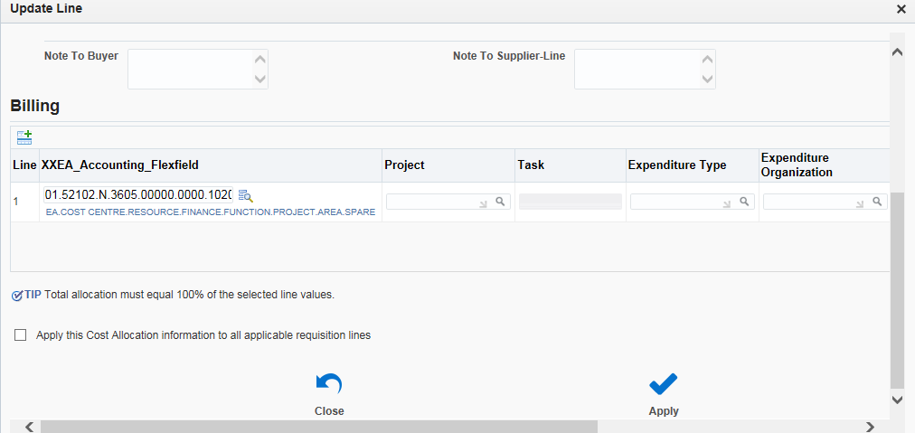
If you forgot to click all the lines earlier in the Edit and Submit Requisition screen & wish to apply the Area code to them all, tick the box beside Apply this Cost Allocation to all applicable lines. Click on Apply

This returns you to the Edit and Submit Requisition screen. Click on Submit
The requisition has now been submitted to the Approver for approval

