

Oracle Financials Notifications (Worklist) User Guide:

How to clear down the notifications from the worklist

Contents

1. View Notifications 1
2. Opening notifications 3
3. Taking the required action 5
4. Close a notification 6
Appendix A: Change Preference to receive notifications by email 7
Appendix B: Receipting goods from notification list 8
Appendix C: Completing requisitions after error message received 9
Appendix D: Vacation Rules (Leave from Work) 10

View Notifications

There are two types of notification:
- Information only notifications – e.g. a requisition has been approved
- Notifications that require a response, e.g. confirm receipt, approve an order, etc
These notifications are also emailed to you provided that your Preferences are set to receive these emails (Appendix A).
When you first log on to Oracle, your homepage will be displayed showing your responsibilities on the left hand side, and notifications in centre of the screen.

View from homepage:
List of responsibilities
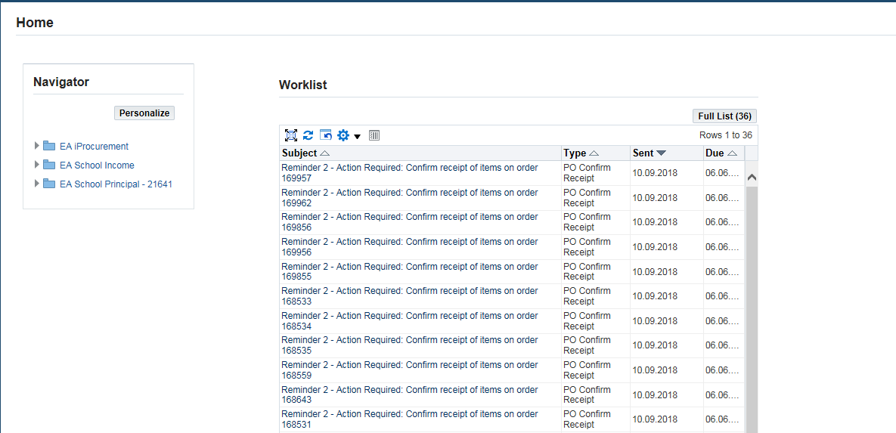
Click on ‘Full List’ to view all notifications and take the required actions
Workflow notifications responsibilities

View from the shopping page in i-procurement
You can also view notifications by clicking on the bell icon – this will display the number of notifications you have and you can open the full worklist from here.
The notifications (bell) icon will show the number of notifications you have – click on this to open the list.

Click on the ‘bell’ to show notifications

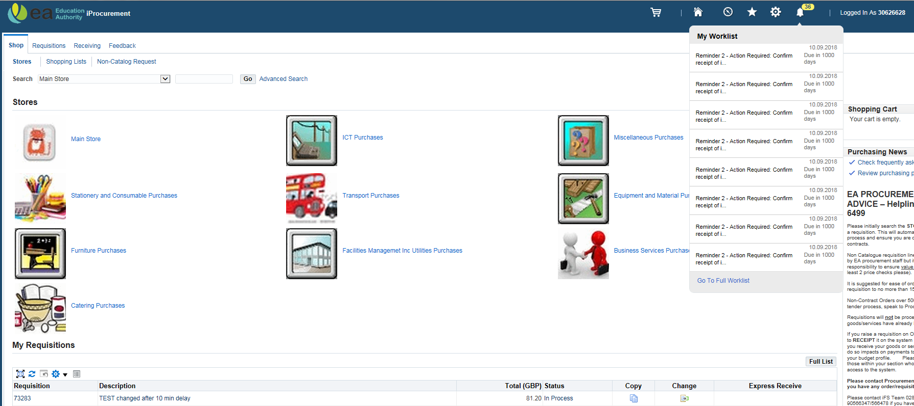
Click ‘Go to Full Worklist’ to take required action

Opening notifications

The full worklist will show all the open notifications you have.
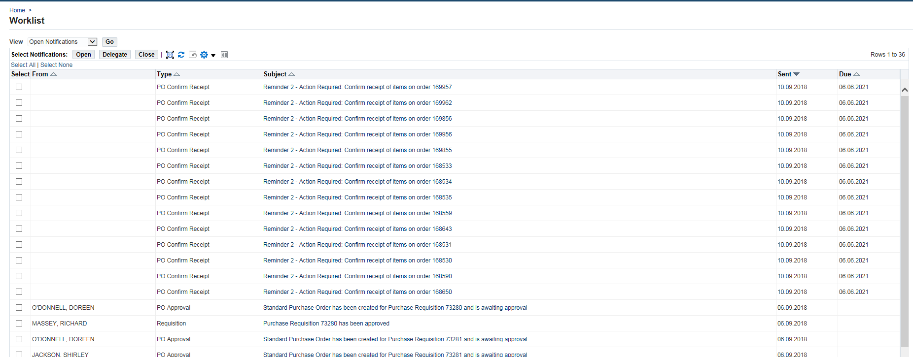

There are a number of options in this window.
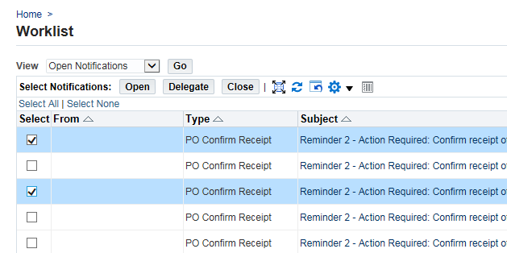
Select required notifications
If action is required it will be stated in the Subject field

Option | Description
Open | Opens the selected notification(s) and gives you options of actions to take
Delegate | APPROVER ONLY - You can select someone else to approve the order
Close | This will close the notifications that do not require any action (information only).  For information-only notifications there is no need to open – these can be closed directly from the worklist

You can open several notifications at the one time by selecting the tick box beside each notification and clicking on ‘Open’. Then you can move to the next opened notification by clicking ‘Next’.

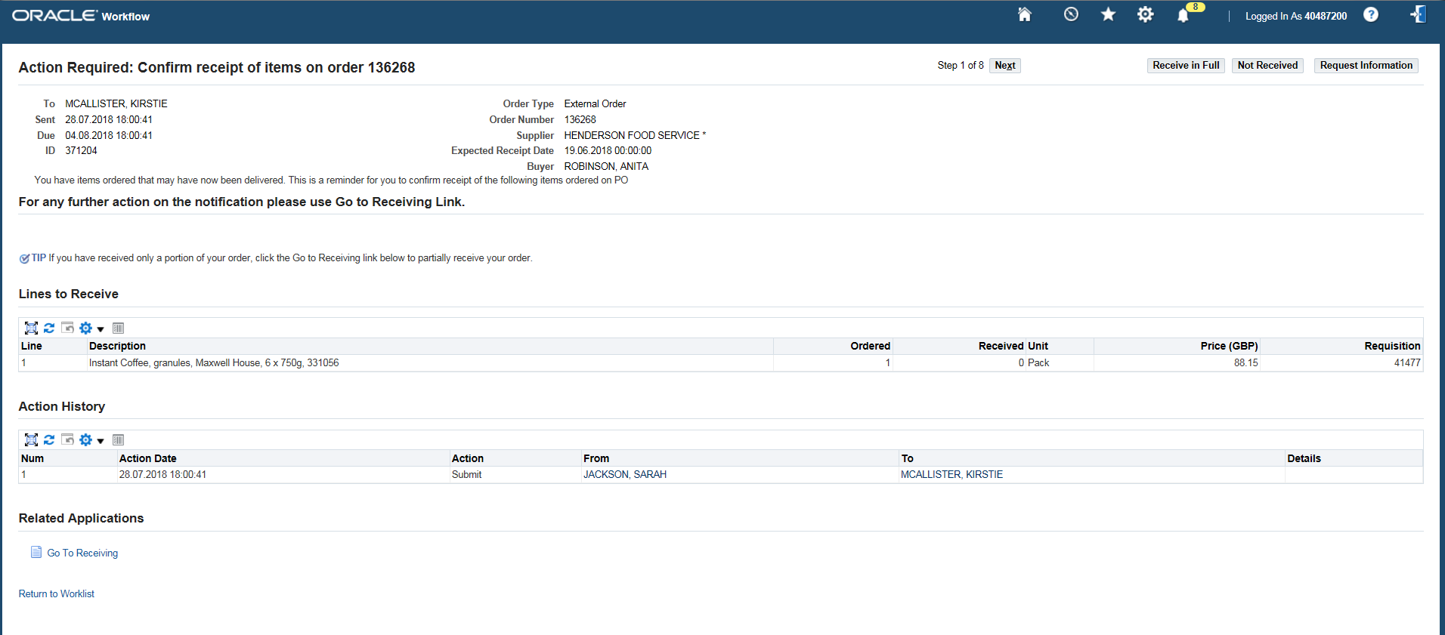
For each notification select the correct action
Click on ‘Return to Worklist’ to go back to the full list of notifications
This shows the number of notifications opened at the same time – click on ‘Next’ to move to the next one

Taking the required action

You can request more information on any of the notifications.

- PO Approval - Requisition is Awaiting Approval/Rejection
Approve | This will approve the requisition
Approve and Forward | This is used when another person has to approve as well
Forward | This will forward to the person who needs to approve
Reject | This will send the requisition back for amendment/cancellation

- Requisition - Purchase Requisition has been Approved
This type of notification is for information only and can be closed directly from worklist.

- PO Confirm Receipt - Confirm Receipt of items (there are 3 reminders that are system generated)
Receive in Full | This will take you to receipt window where you can receipt the goods (Appendix B)
Not Received | This will close the notification

- Error notifications
The following notifications relate to a known error within i-proc which results in the requisition being made ‘Incomplete’. To resolve this, the requisitioner will need to complete and resubmit the requisition (Appendix C).
These error notifications can be closed directly from the worklist (information only notifications):
- PO Failed with Error Number while processing requisition
- PO Approval Error – Approval Workflow database error while approving requisition
- PO Approval Error – Document manager Failed with error while processing requisition

Close a notification

You can close Information only notifications from the worklist. If a notification requires action, you will not be able close it. An error message will be displayed informing you that a response is required.

- Select the items you wish to remove from the worklist by ticking the box beside each line (or click ‘Select All’):
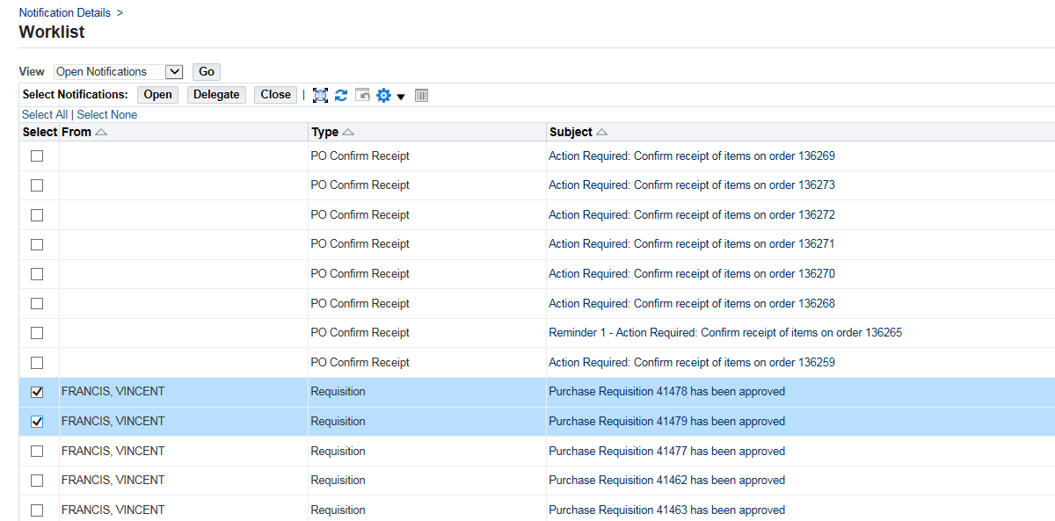

- Click ‘Close’ – the following message will appear:

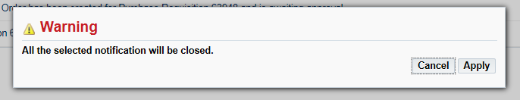

- Click ‘Apply’ – this will remove the selected notifications from the worklist.

- Once closed, the notifications will no longer be shown in the worklist. You can call back the notifications that are no longer open by changing the View in the Worklist from ‘Open Notifications’ to ‘All Notifications’, and click ‘Go’. All notifications will be listed.

Appendix A: Change Preference to receive notifications by email

NB this change will only need to be completed once
From the tool bar at the top, click on ‘Settings’.

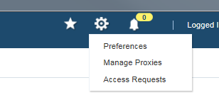
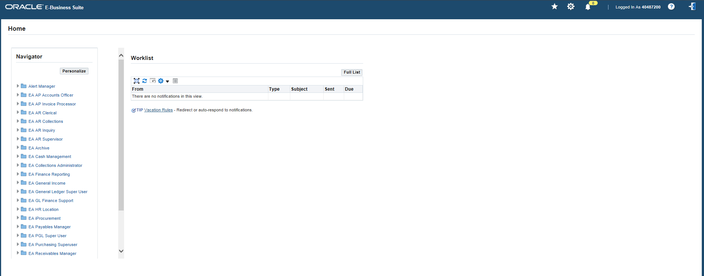
Click on Settings, then Preferences

The General Preferences will be displayed.
Scroll down to the bottom of the page to Notifications and change to HTML mail with attachments and click ‘Apply’.
Change Email Style

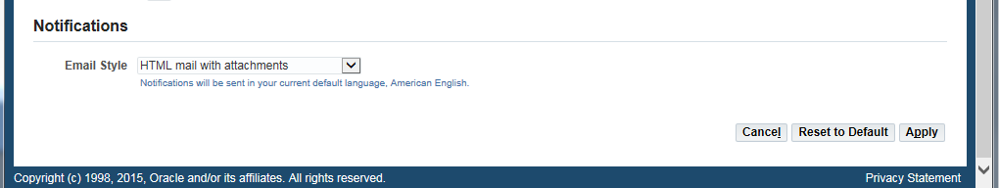
Click Apply

Appendix B: Receipting goods from notification list

Open the notification to confirm receipt of order.
Click on ‘Go To Receiving’ to receipt all or some of the goods

Status of order | Action to take | Description
If some or all of the items have been received | Go to Receiving  (this is a link at the bottom of the page)  **This is the recommended process | This will take you to the Receiving tab within in i-procurement. The delivered items can be receipted in the usual way. See details below.  You will be asked to log on to Oracle. Log on and the receipting window will be displayed; from here you can receipt the quantity that has been delivered.  To return to the worklist, click on the link at the bottom of the page, or use the notifications (bell) icon.
If items have not been received | Not Received | This will close the notification
If all items have been received | Receive in Full  Not recommended | This will automatically receipt all items contained in the requisition.  The receipt number can be found in the Receiving tab.

Appendix C: Completing requisitions after error message received

After an error message is received, check the status of your requisition in i-procurement by clicking into the Requisitions tab.
Your requisitions will be listed, and you should be able to see your requisition that received the error near or at the top of the list. The status of the requisition will be Incomplete.

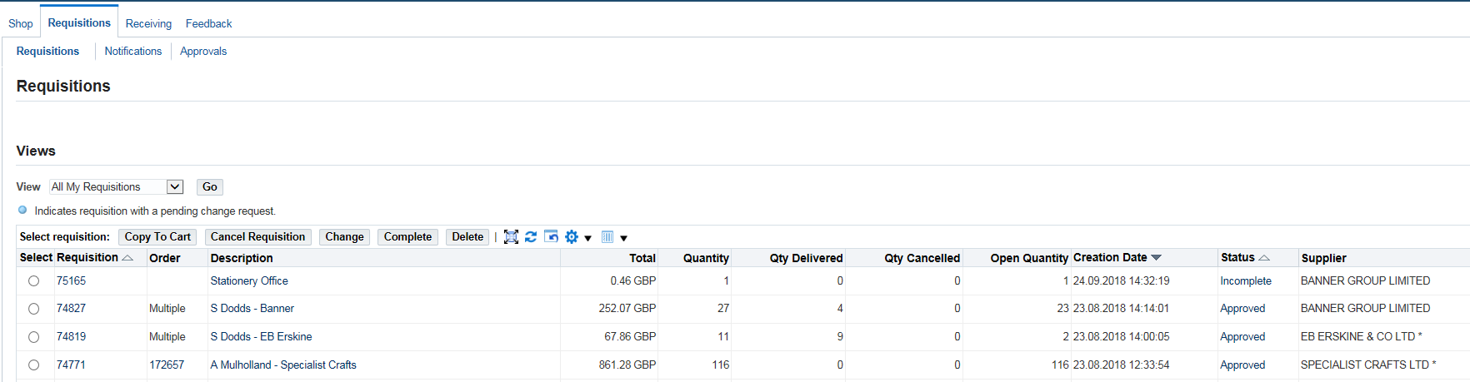
Status will be Incomplete

Select the requisition and click on ‘Complete’.
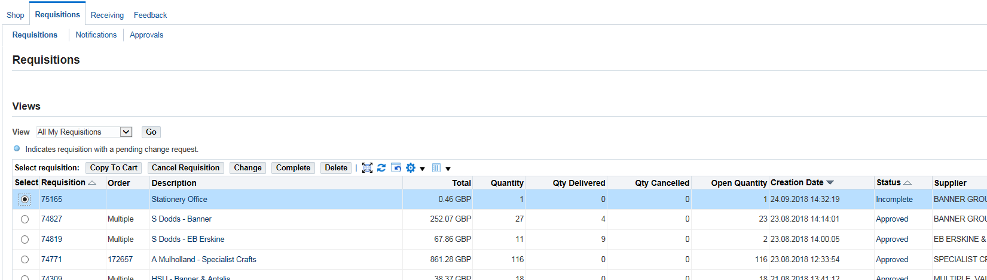
Select and click on Complete

If you get a warning, click on ‘Yes’ to continue.
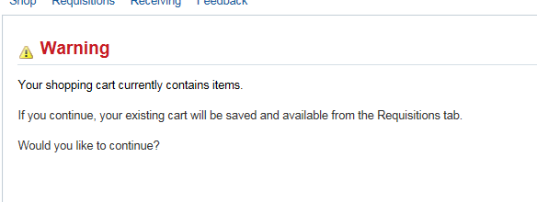
The requisition is put back into the shopping cart and the Edit and Submit Requisition window will be displayed. If no changes are needed, click on ‘Submit’ to send for approval.

Appendix D: Vacation Rules (Leave from Work)

If you know you are going to be off for a period of time, you can set up a ‘Vacation Rule’ to direct your notifications to another user.
From the Full Worklist, click on ‘Vacation Rules’.
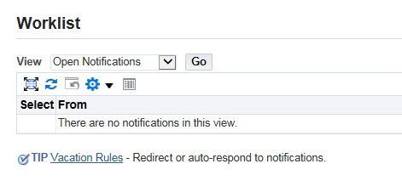
Click on Vacation Rules
Click on ‘Create Rule’
Click Create Rule
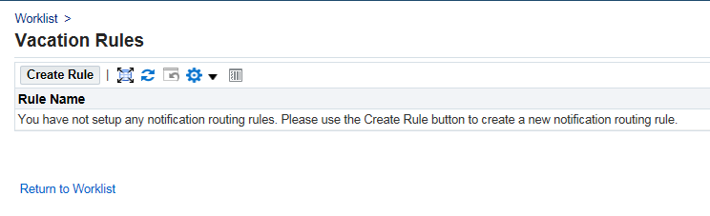
The default for Item Type is All. Click on ‘Next’ (no need to change the default). Enter the dates and Delegate (the person who will get the notifications in your absence).
Click ‘Apply’ to save the changes.

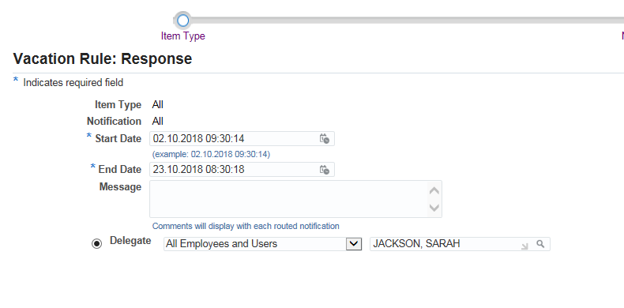
Enter name of person to receive your notifications using the search facility
Enter date range of time you will not be available

